Introduction to NumPy 3

**Introduction to NumPy Data Types** 7

Overview of NumPy Functions 13

Introduction to NumPy Histogram 20

Introduction to numPy.where() 25

Introduction to numpy.sort 30

Introduction to NumPy floor() 35

Introduction to Matrix in NumPy 39

Introduction to NumPy Matrix Transpose 46

Overview of Matrix Multiplication in NumPy 54

Introduction to NumPy Arrays 61

Overview of NumPy Array Functions 69

Introduction to NumPy Ndarray 76

Definition of NumPy Array Append 83

Definition of NumPy empty array 89

Introduction to NumPy ndarray tolist 95

Introduction to numpy.linspace() 100

Introduction to NumPy.argmax() 107

Introduction to NumPy Linear Algebra 112

Introduction to numpy.diff() 119

Introduction to numpy.unique() 123

Introduction to NumPy zeros 126

Introduction to numpy.mean() 130

What is numpy.dot()? 134

Introduction to Numpy.argsort() 138

Introduction to numpy.pad() 142

Introduction to numpy.ravel() 146

Introduction to NumPy stack 150

Definition of NumPy vstack 156

Introduction to NumPy hstack 162

Introduction to NumPy sum 167

Introduction to NumPy cumsum 172

Introduction to NumPy max 176

Introduction to NumPy squeeze 183

Introduction to NumPy median 188

Definition of NumPy Round 192

Introduction to NumPy NaN 197

Introduction to NumPy divide 203

Introduction to NumPy square 207

Introduction of Numpy ones 212

Definition of NumPy Meshgrid 218

Definition of NumPy exponential 224

Introduction to NumPy percentile 231

Introduction of NumPy fft 235

Introduction of NumPy flatten 240

Introduction of NumPy Concatenate 244

Introduction to NumPy Outer 249

Definition of NumPy zip 254

Introduction to NumPy Newaxis 258

Introduction to NumPy Format 266

Definition of Numpy Eigenvalues 270

Introduction to Numpy Random Seed () 276

Definition of NumPy random choice 280

Definition of NumPy random normal 285

Introduction to NumPy unravel_index 291

Introduction to Numpy.eye() 296

<https://www.educba.com/introduction-to-numpy/>

## Introduction to NumPy

In this article, we will learn about Introduction to NumPy. NumPy is a python package, primarily used for scientific and numerical computing. NumPy is a portmanteau of two words, coined by the blending of “Numerical” and “Python”. It is very famous among data scientists and analysts for its efficiency(run time speed) and the wide range of array operations, it provides. In this post, we will be getting acquainted with the NumPy library. NumPy was originally developed as “numeric” by Jim Hugunin in the late 90s. The present version of numpy was created by Travis Oliphant in 2005 by incorporating features from competing for numarray into numeric.

### What is NumPy Library?

NumPy library lets us store and work on a large amount of dense data effectively and efficiently. In NumPY data is stored in the form of arrays. These arrays are the crux of this library. Arrays in NumPy are similar to python built-in type “list”. The closest approximate to a numpy array is a C array. This can be attributed to the fact that NumPy is written primarily in C language. But [numpy arrays provide](https://www.educba.com/numpy-array-functions/) more efficient data storage and operations compared to both.

### Components of NumPy

Now, we will begin understanding some of the basic components of Numpy. The first step is NumPy installation. If you have been following us, you might have already read the post on “Numpy Installation”. You may follow the steps mentioned there to install the module/library on your system. If you want to try and understand the installation process yourself:

#### Importing NumPy

In python, packages/libraries like numpy, matplotlib, scipy, etc. are nothing but an extension module. So, installing a package is more or less similar to downloading its script and using it as a header/extension file. Therefore, whenever you want to use an attribute of the NumPy library, you have to import it as a header file. We can import NumPy using the following command. For the sake of convenience, we have created “np” an alias of NumPy. This alias is widely popular in the data science world.

import numpy as np

**Output:**

Hereupon, we will be using the above method to import and use various classes and methods in Numpy.

* **ndarray(shape, type):** creates an array of the given shape with random numbers
* **array(array_object):** creates an array of the given shape from the list or tuple
* **zeros(shape):** creates an array of the given shape with all zeros
* **ones(shape):**creates an array of the given shape with all ones
* **full(shape,array_object, dtype):** create an array of the given shape with complex numbers
* **arange(range):** creates an array with the specified range

### Example of Introduction to NumPy Array Creation

Below is the Program for better understanding :

**Code:**

import numpy as np  
#creating array using ndarray  
A = np.ndarray(shape=(2,2), dtype=float)  
print("Array with random values:\n", A)  
# Creating array from list  
B = np.array([[1, 2, 3], [4, 5, 6]])  
print ("Array created with list:\n", B)  
# Creating array from tuple  
C = np.array((1 , 2, 3))  
print ("Array created with tuple:\n", C)

**Output:**

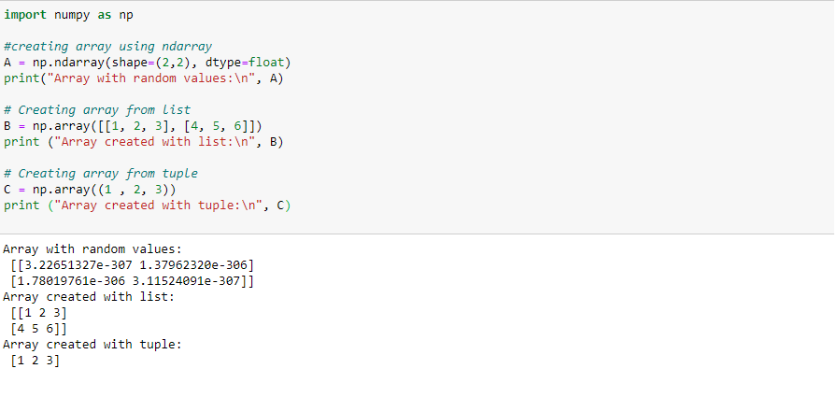

### Characteristics of NumPy

Here, we will be learning some of the characteristic features of the NumPy library. The features are similar to the C language.

* **Support n-dimensional arrays:** NumPy arrays are multidimensional or n-dimensional lists or matrices of fixed size with homogeneous elements( i.e. data type of all the elements in the array is the same).
* **Require a contiguous allocation of memory:** This improves the efficiency as all elements of the array become directly accessible at a fixed offset from the starting of the array.
* Support selection using crop, slice, choose, etc.
* Support vectorized and complex operations.
* Support [linear algebra](https://www.educba.com/numpy-linear-algebra/), Fourier transform, and sophisticated broadcasting functions.

In nutshell, [NumPy provides](https://www.educba.com/numpy-ndarray/) capabilities similar to C/C++ but the simplicity of the use of Python.

### Advantages and Disadvantages of Numpy

Below are mentioned the advantages and disadvantages of Numpy:

#### Advantages of NumPy

Below are the points that explain the advantages of NumPy:

* The core of Numpy is its arrays. One of the main advantages of [using Numpy arrays](https://www.educba.com/numpy-arrays/) is that they take less memory space and provide better runtime speed when compared with similar data structures in python(lists and tuples).
* Numpy support some specific scientific functions such as linear algebra. They help us in solving linear equations.
* Numpy support vectorized operations, like elementwise addition and multiplication, computing Kronecker product, etc. Python lists fail to support these features.
* It is a very good substitute for MATLAB, OCTAVE, etc as it provides similar functionalities and supports with faster development and less mental overhead(as python is easy to write and comprehend)
* NumPy is very good for data analysis.

#### Disadvantages of NumPy

Below are the points that explain the disadvantages of NumPy:

* **Using “nan” in Numpy:** “Nan” stands for “not a number”. It was designed to address the problem of missing values. NumPy itself supports “nan” but lack of cross-platform support within Python makes it difficult for the user. That’s why we may face problems when comparing values within the Python interpreter.
* **Require a contiguous allocation of memory:** Insertion and deletion operations become costly as data is stored in contiguous memory locations as shifting it requires shifting.

### Conclusion – Introduction to NumPy

NumPy is a python package used for numerical and scientific computing. It provides better runtime and space complexity. It provides a wide variety of array operations. If you wish to perform general-purpose operations, use python lists. But, if you care about performance and space complexity, use Numpy.

<https://www.educba.com/numpy-data-types>

**Introduction to NumPy Data Types**

The data types are used for defining a variable with a specific type that is used for identifying the variable and allowing the given types of data. Numpy is a data type used on Python programming, and comes along with the python package that can be used for multiple scientific computational operations. A few of the commonly used NumPy data types are np.byte, np.short, np.int_, np.uintc, np.ubyte, np.bool_, np.longlong, np.single, np.half, np.single, np.double, np.csingle, np.int8, np.int64, np.int32, np.intp, np.unitp, np.float64, etc.

**Numpy Data Types**

The various data types supported by numpy are :

|  |  |  |  |
| --- | --- | --- | --- |
| **Numpy data type** | **Closely associated C data type** | **Storage Size** | **Description** |
| np.bool_ | bool | 1 byte | can hold boolean values, like (True or False) or (0 or 1) |
| np.byte | signed char | 1 byte | can hold values from 0 to 255 |
| np.ubyte | unsigned char | 1 byte | can hold values from -128 to 127 |
| np.short | signed short | 2 bytes | can hold values from -32,768 to 32,767 |
| np.ushort | unsigned short | 2 bytes | can hold values from 0 to 65,535 |
| np.uintc | unsigned int | 2 or 4 bytes | can hold values from 0 to 65,535 or 0 to 4,294,967,295 |
| np.int_ | long | 8 bytes | can hold values from -9223372036854775808 to 9223372036854775807 |
| np.uint | unsigned long | 8 bytes | 0 to 18446744073709551615 |
| np.longlong | long long | 8 bytes | can hold values from -9223372036854775808 to 9223372036854775807 |
| np.ulonglong | unsigned long long | 8 bytes | 0 to 18446744073709551615 |
| np.half / np.float16 | — |  | allows half float precision with Format: sign bit, 5 bits exponent, 10 bits mantissa |
| np.single | float | 4 bytes | allows single float precision Format: sign bit, 8 bits exponent, 23 bits mantissa |
| np.double | double | 8 bytes | allows double float precision Format: sign bit, 11 bits exponent, 52 bits mantissa. |
| np.longdouble | long double | 8 bytes | extension of float |
| np.csingle | float complex | 8 bytes | can hold complex with real and imaginary parts up to single-precision float |
| np.cdouble | double complex | 16 bytes | can hold complex with real and imaginary parts up to double-precision float |
| np.clongdouble | long double complex | 16 bytes | extension of float for complex number |
| np.int8 | int8_t | 1 byte | can hold values from -128 to 127 |
| np.int16 | int16_t | 2 bytes | can hold values from -32,768 to 32,767 |
| np.int32 | int32_t | 4 bytes | can hold values from -2,147,483,648 to 2,147,483,647 |
| np.int64 | int64_t | 8 bytes | can hold values from -9223372036854775808 to 9223372036854775807 |
| np.uint8 | uint8_t | 1 byte | can hold values from 0 to 255 |
| np.uint16 | uint16_t | 2 bytes | can hold values from 0 to 65,535 |
| np.uint32 | uint32_t | 4 bytes | can hold values from 0 to 4,294,967,295 |
| np.uint64 | uint64_t | 8 bytes | can hold values from 0 to 18446744073709551615 |
| np.intp | intptr_t | 4 bytes | a signed integer used for indexing |
| np.uintp | uintptr_t | 4 bytes | an unsigned integer used for holding a pointer |
| np.float32 | float | 4 bytes | single float precision |
| np.float64 | double | 8 bytes | double float precision |
| np.complex64 | float complex | 8 bytes | single float precision in complex numbers |
| np.complex128 | double complex | 16 bytes | double float precision in complex numbers |

**Examples of NumPy Data Types**

Now, let’s understand how a particular numpy data type is used.

**Example #1**

Creating a data type object

dt = np.dtype(np.int8)

**Output:**

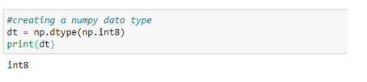

**Example #2**

Finding the size of a data type

dt = np.dtype(np.int8)  
name = dt.name  
sizeoftype = dt.itemsize  
print('name:',name, 'size:',sizeoftype)

**Output:**

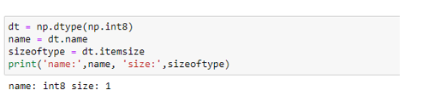

**Example #3**

Creating a data type object using unique symbols for each data type

Each data type in numpy has an associated character code that uniquely identifies it.

dt = np.dtype('i4')

**Output:**

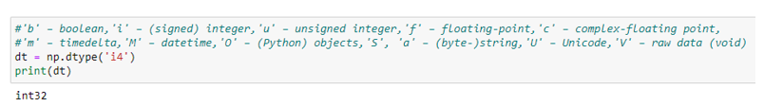

**Example #4**

Using data types to create a structured array

employee_info = np.dtype([('name','S10'), ('age', 'i1'),('salary', 'f4'),('rating', 'f4')])  
print(employee_info)

**Output:**

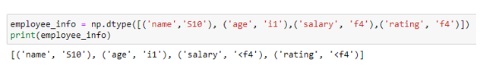

**a = np.array([('Karthik',31,20000,3.84),('Rita',25,25123.34,4.41)], dtype = employee_info)  
print (a)**

**Output:**

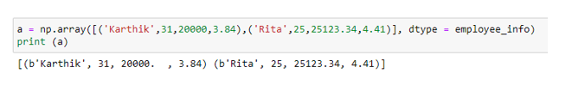

**Conclusion**

Numpy data types are more or less like the C data types. They can be roughly categorized into a bool, byte, int, float, double and complex. It is a must for good programmers to understand how data is stored and manipulated. This can be achieved by understanding data types effectively.

<https://www.educba.com/numpy-functions/>

## Overview of NumPy Functions

Numpy is a python package used for scientific computing. So certainly, it supports a vast variety of functions used for computation. The various functions [supported by numpy](https://www.educba.com/what-is-numpy/) are mathematical, financial, universal, windows, and logical functions. Universal functions are used for array broadcasting, typecasting, and several other standard features. While windows functions are used in signal processing. We will be learning mathematical functions in detail in this article.

### Mathematical Functions in NumPy

Numpy is written purely in C language. Hence, it’s mathematical functions are closely associated with functions present is math.h library in C.

#### 1. Arithmetic Functions

|  |  |
| --- | --- |
| **Function** | **Description** |
| add(arr1, arr2,..) | Add arrays element wise |
| reciprocal(arr) | Returns reciprocal of elements of the argument array |
| negative(arr) | Returns numerical negative of elements of an array |
| multiply(arr1,arr2,…) | Multiply arrays element wise |
| divide(arr1,arr2) | Divide arrays element wise |
| power(arr1,arr2) | Return the first array with its each of its elements raised to the power of elements in the second array (element wise) |
| subtract(arr1,arr2,…) | Subtract arrays element wise |
| true_divide(arr1,arr2) | Returns true_divide of an array element wise |
| floor_divide(arr1,arr2) | Returns floor after dividing an array element wise |
| float_power(arr1,arr2) | Return the first array with its each of its elements raised to the power of elements in the second array (elementwise) |
| fmod(arr1,arr2) | Returns floor of the remainder after division elementwise |
| mod(arr1,arr2) | Returns remainder after division elementwise |
| remainder(arr1,arr2) | Returns remainder after division elementwise |
| divmod(arr1,arr2) | Returns remainder and quotient after division elementwise |

The above-mentioned operations can be performed in the following ways :

In the given code snippet, we try to do some basic operations on the arguments, array a and array b.

**Code:**

**import numpy as np  
a = np.array([10,20,30])  
b= np.array([1,2,3])  
print("addition of a and b :",np.add(a,b))  
print("multiplication of a and b :",np.multiply(a,b))  
print("subtraction of a and b :",np.subtract(a,b))  
print("a raised to b is:",np.power(a,b))**

**Output:**

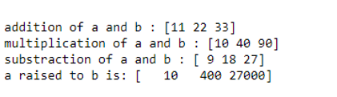

In this code snippet, we try to perform division and related operations on the arguments, array a and array b. We can notice the difference between mod, remainder, divmod and simple division.

**Code:**

**import numpy as np  
a = np.array([10,20,30])  
b= np.array([2,3,4])  
print("division of a and b :",np.divide(a,b))  
print("true division of a  :",np.true_divide(a,b))  
print("floor_division of a and b :",np.floor_divide(a,b))  
print("float_power of a raised to b :",np.float_power(a,b))  
print("fmod of a and b :",np.fmod(a,b))  
print("mod of a and b :",np.mod(a,b))  
print("quotient and remainder of a and b :",np.divmod(a,b))  
print("remainders when a/b :",np.remainder(a,b))**

**Output:**

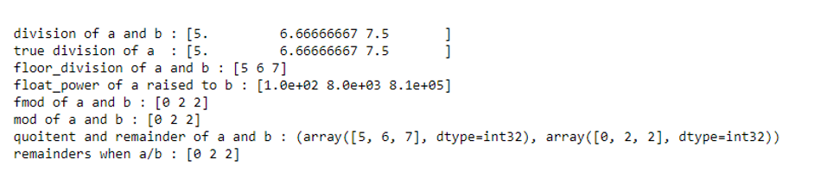

#### 2. Trigonometric Functions

|  |  |
| --- | --- |
| **Function** | **Description** |
| sin(arr) | Returns trigonometric sine element wise |
| cos(arr) | Returns trigonometric cos element wise |
| tan(arr) | Returns trigonometric tan element wise |
| arcsin(arr) | Returns trigonometric inverse sine element wise |
| arccos(arr) | Returns trigonometric inverse cosine element wise |
| arctan(arr) | Returns trigonometric inverse tan element wise |
| hypot(a,b) | Returns hypotenuse of a right triangle with perpendicular and base as arguments |
| degrees(arr)  rad2deg(arr) | Covert input angles from radians to degrees |
| radians(arr)  deg2rad(arr) | Covert input angles from degrees to radians |

Here is an example of how to [use trigonometric functions.](https://www.educba.com/trigonometric-functions-in-python/)

**Code:**

**import numpy as np  
angles = np.array([0,np.pi/2, np.pi])     -----> input array angles  
sin_angles = np.sin(angles)  
cosine_angles = np.cos(angles)  
tan_angles = np.tan(angles)  
rad2degree = np.degrees(angles)  
print("sin of angles:",sin_angles)  
print("cosine of angles:",cosine_angles)  
print("tan of angles:",tan_angles)  
print("angles in radians",rad2degree)**

**Output:**

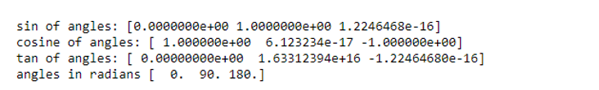

#### 3. Logarithmic and Exponential Functions

|  |  |
| --- | --- |
| **Function** | **Description** |
| exp(arr) | Returns exponential of an input array element wise |
| expm1(arr) | Returns exponential exp(x)-1 of an input array element wise |
| exp2(arr) | Returns exponential 2**x of all elements in an array |
| log(arr) | Returns natural log of an input array element wise |
| log10(arr) | Returns log base 10 of an input array element wise |
| log2(arr) | Returns log base 2 of an input array element wise |
| logaddexp(arr) | Returns logarithm of the sum of exponentiations of all inputs |
| logaddexp2(arr) | Returns logarithm of the sum of exponentiations of the inputs in base 2 |

Here is an example of using logarithmic functions:

**Code:**

**import numpy as np  
a = np.array([1,2,3,4,5])  
a_log = np.log(a)  
a_exp = np.exp(a)  
print("log of input array a is:",a_log)  
print("exponent of input array a is:",a_exp)**

**Output:**



#### 4. Rounding Functions

|  |  |
| --- | --- |
| **Function** | **Description** |
| around(arr,decimal) | Rounds the elements of an input array upto given decimal places |
| round_(arr,decimal) | Rounds the elements of an input array upto given decimal places |
| rint(arr) | Round the elements of an input array to the nearest integer towards zero |
| fix(arr) | Round the elements of an input array to the nearest integer towards zero |
| floor(arr) | Returns floor of input array element wise |
| ceil(arr) | Returns ceiling of input array element wise |
| trunc(arr) | Return the truncated value of an input array element wise |

Example of using rounding functions with numpy arrays:

**Code:**

**import numpy as np  
a = np.array([1.23,4.165,3.8245])  
rounded_a = np.round_(a,2)  
print(rounded_a)**

**Output:**

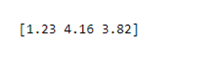

**Code:**

**floor_a = np.floor(a)  
print(floor_a)**

**Output:**

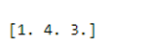

#### 5. Miscellaneous Functions

|  |  |
| --- | --- |
| **Function** | **Description** |
| sqrt(arr) | Returns the square root of an input array element wise |
| cbrt(arr) | Returns cube root of an input array element wise |
| absolute(arr) | Returns absolute value each element in an input array |
| maximum(arr1,arr2,…) | Returns element wise maximum of the input arrays |
| minimum(arr1,arr2,…) | Returns element wise minimum of the input arrays |
| interp(arr, xp, fp) | Calculates one-dimensional linear interpolation |
| convolve(arr, v) | Returns linear convolution of two one-dimensional sequences |
| clip(arr, arr_min, arr_max) | Limits the values in an input array |

Some examples using the above functions.

**Finding the Maxima:**

**Code:**

**import numpy as np  
a = [1,2,3] b = [3,1,2] maximum_elementwise = np.maximum(a,b)  
print("maxima are:",maximum_elementwise)**

**Output:**

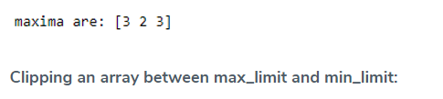

**Code:**

**import numpy as np  
a = [1,2,3] b = [3,1,2] limiting_a = np.clip(a,0,2)  
print("limiting a between 0 and 2:",limiting_a)**

**Output:**

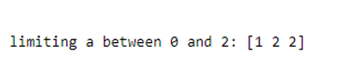

### Conclusion

In this post, we have tried to cover the most frequently used mathematical functions in numpy. However, there are some other functions like complex functions which helps in working with real and imaginary parts of a number, floating-point routines which helps in performing decimal operations and hyperbolic functions which helps in calculating hyperbolic sine, tan, cos, etc.

<https://www.educba.com/numpy-histogram/>

## Introduction to NumPy Histogram

The famous programming language python has a core library which is specifically designed for scientific computation that provides for tools to integrate languages like C and C ++ which is known as NumPy (meaning numerical python). It is specifically useful for coders who deal with data science and big data analysis with parallel mathematical operations being conducted which are provided by calling the predefined [numpy functions](https://www.educba.com/numpy-functions/) or tools. Among one of the features present in this library is the histogram function known as NumPy Histogram().

The numpy histogram function provides for the data scientist to perform graphical analysis on the basis of the data and their respective frequency distribution. The Numpy histogram function has two parameters called bins and input arrays. The bins are rectangular-shaped blocks that are distanced at equal horizontal width that correspond to the respective class interval. The difference in the height of these beans is representative of the difference in the frequency of these class intervals.

### Syntax

Following is the representation in which code has to be drafted in the [Python language for the application](https://www.educba.com/python-scripting-language/) of the numpy histogram function:

import numpy as np  
//The core library of numpy is being imported so that the histogram function can be applied which is a part of the numpy library  
numpy.histogram (a, bins=10, range = None, normed = None, weights = None, density = None)

The various criteria is set to define the histogram data are represented by bins, range, density, and weights.

Another function called the plt() from the matplot library is used in converting the numeric data into histogram graphs. The function uses the data from the array as parameters converting it to a histogram.

### Parameters

Here are the following Parameters of NumPy Histogram mention below

1. **a:** array_like (Represent the set of values that has been input by the user)

These values would be arranged in the set of arrays which would be flattened and computed to who returned the histogram.

1. **bins:** can be either int or sequence (of values which are either string or scalar)

If the bins are int (which define the total number of bins with equal width that have been mentioned in the range which is taken to be 10 as a default value)

If the pins are sequence then that represents the monotonic increase in the array which effects on the bin’s width edges (this is inclusive of the rightmost age which gives rise to two non-uniform bin width)

The histogram’s bin edges define the method of calculation which has to be used depending upon the optimal width of the bin. This is specifically true if the bin has string values.

1. **range :** (float [upper value] , float [lower value]) (optional)

Operations and the lower range of the bin are represented through the float values. If the limit has not been provided and automatic range is taken by the system which is represented by the syntax a.min(), a.max(). The range helps in ignoring or by-passing any values which lie outside of the range are not considered during the computation, which has a great impact on the automated bin computation. It must be noted that the value of the first element which has been mentioned in the range must be less than or at least equal to the second element.

1. **normed:** bool (optional for code syntax) [It has been deprecated since the release of version 1.6.0 of Python]

The density argument used in Python can be taken to be its equivalent in terms of functionality, but its application produces discrepancies in the result when there is and an equal distribution with regard to the width of the bins.

1. **weights :** array_like (optional for code syntax)

An array of weights, of the same shape as a. Each value in an only contributes its associated weight towards the bin count (instead of 1). If the density is True, the weights are normalized, so that the integral of the density over the range remains 1.

1. **density :** bool (optional for code syntax)

The bin count accounts for the contribution of each value in accordance with its associated weight. The density value true normalization of the weights occurs making the integral of the density remain over 1. If the value is false, there are a number of samples that are contained in each of the resultant bins.

### Examples to implement histogram in NumPy

Let us consider the example of the number of votes that went in the favour of Obama in the elections across different countries. So, the matplot library module has to be utilized whether his function would be called to generate the histogram.

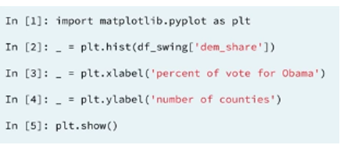

* A dummy variable called underscore is assigned to the histogram. After the creation of the histogram, the axis has to be labelled. The axis of the bar of the histogram can be specifically changed by the user.

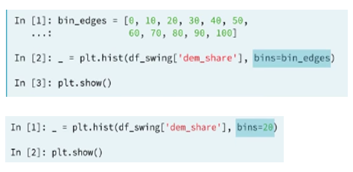

* Adding to it, the number of bins can also be specified by the user (say 20) by simply using the bins keyword and matplotlib will automatically generate 20 evenly spaced bins.
* Generally, the seaborn styling setting is preferred to be used which is a visualisation package that was written primarily by Michael Waskom. It can also be used as default by using the SNS set function using the below-mentioned code.

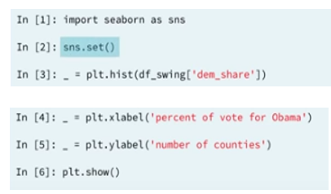

The following histogram is generated as an output by performing the above-mentioned coding procedure which represents the number of votes which were in the favour of Obama by various countries.

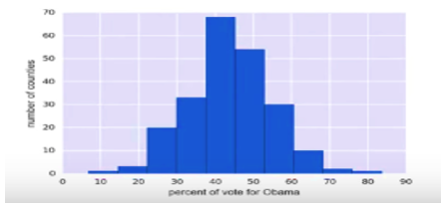

### Conclusion

The number histogram function provides for a pre-developed graphical representation functionality which is quintessential and very handy acting as a preparatory step the four functions such as edge detection or thresholding are performed. It serves as a very efficient tool when dealing with data that need visualization and creating a visual difference using image formats that are compressed and uncompressed. It specifically is advantages for project detection of color changes between various histogram plots serve as a tool to perform analysis.

<https://www.educba.com/numpy-where>

## Introduction to numPy.where()

The numPy.where() function is used to deliver back to the user the specific indices of certain elements which are present in the array which has been entered by the user where certain predefined conditions with respect to the function parameters get satisfied. In simple words, we can say that the function helps the user to locate where exactly is the element with the specified conditions positioned in the array which has been entered. This can be done by using both single argument as well as specifying multiple arguments.

**Syntax for numPy.where() function**

numpy *. * where * (* condition * [,* x *, * * y *] *

**Parameters for numPy.where() function in Python language**

condition * *: * *array *_ *like *, * bool *

The conditional check to identify the elements in the array entered by the user complies with the conditions that have been specified in the code syntax. If the condition is false to be TRUE, the value x is used. If the condition false is to be FALSE, then the value y is rather used. These are generally Boolean values.

*x *, * *y * *: * *array *_ *like *

The values which are to be replaced in case of a true or false condition and the conditions as the parameter has to be converted into a broadcasted to structured array for the resultant elements to be displayed which needed to have a specific orientation.

**Returns for numPy.where() function in Python language**

**out* *:* *ndarray* *

It is the output array that is assimilated after the original array entered by the user is processed for the conditions applied, and the elements are replaced by the conditional elements X and Y.

**Note while the conditional parameters for numPy.where() function is passed**

 It must be noted that when all the arguments in your conditions have been passed and the resultant are produced with the elimination of the conditional values replaced by the selected X and Y values would be produced, all free of the arrays should be of similar dimensions of size.

* If the replacement values (i.e., x and y arguments) have not been passed and the condition alone has been applied to the numpy.where() function then the resultant reproduce would be array tuples (i.e., one array for each of the axis of the original array entered). These array tuples would contain the specific indices the elements which test out to be matching the true value for the Boolean condition which has been passed.

### How does the numPy.where() Function work?

In functional ability of the numPy.where() we have to see that when the logical operation is being run through the function a Boolean array is returned as a result off the condition being true.

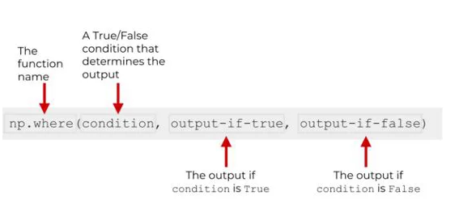

Visually display what the system processes and identifies while running the numpy.where() function:

Create an array containing a list of elements:

a1 = n1.array([21 , 22 , 23, 24 , 25 , 26 , 27 , 28 , 29 , 30)]

Passing a conditional expression for the array entered to be tested:

ans = n1.where((a1 > 22) & (a1 < 26))

The function runs through each element in the array entered by the user to check if it performs with the condition given in the function. For each element which test to be true, to the numpy.where() captures the indices of the element into a new array containing the indices of each of the element testing true.

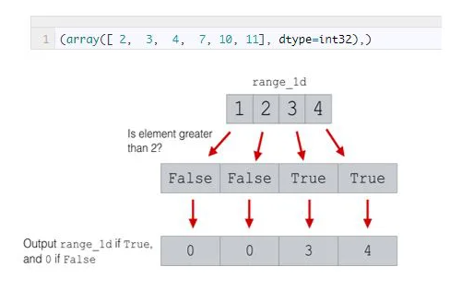

This diagram shows the mechanism of how the array is checked for the specific condition implied and returns the output returning the relevant output array in accordance with indices returned.

### Examples of numPy.where() Function

The following example displays how the numPy.where() function is used in a python language code to conditionally derive out elements complying with conditions:

#### Example #1

Python numPy function integrated program which illustrates the use of the where() function.

**Code:**

import numpy as n1  
# entering the array  
a1 = n1.array([[10, 20, 30], [40, 50, 60]])  
# printing the elements in the given array  
print ("The original array entered by the user")  
print(a1)  
# specifically sorting out the array which are greater than 30  
print ("Print all indices containing elements greater than 30")  
ans = n1.where(a1>30)  
print(ans)  
print("Displaying all the elements of the array that are greater than 30")  
print(a1[ans])

**Output:**

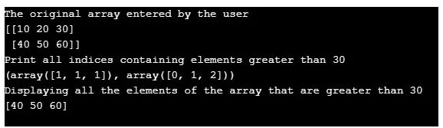

#### Example #2

Python numPy function integrated program which illustrates the use of the where() function.

**Code:**

import numpy as n2  
# entering the elements of the original array  
a2 = n2.array([[4, 5, 6], [7, 8, 9]])  
# printing the elements in the given array  
print ("The original array entered by the user")  
print(a2)  
# specifically sorting out the array which are less than 7  
print ("Print all indices containing elements less than 7 ")  
ans2 = n2.where(a2<7)  
print(ans2)  
print("Displaying all the elements of the array that are less than 7")  
print(a2[ans2])

**Output:**

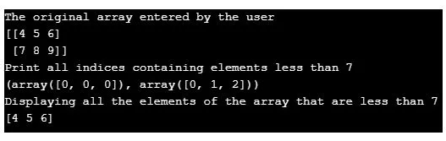

### Conclusion

The numPy.where() function provides for a pre-developed functionality which is quintessential and very handy acting as a preparatory step functions for major large threshold data processing programs. It serves as a solution against the creation of many additional arrays that stores new elements specifically which increased the processing time and reduces the verbosity of the program.

<https://www.educba.com/numpy-sort/>

## Introduction to numpy.sort

Numpy.sort() is a sorting function that helps in arranging the elements of an array in a certain order. Let’s say we want to sort our array in ascending order along the first axis, then numpy.sort() comes to our rescue. Numpy provides four different sorting algorithms: quicksort, heapsort, mergesort, and timsort. We will be discussing these algorithms in great detail while solving some examples.  We can choose any of the mentioned algorithms based on the required time and space complexity.

**Syntax and Parameters:**

Moving ahead, let’s discuss the numpy.sort() function in greater details. The standard syntax for writing this function is as follows :

numpy.sort(a, axis=-1, kind=None, order=None)

The parameters of numpy.sort() are :

* **a: array-like object –** The input array to be sorted.
* **axis: 0, -1 or none –** The axis along which the array has to be sort. If nothing is mentioned, then the array is flattened before sorting. By default, the array is sorted along the last axis. It is denoted by axis = -1.
* **kind: {‘quicksort’, ‘mergesort’, ‘heapsort’, ‘stable’} –** In numpy, we can choose from any of these sorting algorithms {‘quicksort’, ‘mergesort’, ‘heapsort’, ‘stable’}. By default, the input array will be sorted by using quicksort.
* **order: order of sorting {string or list} –** This parameter specifies the field along which the sorting has to be done. It usually used when we have a field defined array.

Out of the above-mentioned parameters, the first parameter is compulsory. The other parameters are optional and can be used based on the specific requirement. The numpy.sort() function returns a sorted copy of the input array.

### Examples to Illustrate numpy.sort

Following are the different examples to illustrate numpy.sort.

#### Example #1

Program to illustrate sorting along different axes using numpy.sort()

**Code:**

import numpy as np  
#creating an array  
A = np.array([[15, 1], [19, 94]])  
print ("The input array is : \n", A)  
# sorting along the first axis  
A_sorted = np.sort(A, axis = 0)  
print ("Sorted array along the first axis : \n", A_sorted)  
#sorting along the last axis  
A_sorted = np.sort(A, axis = -1)  
print ("Sorted array along the last axis : \n", A_sorted)  
#sorting the flattened axis  
A_sorted = np.sort(A, axis = None)  
print ("Sorted array when flattened: \n", A_sorted)

**Output:**

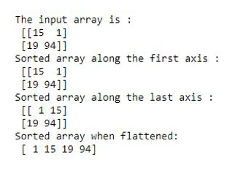

#### Example #2

Program to illustrate sorting using different sorting algorithms using numpy.sort()

**Code:**

import numpy as np  
#creating an array  
A = np.array([[19, 3], [19, 94]])  
print ("The input array is : \n", A)  
# sorting along the first axis using quicksort  
A_sorted = np.sort(A, axis = 0, kind = 'quicksort')  
print ("Sorted array using quicksort : \n", A_sorted)  
# sorting along the first axis using mergesort  
A_sorted = np.sort(A, axis = 0, kind = 'mergesort')  
print ("Sorted array using mergesort : \n", A_sorted)  
# sorting along the first axis using heapsort  
A_sorted = np.sort(A, axis = 0, kind = 'heapsort')  
print ("Sorted array using heapsort : \n", A_sorted)  
# sorting along the first axis using stable  
A_sorted = np.sort(A, axis = 0, kind = 'stable')  
print ("Sorted array using stable : \n", A_sorted)

**Output:**

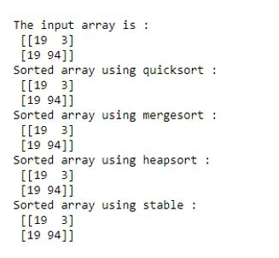

Quickly comparing the space and time complexity of different algorithms.

|  |  |  |  |  |
| --- | --- | --- | --- | --- |
| **Type of Analysis** | **Quicksort** | **Heapsort** | **Mergesort** | **timsort** |
| Best Case | O(n*log(n)) | O(n*log(n)) | O(n*log(n)) | O(nk) |
| Worst Case | O(n^2) | O(n*log(n)) | O(n*log(n)) | O(nk) |
| Average Case | O(n*log(n)) | O(n*log(n)) | O(n*log(n)) | O(nk) |
| Space | Constant | Constant | Depends | Depends |
| Stability | No | No | Yes | Yes |

Stable in itself is not a sorting algorithm. It is a keyword used to direct the function to automatically choose the best stable sorting algorithm for the data type being sorted. In the current versions of numpy, it has been mapped to merge sort and radix sort. They are used alternatively based on the data type.

Quicksort and heapsort are in-place sorting algorithms. They do not require additional space for making comparisons. Whereas merge sort is an out-place algorithm. It requires O(n) space in arrays. So, you may choose any of these algorithms based on space constraints. Timsort is best for almost or already sorted arrays. If you do not mention the kind parameter in the function, then numpy.sort() will use quicksort by default.

#### Example #3

Program to illustrate sorting in a field defined or structured array using numpy.sort()

**Code:**

import numpy as np  
#defining values and data type for creating a field defined array  
dtype = [('student', 'S10'), ('weight', float),('height', float),('age', int)] values = [('Jane',53.2,1.63,18), ('Janice',69.4,1.56,22),('Gartner',72.5,1.7,21),('Raul',70.5,1.5,21)] # creating a field defined array  
A = np.array(values, dtype=dtype)  
print ("The input array is : \n", A)  
# sorting the array by age  
A_sorted = np.sort(A, order = 'age')  
print ("Sorted array by age: \n", A_sorted)  
# sorting the array by age then by height if age is equal  
A_sorted = np.sort(A, order = ['age','height'])  
print ("Sorted array by age and then by height: \n", A_sorted)  
# sorting the array by age then by height and finally by weight if age and height are equal  
A_sorted = np.sort(A, order = ['age','height'])  
print ("Sorted array by age and then by height and weight: \n", A_sorted)

**Output:**

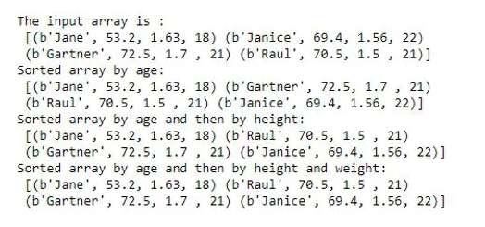

### Conclusion

Numpy.sort() is a sorting function used for arranging the elements of an array-like object. The function takes an array-like object as an input and outputs a sorted copy of the input array. In numpy, we can use four types of algorithms to sort the arrays. The algorithms are quicksort, heapsort, mergesort, and timsort.

There are a few other sorting functions in the numpy module, such as ndarray.sort()( to sort an array in-place), np.argsort() (for indirect sort), np.lexsort() (for indirect stable sort on multiple keys) and np.partition() ( for partial sort). We will be discussing them in greater detail in the coming posts.

<https://www.educba.com/numpy-floor/>

## Introduction to NumPy floor()

Python offers a core library providing for scientific computing tools which are known [as Numpy](https://www.educba.com/what-is-numpy/). It is an array object which is known for its multi-dimensional and high-performance arrays. NumPy floor() is a mathematical function that is present in the tool used while coding in the Python language. It returns the floor value of the elements that are present in an array. So, for an array containing scalar values coma foreign element ‘x’ a value ‘i’ would be returned which would be the largest integer (such that the value of i <=x)

### Advantages of NumPy

To simplify the advantage of [a Numpy array](https://www.educba.com/numpy-arrays/) we can look at its output delivery on the basis of three parameters. They are as follows:

* **Size:** Numpy data structures pick up comparatively much lower space in the memory.
* **Performance:** Compare two lists that are provided in the arrays, Numpy data structures are much faster.
* **Functionality:** It is well known for a high level of Optimisation going to inbuilt functions (for example; inbuilt[linear algebra operations](https://www.educba.com/numpy-linear-algebra/)).

**Syntax**

**numpy.floor(x, /, out=None, *, where=True, casting='same_kind', order='K', dtype=None, subok=True[, signature, extobj]) = <ufunc 'floor'>**

The floor of the scalar x is the largest integer i, such that i <= x. It is often denoted as.

**Parameters**

Following is the list of element-wise breakdown of the floor() syntax where the detail has been listed below which explains the function and implication of all:

|  |  |
| --- | --- |
| **Parameters:** | **x:**stands for the set of arrays that would be processed by the floor()  function.  It can be either a programmer defines a set of values or the user can be prompted to enter values, which will be used as a variable array.  **out**: Multiple features can be e allocated to out amongst None, ndarray, or tuple of ndarray along with None. This is an optional step.   * If None is mentioned then an array which is freshly allocated is returned. * If tuple (possible to be written as a keyword in some instances only) is written, so the returned valued should have its length equal to the number of output.   **Where**: array_like ( it is optional to be included in the code)  The values reflected when False is used, indicates that the value in the output has to be left alone while the value reflected by True indicates that calculation has to be performed on the ufuncn at that memory position where the value is saved. |
| **Returns:** | **y**: ndarray or scalar values that are returned after processing of the entered code on the values entered by the user, which has been made by the programmer  The floor of each element in x () is returned (This value returns the round down value in technical terms, i.e., for a number 9.9999 the value returned is 9 and not 10). This is a scalar value if x is a scalar entity. |

### How NumPy floor() Function works?

Numpy floor () checks the value of the input variable (must be a real number; assume x) and rounds the variable in a downwards manner to the nearest integer and finally returns the processed output. It must be noted that it is not rounded off but would be less than or equal to the value entered (i.e., x itself). It differs from another function [ceil()] which is used to return the variable rounded upwards.

Let us simplify the difference between the floor and ceil by the following table:

|  |  |  |  |
| --- | --- | --- | --- |
| **x** | **Ceiling ⌈ x ⌉ {\displaystyle \lceil x\rceil }** | **Floor ⌊ x ⌋ {\displaystyle \lfloor x\rfloor }** | **Fraction { x } {\displaystyle \{x\}}** |
| **3** | 3 | 3 | 0.0 |
| **3.4** | 4 | 3 | 0.4 |
| **3.9** | 4 | 3 | 0.9 |
| **−3.7** | −3 | −4 | 0.3 |
| **−3** | −3 | −3 | 0.0 |

### Example to Implement floor() Function in Numpy

Let us explain the working of the floor function with the help of an example

**Code:**

**import numpy as np  
arr= [0.123, 0.009, 1.3, 1.2344, 9.99999] print ("Input a set of five numbers (integer or non-integer):", arr)  
r_arr = np.floor(arr)  
print("Changed array after Numpy floor function used:",r_arr)**

**Output:**

Input a set of five numbers (integer or non-integer):  
0.123, 0.009, 1.3, 1.2344, 9.99999*  
Changed array after Numpy floor function used:,: [0. 0. 1. 1. 9.]

So we see that the output reflected the round down values for each of the numbers entered. This would have been round up if the numPy ceil() function had been used.

**Explanation:**

The functions numpy has to be imported from the python toolset

* The user is prompted to enter values for an array (the number of values the user has to enter is prompted in the output screen in the comments)
* The function flooroff_values are called, which approximants the numbers which have mean input by the user and returns the nearest integer
* The rounded values return on the output window (i. e., 0.1, 1., 0.).
* We can see that all the values which are returned are to the nearest integer.

So, we see, that we do not get values that are rounded off but are closer to its base integer. For numbers that are in their decimals and have and integer value of zero, they will return zero only. So for a value 0.99999 to 0.000001 all floor() values returned would be 0.

### Conclusion

The function though fairly simple in its use is bundled along with other such utilizable functions out of the multiple scientific calculation tools offered by the Nympy package in python. It significantly reduces the time which a programmer will need to write small codes while making complex functions that utilize them.

This thereby reduces the verbosity of the codes, which adds to the credibility and positive words for more user adoption of the users for Python as a preferred coding language. These sets of codes are specifically helpful when people are working on core quantitative data which uses very huge volumes of mathematical applications.

So, the coders who use R for such mathematical functionality owing to its precision and inbuilt features for scientific calculation based tools, give an add on the benefit of better User Interface and reduced verbosity to make its demand as a programming language for all functional operations.

<https://www.educba.com/matrix-in-numpy/>

## Introduction to Matrix in NumPy

Matrix is a subclass within ndarray class in the Numpy python library. It is primarily used to convert a string or an array-like object into a 2D matrix. The matrix so returned is a specialized 2D array. Coming to the syntax, a matrix function is written as follows:

**Syntax:**

**numpy.matrix(data, dtype, copy)**

**Important Parameters:**

* **Data:** Data should be in the form of an array-like an object or a string separated by commas
* **Dtype:** Data type of the returned matrix
* **Copy:** This a flag like an object. It determines whether if data is already an array. The flag determines whether the data is copied or whether a new view is constructed.

### How to Create a Matrix in NumPy?

We can create a matrix in Numpy using functions like array(), ndarray() or matrix(). Matrix function by default creates a specialized 2D array from the given input. The input should be in the form of a string or an array object-like. Let’s demonstrate matrix creation using a matrix() with string as an input type.

**Code:**

**import numpy as np  
#creating matrix from string  
A = np.matrix('1 2 3; 4 5 6')  
print("Array created using string is :\n", A)**

**Output:**

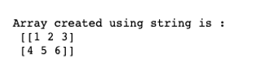

Now, let’s demonstrate matrix creation using a matrix() with an array-like object as the input type.

**Code:**

**import numpy as np  
#creating matrix from array like object  
B = np.matrix([[1, 2, 3], [4, 5, 6]])  
print("Array created using array like object is :\n", B)**

**Output:**

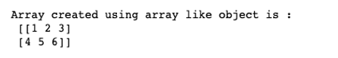

### Matrix Functions in NumPy with Examples

Having discussed Numpy matrix creation, now let’s discuss some important functions in this class. All the functions in the matrix subclass are very similar to the ndarray class.

|  |  |
| --- | --- |
| **Function** | **Description** |
| matrix.T | Returns transpose of the input matrix |
| matrix.H | Returns complex conjugate transpose of the input matrix |
| matrix.I | Returns the multiplicative inverse of the matrix |
| matrix.A | Return the input matrix as a ndarray object. |
| matrix.all() | Checks whether all matrix elements along a given axis evaluate to True. It is similar to ndarray.all() function. |
| matrix.any() | Checks whether any of the matrix elements along a given axis evaluate to True. |
| matrix.argmax() | Returns the indices of the maximum values along an axis in the input matrix |
| matrix.argmin() | Returns the indices of the minimum values along an axis in the input matrix |
| matrix.argsort() | Returns the indices that would sort the matrix |
| matrix.astype() | Returns the copy of the input matrix after type change |
| matrix.choose() | Returns a new matrix with chosen indices from the input matrix |
| matrix.clip() | Returns a new matrix within chosen limits from the input matrix |
| matrix.compress() | Returns the selected slice of a matrix along the given axis |
| matrix.conj() | Returns the complex conjugate of the given matrix |
| matrix.cumprod() | Returns cumulative product of elements in the given matrix along a given axis |
| matrix.cumsum() | Returns the cumulative sum of elements in the given matrix along with the given axis |
| matrix.diagonal() | Returns diagonal elements of the matrix |
| matrix.dot() | The returns dot product of two matrices |

Few examples to illustrate matrix functions

#### Example #1 – Program to Find Transpose and Multiplicative Inverse of a Given Matrix

**Code:**

**import numpy as np  
A = np.matrix('1 2 3; 4 5 6')  
print("Matrix is :\n", A)  
#Transpose of matrix  
print("The transpose of matrix A is :\n", A.getT())  
#Complex conjugate transpose  
print("Complex transpose of matrix A is :\n", A.getH())  
#Multiplicative inverse  
print("Multiplicative inverse of matrix A is :\n", A.getI())**

**Output:**

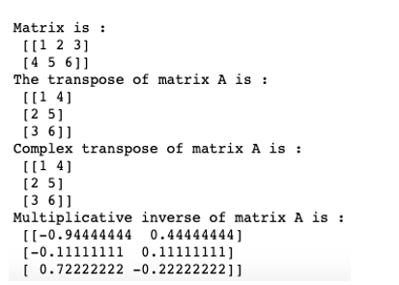

#### Example #2 – Program to Find the Maximum and Minimum Indices in A Given Matrix

**Code:**

**import numpy as np  
A = np.matrix('1 2 3; 4 5 6')  
print("Matrix is :\n", A)  
#maximum indices  
print("Maximum indices in A :\n", A.argmax(0))  
#minimum indices  
print("Minimum indices in A :\n", A.argmin(0))**

**Output:**

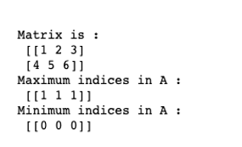

#### Example #3 – Program to Illustrate Clipping in A Given Matrix

**Code:**

**import numpy as np  
A = np.matrix('1 2 3; 4 5 6')  
print("Matrix is :\n", A)  
#clipping matrix  
print("Clipped matrix is :\n", A.clip(1,4))**

**Output:**

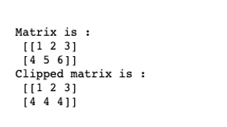

Clip, slice, compress and choose are similar functions that can be used to select a specific part of the input matrix/array.

#### Example #4 – Program to Find Cumulative Sum and Product of a Given Matrix

**Code:**

**import numpy as np  
A = np.matrix('1 2 3; 4 5 6; 7,8,9')  
print("Matrix is :\n", A)  
#cumulative product along axis = 0  
print("Cumulative product of elements along axis 0 is : \n", A.cumprod(0))  
#cumulative sum along axis = 0  
print("Cumulative sum of elements along axis 0 is : \n", A.cumsum(0))**

**Output:**

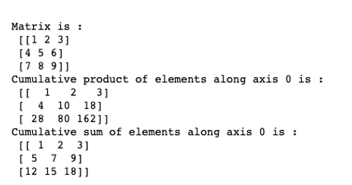

#### Example #5 – Program to Find the Dot Product and Diagonal Values of a Given Matrix

In order to find the diagonal values of a given matrix, we can use a diagonal function with attributes such as offset, axis 1 and axis 2.

**Code:**

**import numpy as np  
A = np.matrix('1 2 3; 4 5 6; 7,8,9')  
print("Matrix is :\n", A)  
#diagonal values  
print("Diagonal of matrix A :\n", A.diagonal(0,0,1))  
#dot product  
print("Dot product of matrix A with 2 :\n", A.dot(2))**

**Output:**

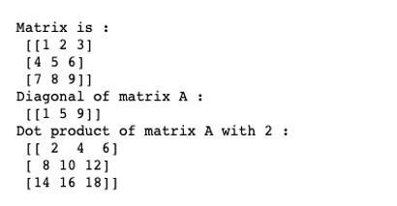

### Advantages of Matrix in NumPy

* One of the main advantages of using the NumPy matrix is that they take less memory space and provide better runtime speed when compared with similar data structures in python(lists and tuples).
* NumPy matrix support some specific scientific functions such as element-wise cumulative sum, cumulative product, conjugate transpose, and multiplicative inverse, etc. The python lists or strings fail to support these features**.**

### Conclusion

A NumPy matrix is a specialized 2D array created from a string or an array-like object. It is immensely helpful in scientific and mathematical computing. However, we should remember that a matrix is a subclass within the ndarray class in numpy. As such all the functions in the matrix subclass can be performed using ndarray class. Hence, in order to be an efficient data scientist or machine learning engineer, one must be very comfortable with numpy ndarrays.

<https://www.educba.com/numpy-matrix-transpose/>

## Introduction to NumPy Matrix Transpose

The transpose matrix function is a very commonly needed component of the coding language and is generally performed using the nested loop. But with the Numpy transpose matrix () function present in the programming language python enables just a single line code to return the transposed value to a matrix entered by the user, thereby simplifying an important function in terms of logic and verbosity. The transpose function to be simply put reverses the order of the elements arranged in rows and columns, i.e., an array having an orientation of (X, Y) would become (Y, X).

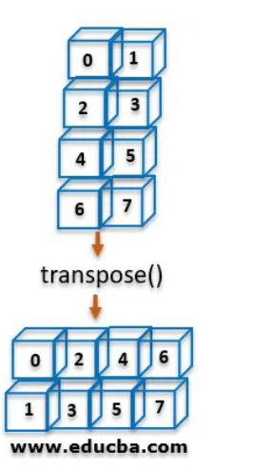

The Numpy package is a multi-purpose prebuilt package developed majorly to process and aid in the data manipulation of arrays (majorly focusing on the multi-dimensional arrays).

**Syntax:**

**numpy.transpose(a,axes=None)**

**Parameter:**

|  |  |  |
| --- | --- | --- |
| **Name of Parameter** | **Description** | **Status** |
| A | Input array – It represents the inbuild array that is used by the coder. (It can be both a variable pre-entered or be prompted to the user to feed values and custom-make an array by defining its dimensional size and elements) | Required |
| Axis | By default, the array is reversed dimensionally. It can also be done by permuting the axes according to value, which is defined by the user, through the formula syntax) | Optional |

**Axes:** The second argument used in the numpytranspose() function is axes by utilizing which the values are being permuted.

To simplify it, let us take an example:

Let us assume the index of initial elements is (x,y,z)

(here  x  represents the 0th axes

y  represents the 1st axes

and  z  represents the 2nd axes)

The resultant transposed array would have its orientation as (z,y,x) ; where the 0th and 2nd axes have interchanged.

(here  z  represents the 0th axes

y  represents the 1st axes

and  x  represents the 2nd axes)

**Return value:[ndarray]**

Itis returned as the output value where the axes are permuted. A view of the array is returned if possible.

### Example of NumPy Matrix Transpose

An example of the application of Numpy matrix is given below:

|  |  |
| --- | --- |
| **Code to Transpose the array using Numpy transpose** | **Comments** |
| **import numpy as np xyz = np.matrix('[1, 2 ; 3, 4]') ans= np.transpose(xyz) print(ans)**  **Output:** | Function used to import the important module needed to implement the solution in python  numpy function used to create the matrix  numpy function used to create a matrix  application of the matrix.transpose() function to give the required result |

**matrix.transpose() –** The function gives back a view of the array with the axes reversed.

This has no effect on the one-dimensional array as the resultant array is exactly the same. The effect is seen on multi-dimensional arrays. An additional dimension has to be added when transposing arrays of one and two-dimension columned vector respectively. This is achieved by ndarray.T and np.newaxis.

For an array a where its dimension is not defined, assuming it be n-dimensional

**a.shape=(i[0],i[1],i[2]...i[n-2],i[n-1])  
a.transpose().shape=(i[n-1],i[n-2],...i[2],i[1],i[0])**

### Explanation of the Process of Transposing and Pictorial Representation

To understand the mechanism of transposing we have to understand that Numpy function just uses the information of the shapes and strides and swaps them to return the transposed array. The below example displays the way in which the function happens:

**Code:**

**arr = np.array([[12, 32, 4]])  
arr**

**Output:**

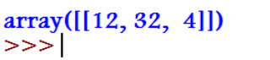

**Code:**

**arr.strides**

**Output:**

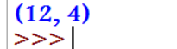

**Code:**

**arr.transpose(1, 0).strides**

**Output:**

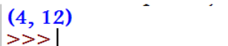

You can see that the transpose operation, no data needs is needed to be copied and NumPy uses the underlying memory to rearrange the construct of the new transposed array.

### Visualizing the Strides

Stride value is a representation of a byte that is traveling in the memory to reach the next value of an axis of an array.

Let us consider a 3-dimentional array arr that looks like below. This array gets stored in the contiguous block of memory in the computer which seems 1D to it, in order to have an interpretation on its 3D visualization the Numpy function jumps over certain bytes to move along one of the axes.

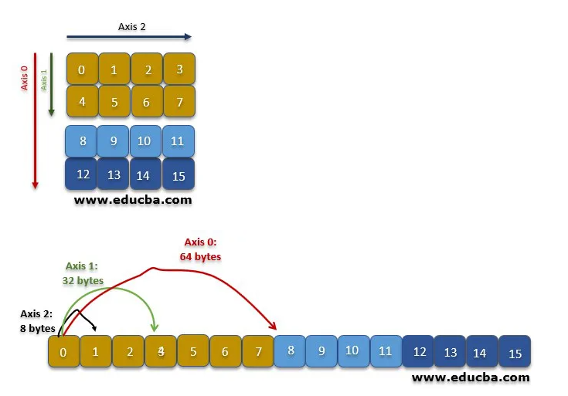

So to move along the axis-1, four values (8bytes x 4 = 32 bytes) are jumped, while moving along the axis-0, eight values (8 bytes x 8 = 64 bytes) is jumped.

On the execution of the function transpose -> arr.transpose(1, 0, 2)

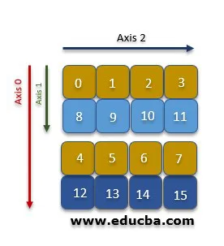

So the NumPy here swaps the strides of information from two of the axises (i.e., axis 1 and axis 0) and the axis 2 remains unchanged. Further, the system has to jump farther away in order to move in axis 1 instead of axis 0 where it was moving previously.

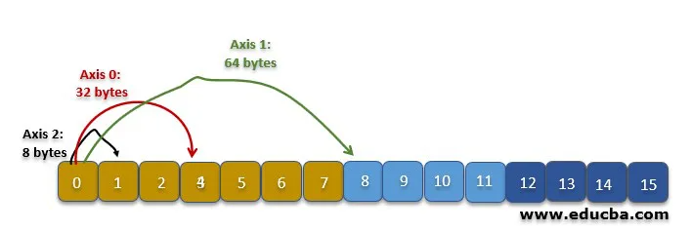

**Code:**

**import numpy as np  
A =np.arange(30). reshape((2,3,5))  
print(A)  
print(np.transpose(A,(1,2,0)))**

**Output:**

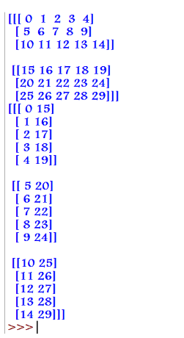

### Conclusion

Transpose is a very crucial function that is needed in a lot of mathematical and statistical coding. To write a code of multiple lines for a single function which is repetitively needed across the program. The numpy function of transpose ()gives a solution to directly give the desired function and at the same time decreasing the verbosity of the program which directly affects the runtime and execution of the output.

Libraries like NumPy with various inbuilt tools such as transpose provide with data-frames where data can be stored, and various operations can be performed on that data frame. It also provides the added advantage of parallel computation. When we are dealing with a limited amount of data to be processed, the core of data processing is not impacted much. When the data turns out to be enormous a single core is not sufficient for processing where NumPy data set divides the process into different ores making the overall process comparatively a lot quicker.

<https://www.educba.com/matrix-multiplication-in-numpy/>

## Overview of Matrix Multiplication in NumPy

Matrix Multiplication in NumPy is a python library used for scientific computing. Using this library, we can perform complex matrix operations like multiplication, dot product, multiplicative inverse, etc. in a single step. In this post, we will be learning about different types of matrix multiplication in the numpy library.

### Different Types of Matrix Multiplication

There are primarily three different types of matrix multiplication :

|  |  |
| --- | --- |
| **Function** | **Description** |
| **np.matmul(array a, array b)** | Returns matrix product of two given arrays |
| **np.multiply(array a, array b)** | Returns element-wise multiplication of two given arrays |
| **np.dot(array a, array b)** | Returns scalar or dot product of two given arrays |

#### 1. Matrix product of two given arrays

In order to find the matrix product of two given arrays, we can use the following function :

**np.matmul(array a, array b)**

Input for this function cannot be a scalar value

|  |  |  |  |  |
| --- | --- | --- | --- | --- |
| A = | all | a12 | | a13 |
| a21 | a22 | | a23 |
| B = | b11 | | b12 | b13 |
| b21 | | b22 | b23 |
| b31 | | b32 | b33 |

**A @B =**

|  |  |  |
| --- | --- | --- |
| a11*b11 + a12*b21 + a13*b31 | a11*b12 + a12*b22 + a13*b32 | a11*b13 + a12*b23 + a13*b33 |
| a21*b11 + a22*b21 + a23*b31 | a21*b12 + a22*b22 + a23*b32 | a21*b13 + a22*b23 + a23*b33 |

##### Example #1

Program to illustrate the matrix product of two given n-d arrays.

**Code:**

**import numpy as np  
A = np.array([[1,2,3], [4,5,6]])  
B = np.array([[1,1,1], [0,1,0], [1,1,1]])  
print("Matrix A is:\n",A)  
print("Matrix A is:\n",B)  
C = np.matmul(A,B)  
print("Matrix multiplication of matrix A and B is:\n",C)**

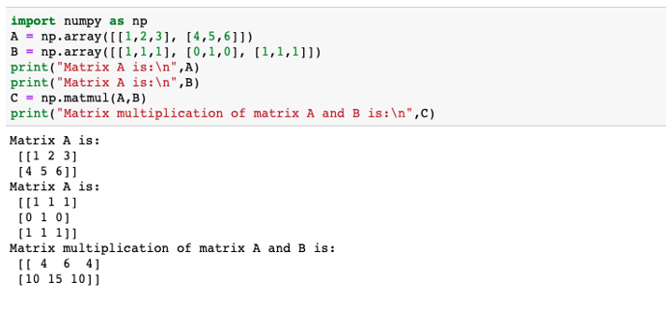

The matrix product of the given arrays is calculated in the following ways:

|  |  |  |  |
| --- | --- | --- | --- |
| A= | 1 | 2 | 3 |
| 4 | 5 | 6 |
| B= | 1 | 1 | 1 |
| 0 | 1 | 0 |
| 1 | 1 | 1 |

**A @ B =**

|  |  |  |
| --- | --- | --- |
| 1*1 + 2*0 + 3*1 = 4 | 1*1 + 2*1 + 3*1 = 6 | 1*1 + 2*0 + 3*1 = 4 |
| 4*1 + 5*0 + 6*1 = 10 | 4*1 + 5*1 + 6*1 = 15 | 4*1 + 5*0 + 6*1 = 10 |

#### 2. Element wise multiplication of two given arrays

In order to find the element-wise product of two given arrays, we can use the following function.

**np.multiply(array a, array b)**

|  |  |  |  |
| --- | --- | --- | --- |
| A = | all | a12 | a13 |
| a21 | a22 | a23 |
| B = | a21 | a22 | a23 |
| a21 | a22 | a23 |

**A*B =**

|  |  |  |
| --- | --- | --- |
| a11*b11 | a12*b12 | a13*b13 |
| a21*b21 | a22*b22 | a23*b23 |

##### Example #2

Program to illustrate element-wise multiplication of two given matrices

**Code:**

**import numpy as np  
A = np.array([[1,2,3], [4,5,6]])  
B = np.array([[1,2,3], [4,5,6]])  
print("Matrix A is:\n",A)  
print("Matrix A is:\n",B)  
C = np.multiply(A,B)  
print("Matrix multiplication of matrix A and B is:\n",C)**

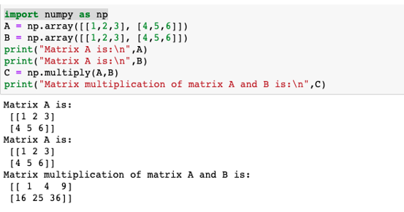

The element-wise matrix multiplication of the given arrays is calculated in the following ways:

|  |  |  |  |
| --- | --- | --- | --- |
| A = | 1 | 2 | 3 |
| 4 | 5 | 6 |
| B = | 1 | 1 | 1 |
| 0 | 1 | 0 |
| 1 | 1 | 1 |

**A * B =**

|  |  |  |
| --- | --- | --- |
| 1*1 = 1 | 2*2 = 4 | 3*3 = 9 |
| 4*4 = 16 | 5*5 = 25 | 6*6 = 36 |

#### 3. Scalar or Dot product of two given arrays

The dot product of any two given matrices is basically their matrix product. The only difference is that in dot product we can have scalar values as well.

|  |  |  |  |  |
| --- | --- | --- | --- | --- |
| A= | a11 | a12 | | a13 |
| B= | | | b11 | |
| b12 | |
| b13 | |

A.B = a11*b11 + a12*b12 + a13*b13

##### Example #3

A program to illustrate dot product of two given 1-D matrices

**Code:**

**import numpy as np  
A = np.array([1,2,3])  
B = np.array([4,5,6])  
print("Matrix A is:\n",A)  
print("Matrix A is:\n",B)  
C = np.dot(A,B)  
print("Matrix multiplication of matrix A and B is:\n",C)**

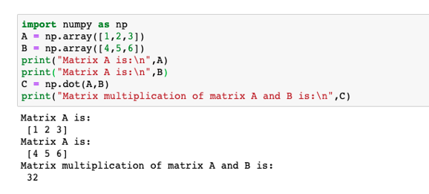

The dot product of two given 1-D arrays is calculated in the following ways:

|  |  |  |  |
| --- | --- | --- | --- |
| A= | 1 | 2 | 3 |
| B= | 4 | 5 | 6 |

A.B = 1*4 + 2*5 + 3*6 = 32

##### Example #4

A program to illustrate dot product of two given 2-D matrices

**Code:**

**import numpy as np  
A = np.array([[1,2],[2,1]])  
B = np.array([[4,5],[4,5]])  
print("Matrix A is:\n",A)  
print("Matrix A is:\n",B)  
C = np.dot(A,B)  
print("Matrix multiplication of matrix A and B is:\n",C)**

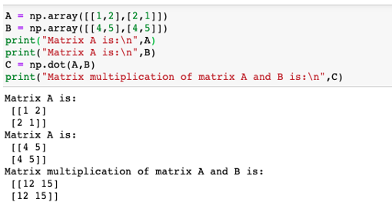

The dot product of given 2D or n-D arrays is calculated in the following ways:

|  |  |  |
| --- | --- | --- |
| A = | l | 2 |
| 2 | 1 |
| B= | 4 | 5 |
| 4 | 5 |

**A.B =**

|  |  |
| --- | --- |
| 1*4 + 2*4 = 12 | 1*5+2*5 = 15 |
| 2*4+ 1*4 = 12 | 2*5+ 1*5 = 15 |

##### Example #5

A program to illustrate the dot product of a scalar value and a 2-D matrix

**Code:**

**A = np.array([[1,1],[1,1]])  
print("Matrix A is:\n",A)  
C = np.dot(2,A)  
print("Matrix multiplication of matrix A and B is:\n",C)**

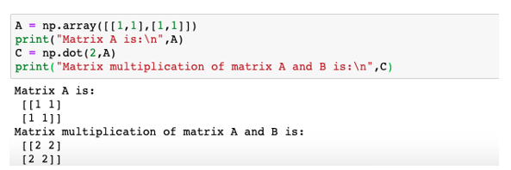

|  |  |  |
| --- | --- | --- |
| A = | 1 | 1 |
| 1 | 1 |

Scalar value = 2

Then, np.dot(2,A) = 2* A

**2*A =**

|  |  |
| --- | --- |
| 1*2 = 2 | 1*2 = 2 |
| 1*2 = 2 | 1*2 = 2 |

### Conclusion

Numpy offers a wide range of functions for [performing matrix multiplication](https://www.educba.com/matrix-multiplication-in-matlab/). If you wish to perform element-wise matrix multiplication, then use np.multiply() function. The dimensions of the input matrices should be the same. And if you have to compute matrix product of two given arrays/matrices then use np.matmul() function. The dimensions of the input arrays should be in the form, mxn, and nxp. Finally, if you have to multiply a scalar value and n-dimensional array, then use np.dot(). np.dot() is a specialisation of np.matmul() and np.multiply() functions.

<https://www.educba.com/numpy-arrays/>

## Introduction to NumPy Arrays

Numpy arrays are a very good substitute for python lists. They are [better than python lists](https://www.educba.com/python-list/) as they provide better speed and takes less memory space. For those who are unaware of what numpy arrays are, let’s begin with its definition. These are a special kind of data structure. They are basically multi-dimensional matrices or lists of fixed size with similar kind of elements.

**1D-Array**

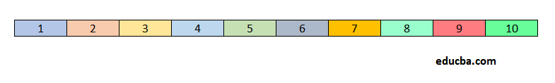

**2D-Array**

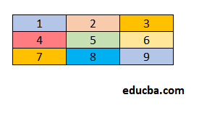

A typical array function looks something like this:

**numpy.array(object, dtype=None, copy=True, order='K', subok=False, ndmin=0)**

Here, all attributes other than objects are optional. So, do not worry even if you do not understand a lot about other parameters.

* **Object:** Specify the object for which you want an array
* **Dtype:** Specify the desired data type of the array
* **Copy:** Specify if you want the array to be copied or not
* **Order:** Specify the order of memory creation
* **Subok:** Specify if you want a sub-class or a base-class type array
* **Ndmin:** Specify the dimensions of an array

### Attributes of an Array

An array has the following six main attributes:

* **Size:** The total number of elements in an array
* **Shape:** The shape of an array
* **Dimension:** The dimension or rank of an array
* **Dtype:** Data type of an array
* **Itemsize:** Size of each element of an array in bytes
* **Nbytes:** Total size of an array in bytes

### Example of NumPy Arrays

Now, we will take the help of an example to understand the different attributes of an array.

#### Example #1 – To Illustrate the Attributes of an Array

**Code:**

**import numpy as np  
#creating an array to understand its attributes  
A = np.array([[1,2,3],[1,2,3],[1,2,3]])  
print("Array A is:\n",A)  
#type of array  
print("Type:", type(A))  
#Shape of array  
print("Shape:", A.shape)  
#no. of dimensions  
print("Rank:", A.ndim)  
#size of array  
print("Size:", A.size)  
#type of each element in the array  
print("Element type:", A.dtype)**

**Output:**

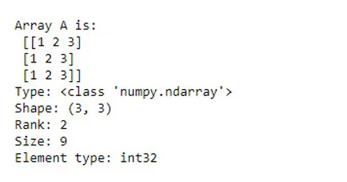

### How to Create an Array in NumPy?

Numpy provides us with several built-in functions to create and work with arrays from scratch. An array can be created using the following functions:

* **ndarray(shape, type):** Creates an array of the given shape with random numbers
* **array(array_object):** Creates an array of the given shape from the list or tuple
* **zeros(shape):** Creates an array of the given shape with all zeros
* **ones(shape):** Creates an array of the given shape with all ones
* **full(shape,array_object, dtype):** Create an array of the given shape with complex numbers
* **arange(range):** Creates an array with the specified range

#### Example #2 – Creation of a NumPy Array

**Code:**

**import numpy as np  
#creating array using ndarray  
A = np.ndarray(shape=(2,2), dtype=float)  
print("Array with random values:\n", A)  
# Creating array from list  
B = np.array([[1, 2, 3], [4, 5, 6]])  
print ("Array created with list:\n", B)  
# Creating array from tuple  
C = np.array((1 , 2, 3))  
print ("Array created with tuple:\n", C)**

**Output:**

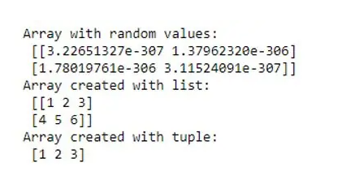

**Code:**

**# Creating array with all ones  
D = np.ones((3, 3))  
print ("Array with all ones:\n", D)  
# Creating array with all zeros  
E = np.zeros((3, 3))  
print ("Array with all zeroes:\n",E)  
# Creating an array with complex data type  
F = np.full((3, 3), 1, dtype = 'complex')  
print ("Array of complex data type:\n", F)  
#creating an array with buffer  
G = np.ndarray((2,), buffer=np.array([1,2,3]),dtype=int)  
print ("Array with buffer specified:\n", G)  
#creating an array with range  
H = np.arange(10)  
print ("Array with range specified:\n", H)**

**Output:**

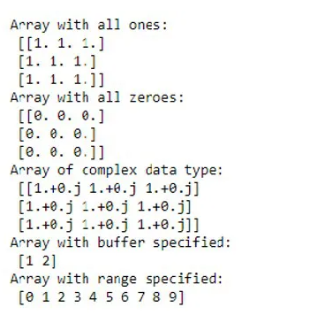

### How to Access Array Elements in NumPy?

We can access elements of an array by using their indices. We can take the help of the following examples to understand it better.

#### Example #3 –  Element Accessing in a 2D Array

**Code:**

**import numpy as np  
#creating an array to understand indexing  
A = np.array([[1,2,1],[7,5,3],[9,4,8]])  
print("Array A is:\n",A)  
#accessing elements at any given indices  
B = A[[0, 1, 2], [0, 1, 2]] print ("Elements at indices (0, 0),(1, 1), (2, 2) are : \n",B)  
#changing the value of elements at a given index  
A[0,0] = 12  
A[1,1] = 4  
A[2,2] = 7  
print("Array A after change is:\n", A)**

**Output:**

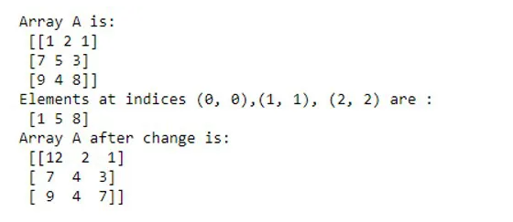

#### Example #4 – Array Indices in a 3D Array

**Code:**

**import numpy as np  
#creating a 3d array to understand indexing in a 3D array  
I = np.array([[[ 0,  1,  2,  3],  
[ 4,  5,  6,  7],  
[ 8,  9, 10, 11]],  
[[12, 13, 14, 15],  
[16, 17, 18, 19],  
[20, 21, 22, 23]]])  
print("3D Array is:\n", I)  
print("Elements at index (0,0,1):\n", I[0,0,1])  
print("Elements at index (1,0,1):\n", I[1,0,1])  
#changing the value of elements at a given index  
I[1,0,2] = 31  
print("3D Array after change is:\n", I)**

**Output:**

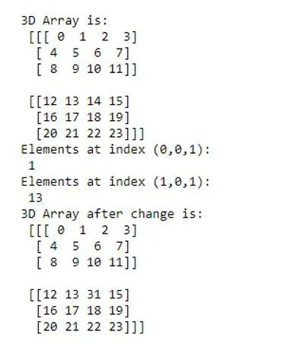

### Array Operation in NumPy

The example of an array operation in NumPy explained below:

#### Example

Following is an example to Illustrate Element-Wise Sum and Multiplication in an Array

**Code:**

**import numpy as np  
A = np.array([[1, 2, 3],  
[4,5,6],[7,8,9]])  
B = np.array([[1, 2, 3],  
[4,5,6],[7,8,9]])  
# adding arrays A and B  
print ("Element wise sum of array A and B is :\n", A + B)  
# multiplying arrays A and B  
print ("Elementwise multiplication of array A and B:\n", A*B)**

**Output:**

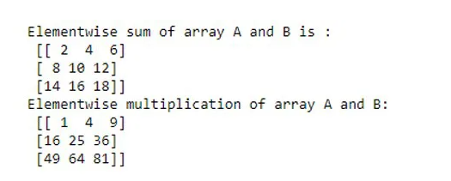

### Conclusion

A NumPy array is a multidimensional list of the same type of objects. It is immensely helpful in scientific and mathematical computing. As such, they find applications in [data science and machine learning](https://www.educba.com/data-science-vs-machine-learning/).

<https://www.educba.com/numpy-array-functions/>

## Overview of NumPy Array Functions

In python, we do not have built-in support for the array data type. But do not worry; we can still create arrays in python by converting python structures like lists and tuples into arrays or by using intrinsic numpy array creation objects like arrange, ones, zeros, etc. This particular post will discuss intrinsic numpy array functions to create and work with arrays.

**Array Creation:**Numpy provides us with several built-in functions to create and work with arrays from scratch. A typical numpy array function for creating an array looks something like this:

numpy.array(object, dtype=None, copy=True, order='K', subok=False, ndmin=0)

Here, all attributes other than objects are optional. So, do not worry even if you do not understand a lot about other parameters.

* **Object:** specify the object for which you want an array
* **Dtype:** specify the desired data type of the array
* **Copy:** specify if you want the array to be copied or not
* **Order:** specify the order of memory creation
* **Subok:** specify if you want a sub-class or a base-class type array
* **Ndmin:** specify the dimensions of an array

### Examples of NumPy Array Creation

Below are the different examples of NumPy Array Functions:

#### Example #1 – Array Creation using np.array() Function

**Code:**

#importing numpy  
import numpy as np  
#creating an array a  
a = np.array( [[ 1, 2, 3, 4],  
[ 5, 6, 7,8],  
[9,10,11,12]] )  
#printing array a  
print ("Array is:",a)  
#we can also print the other attributes like dimensions,shape and size of an array  
print ("Dimensions of a are:", a.ndim)  
print ("Shape of a is", a.shape)  
print ("Size of a is", a.size)

**Output:**

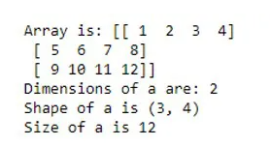

#### Example #2 – Creating an Empty Array using empty_like Function

Empty_like function returns [an empty array with shape](https://www.educba.com/javascript-empty-array/) and type as input.

**np.empty(shape, dtype)**

**Code:**

import numpy as np  
#creating an array an empty square array of dimensions 2X2  
empty_array = np.empty([2,2], dtype = int)  
#np.empty() creates an array with random values  
print ("Array is:", empty_array)

**Output:**

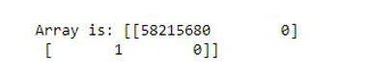

#### Example #3 – Creating an Array with Zeros using zero_like Function

Zero_like function returns an array of zeros with shape and type as input.

**np.zeros(shape,dtype)**

**Code:**

import numpy as np  
#creating an array a zeros square array of dimensions 2X2  
zeros_array = np.zeros([2,2], dtype = int)  
print ("Array is:", zeros_array)

**Output:**

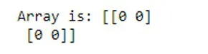

There are few other similar functions for creating arrays like ones_like, full_like, eye(), arange() np.asarray(), etc.

### Examples of Array Manipulation

Following are the different examples of an array manipulation in NumPy Array Functions:

#### Example #1 – Copying from One Array to Another

We can copy content from one array to another using the copyto function.

**np.copyto(destination, source)**

**Code:**

import numpy as np  
#creating an array a zeros square array of dimensions 2X2  
zeros_array = np.zeros([2,2], dtype = int)  
print ("Array zeros is:", zeros_array)  
ones_array = np.ones([2,2], dtype = int)  
print ("Array ones is :", ones_array)  
#copying content from ones_array to zeros  
np.copyto(zeros_array,ones_array)  
print ("New zeros array :", zeros_array)

**Output:**

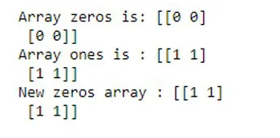

#### Example 2 – Changing the Shape of an Array

Reshape changes the shape of an array without changing the data in it.

**np.reshape(object, shape)**

**Code:**

import numpy as np  
#creating an array a 1D array  
a = np.array([[1,2],[3,4]])  
print ("array a is :", a)  
#changing the shape of array from 2D to 1D  
print ("reshape array a is:",np.reshape(a,4))

**Output:**

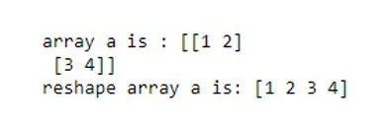

#### Example 3 – Transposing an Array

Transpose_like array functions help in transposing the array.

**ndarray.T**

**Code:**

import numpy as np  
#creating an array a 1D array  
a = np.array([[1,2],[3,4]])  
print ("array a is :", a)  
#transposing array a using array.T  
print ("transposed array a is:", a.T)

**Output:**

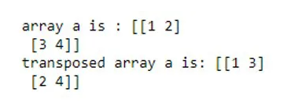

We can also use,

np.moveaxis(a, source, destination), np.rollaxis(a, axis) and np.swapaxes(a, axis1, axis2) to transpose an array.

#### Example 4 – Joining Two or More Arrays

Concatenate function helps in joining two or more array along the given axis.

**np.concatenate((a1, a2, …), axis=0, out=None)**

**Code:**

import numpy as np  
#creating two arrays a and b  
a = np.array([[1, 2], [3, 4]])  
b = np.array([[5, 6]])  
#joining a and b vertically  
print ("concatenated array vertically:", np.concatenate((a, b), axis=0))  
#joining a and b horizontally  
print ("concatenated array horizontally:", np.concatenate((a, b), axis=None))

**Output:**

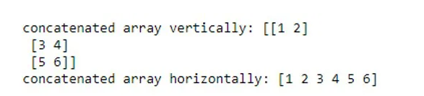

Other numpy array functions such as np.stack(array, axis) and np.block(array1,array2, etc) can also be used to join two or more arrays together along the desired axes.

#### Example #5 – Splitting an Array Into Multiple Sub-Arrays

The [split function helps](https://www.educba.com/split-function-in-python/) splitting an array into multiple sub-arrays of equal or near-equal size.

**np.split(array, indices)**

**Code:**

import numpy as np  
#creating an array using arange function.  
a = np.arange(8)  
print (a)  
#splitting array a into 4 equal parts  
print ("sub-parts of array a:", np.split(a, 4))

**Output:**



There are few other functions like hsplit(array,index), vsplit(array,index), array_split(array,index,axis) that can be employed to perform the similar task.

#### Example 6 – Adding Elements to an Existing Array

We can use np.insert(array, index, value) to insert values along the given axis before the given indices. But, if we want to add values at the end of the array, we can use,

**np.append(array, value, axis = 0)**

**Code:**

import numpy as np  
#creating an array using arange function.  
a = np.array([[1,2,3],[1,2,3]])  
print ("array a is :", a)  
#inserting elements along the y axis at index 1  
print ("array a after insertion :", np.insert(a,1,5, axis = 1))

**Output:**

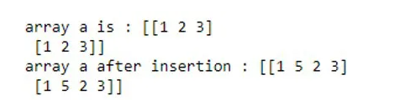

#### Example 7 – Deleting the Elements from an Array

Delete function can be used to delete an axis of the given array and returns a new array with sub-arrays along the deleted axis.

**np.delete(array, object, axis)**

**Code:**

import numpy as np  
#creating an array using arange function.  
a = np.array([[1,2,3],[1,2,3]])  
print ("array a is :", a)  
#deleting elements  
print ("array a after deletion :", np.delete(a,[1,2,3], axis = 0))

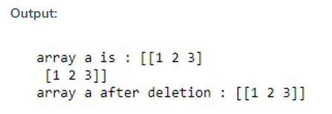

#### Example 8 – Rotating the Elements of an Array by 90 Degrees

We can use np.rot90() to rotate an array by 90 degrees in the plane specified by axes.

**np.rot90(array, no_of_times_to_rotate, axes)**

**Code:**

**import numpy as np  
#creating an array using arange function.  
a = np.array([[1,2],[3,4]])  
print ("array a is :", a)  
#rotating elements by 90 degrees once along (1,0)  
print ("rotated array is :",np.rot90(a,1,(1,0)))**

**Output:**

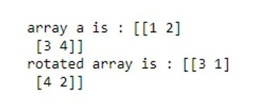

### Conclusion

In this post, we have discussed some basic and commonly used array functions. There are many other versions of these functions. If you are curious to earn more about them, keep experimenting with the discussed functions along with different arrays, axes, shapes, and indices.

<https://www.educba.com/numpy-ndarray/>

## Introduction to NumPy Ndarray

Ndarray is one of the most important classes in the NumPy python library. It is basically a multidimensional or n-dimensional array of fixed size with homogeneous elements( i.e., the data type of all the elements in the array is the same). A multidimensional array looks something like this:

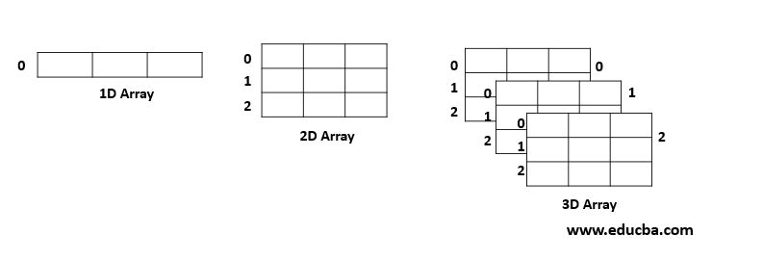

In Numpy, the number of dimensions of the array is given by Rank. Thus, in the above example, the ranks of the array of 1D, 2D, and 3D arrays are 1, 2 and 3 respectively.

**Syntax:**

**np.ndarray(shape, dtype= int, buffer=None, offset=0, strides=None, order=None)**

Here, the size and the number of elements present in the array is given by the shape attribute. The data type of the array(elements in particular) is given by the dtype attribute. Buffer attribute is an object exposing the buffer interface. An offset is the offset of the array data in the buffer. Stride attribute specifies the number of locations in the memory between the starting of successive array elements.

It should always be greater or equal to the size of the data type of the elements. Finally, the order attribute is to specify if we want a row-major or column-major order. Among all the above-mentioned attributes, shape and dtype are the compulsory ones. All other attributes are optional and can be specified on the requirement basis.

### Working with Ndarray

An array can be created using the following functions :

* **np.ndarray(shape, type):** Creates an array of the given shape with random numbers.
* **np.array(array_object):**Creates an array of the given shape from the list or tuple.
* **np.zeros(shape):** Creates an array of the given shape with all zeros.
* **np.ones(shape):** Creates an array of the given shape with all ones.
* **np.full(shape,array_object, dtype):** Creates an array of the given shape with complex numbers.
* **np.arange(range):** Creates an array with the specified range.

### Examples of Ndarray

Given below are the examples of Ndarray:

#### Example #1: Attributes of a multidimensional array(ndarray)

**import numpy as np  
#creating an array to understand its attributes  
A = np.array([[1,2,3],[1,2,3],[1,2,3]])  
print("Array A is:\n",A)  
#type of array  
print("Type:", type(A))  
#Shape of array  
print("Shape:", A.shape)  
#no. of dimensions  
print("Rank:", A.ndim)  
#size of array  
print("Size:", A.size)  
#type of each element in the array  
print("Element type:", A.dtype)**

**Output:**  
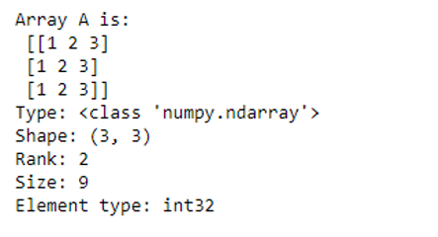

#### Example #2: Creation of a multidimensional array(ndarray)

**import numpy as np  
#creating array using ndarray  
A = np.ndarray(shape=(2,2), dtype=float)  
print("Array with random values:\n", A)  
# Creating array from list  
B = np.array([[1, 2, 3], [4, 5, 6]])  
print ("Array created with list:\n", B)  
# Creating array from tuple  
C = np.array((1 , 2, 3))  
print ("Array created with tuple:\n", C)  
# Creating array with all ones  
D = np.ones((3, 3))  
print ("Array with all ones:\n", D)  
# Creating array with all zeros  
E = np.zeros((3, 3))  
print ("Array with all zeroes:\n",E)  
# Creating an array with complex data type  
F = np.full((3, 3), 1, dtype = 'complex')  
print ("Array of complex data type:\n", F)  
#creating an array with buffer  
G = np.ndarray((2,), buffer=np.array([1,2,3]),dtype=int)  
print ("Array with buffer specified:\n", G)  
#creating an array with range  
H = np.arange(10)  
print ("Array with range specified:\n", H)**

**Output:**

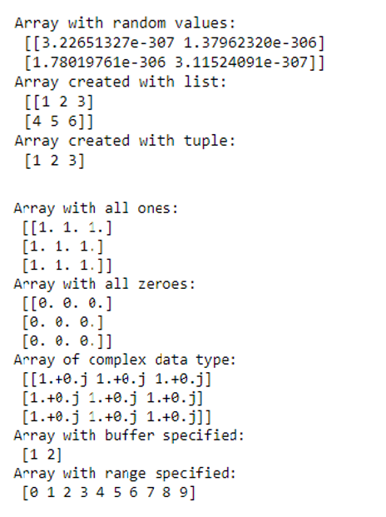

#### Example #3: ****Program to illustrate****Indexing in Ndarrays

Indexing in a 2D array

**#creating an array to understand indexing  
A = np.array([[1,2,1],[7,5,3],[9,4,8]])  
print("Array A is:\n",A)  
B = A[[0, 1, 2], [0, 1, 2]] print ("Elements at indices (0, 0),(1, 1), (2, 2) are : \n",B)  
#changing the value of elements at a given index  
A[0,0] = 12  
A[1,1] = 4  
A[2,2] = 7  
print("Array A after change is:\n", A)**

**Output:**

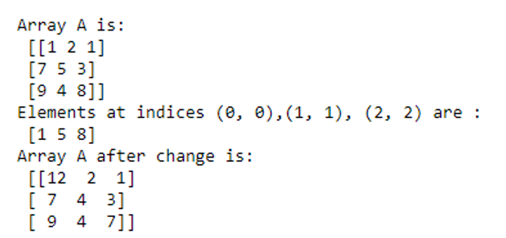

#### Example #4: ****Program to illustrate****Indexing in a 3D array

**#creating a 3d array to see indexing in a 3D array.  
import numpy as np  
I = np.array([[[ 0,  1,  2,  3],  
[ 4,  5,  6,  7],  
[ 8,  9, 10, 11]],  
[[12, 13, 14, 15],  
[16, 17, 18, 19],  
[20, 21, 22, 23]]])  
print("3D Array is:\n", I)  
print("Elements at index (0,0,1):\n", I[0,0,1])  
print("Elements at index (1,0,1):\n", I[1,0,1])  
#changing the value of elements at a given index  
I[1,0,2] = 31  
print("3D Array after change is:\n", I)**

**Output:**

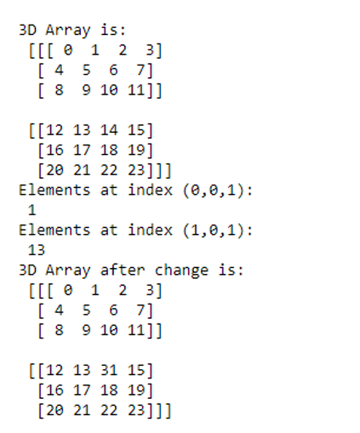

#### Example #5: Operations on Ndarray

Elementwise operations in Ndarrays.

**import numpy as np  
A = np.array([[1, 2, 3],  
[4,5,6],[7,8,9]])  
B = np.array([[1, 2, 3],  
[4,5,6],[7,8,9]])  
# adding arrays A and B  
print ("Elementwise sum of array A and B is :\n", A + B)  
# multiplying arrays A and B  
print ("Elementwise multiplication of array A and B:\n", A*B)**

**Output:**

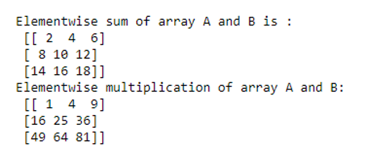

### Advantages of Ndarrays

* One of the main advantages of using Numpy Ndarrays is that they take less memory space and provide better runtime speed when compared with similar data structures in python(lists and tuples).
* Numpy Ndarrays support some specific scientific functions such as [linear algebra](https://www.educba.com/numpy-linear-algebra/). They help us in solving linear equations.
* Ndarrays support vectorized operations, like elementwise addition and multiplication, computing Kronecker product, etc. Python lists fail to support these features.

### Conclusion – NumPy Ndarray

A NumPy Ndarray is a multidimensional array of objects all of the same type. It is immensely helpful in scientific and mathematical computing. As such, they find applications in data science, machine learning, and artificial intelligence. So, in order to be an efficient data scientist or machine learning engineer, one must be very comfortable with Numpy Ndarrays.

<https://www.educba.com/numpy-array-append/>

## Definition of NumPy Array Append

NumPy append is a function which is primarily used to add or attach an array of values to the end of the given array and usually, it is attached by mentioning the axis in which we wanted to attach the new set of values axis=0 denotes row-wise appending and axis=1 denotes the column-wise appending and any number of a sequence or array can be appended to the given array using the append function in numpy.

**Syntax:**

The basic syntax of the Numpy array append function is:

**numpy.append(ar, values, axis=None)**

* numpy denotes the numerical python package.
* append is the keyword which denoted the append function.
* ar denotes the existing array which we wanted to append values to it.
* values are the array that we wanted to add/attach to the given array.
* axis denotes the position in which we wanted the new set of values to be appended.
* axis=0 represents the row-wise appending and axis=1 represents the column-wise appending.

### Examples of NumPy Array Append

Following are the examples as given below:

#### Example #1

Let us look at a simple example to use the append function to create an array.

**import numpy as np  
arr1=np.append ([12, 41, 20], [[1, 8, 5], [30, 17, 18]])  
arr1**

**Output:**

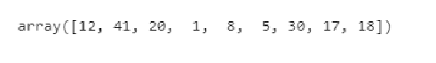

In the above example, arr1 is created by joining of 3 different arrays into a single one. np.append () function is used to perform the above operation. We also see that we haven’t denoted the axis to the append function so by default it takes the axis as 1 if we don’t denote the axis.

#### Example #2

**import numpy as np  
arr1=np.append ([[12, 41, 20], [1, 8, 5]], [[30, 17, 18]],axis=0)  
arr1**

**Output:**

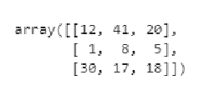

In this example, we have performed a similar operation as we did in example 1 but we have to append the array into a row-wise order. The axis=1 denoted the joining of three different arrays in a row-wise order.

#### Example #3

In this example, let’s create an array and append the array using both the axis with the same similar dimensions.

**import numpy as np  
arr1=np.array([[12, 41, 20], [1, 8, 5]])  
print(arr1)  
#### Appending Row-wise  
print(np.append(arr1,[[41,80,14]],axis=0))  
print('\n')  
#### Appending column-wise  
print(np.append(arr1,[[41,80,14],[71,15,60]],axis=1))  
print('\n')**

**Output:**

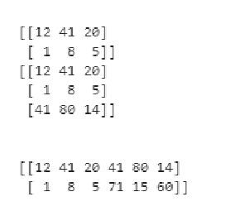

In this example, we have created a numpy array arr1 and we have tried to append a new array to it in both the axis. Here while appending the existing array we have to follow the dimensions of the original array to which we are attaching new values else the compiler throws an error since it could not concatenate the array when its out the boundaries of the dimension. So we have to keep the dimension in mind while appending the arrays and also the square brackets should be used when we are declaring the arrays else the data type would become different.

#### Example #4

**import numpy as np  
arr1 = np.arange(10)  
print("one dimensional arr1 : ", arr1)  
print("Shape of the array : ", arr1.shape)  
arr2 = np.arange(5, 15)  
print("one dimensional arr2 : ", arr2)  
print("Shape of the array : ", arr2.shape)  
# Array appending  
arr3 = np.append(arr1, arr2)  
print("Appended arr3 : ", arr3)**

**Output:**

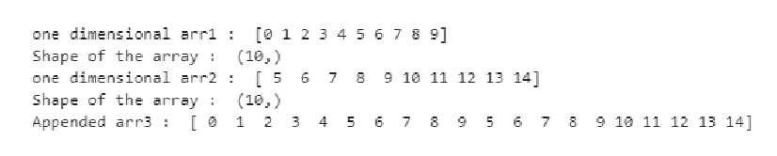

In this example, we have created two arrays using the numpy function arrange from 0 to 10 and 5 to 15 as array 1 & array 2 and for a better understanding we have printed their dimension and shape so that it can be useful if we wanted to perform any slicing operation. The array 3 is a merger of array 1 & 2 were in previous methods we have directly mention the array values and performed the append operation. Here in this example we have separately created two arrays and merged them into a final array because this technique is very easy to perform and understand. It involves less complexity while performing the append operation.

#### Example #5

**import numpy as np  
arr1 = np.arange(10).reshape(2, 5)  
print("one dimensional arr1 : ", arr1)  
print("Shape of the array : ", arr1.shape)  
arr2 = np.arange(5, 15).reshape(2, 5)  
print("one dimensional arr2 : ", arr2)  
print("Shape of the array : ", arr2.shape)  
# Array appending  
arr3 = np.append(arr1, arr2)  
print("Appended arr3 : ", arr3)**

**Output:**

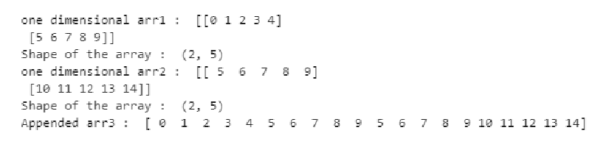

In this example, we have used a different function from the numpy package known as reshape where it allows us to modify the shape or dimension of the array we are declaring. Array 1 has values from 0 to 10 we have split them into 5×2 structure using the reshape function with shape (2,5) and similarly, we have declared array 2 as values between 5 to 15 where we have reshaped it into a 5×2 structure (2,5) since there are 10 values in each array we have used (2,5) and also we can use (5,2). So depending upon the number of values in our array we can apply the shape according to it. So the resulting appending of the two arrays 1 & 2 is an array 3 of dimension 1 and shape of 20. Since we haven’t denoted the axis the append function has performed its operation in column-wise.  
Let’s see another example where if we miss the dimensions and try to append two arrays of different dimensions we’ll see how the compiler throws the error.

**import numpy as np  
arr1=np.array([[12, 41, 20], [1, 8, 5]])  
print(arr1)  
#### Appending Row-wise  
print(np.append(arr1,[[41,80]],axis=0))  
print('\n')**

**Output:**

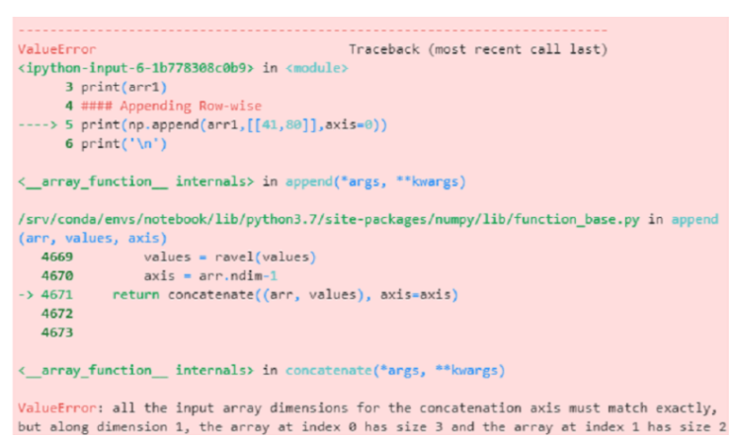

So here we can see that we have declared an array of 2×3 as array 1 and we have performed an append operation using an array of 1×2 in axis 0 so it is not possible to merge a 2×3 array with 1×2 so the output throws an error telling “all the input array dimensions except for the concatenation axis must match exactly”.

### Conclusion

In this article, we have discussed numpy array append in detail using various examples. We have also discussed how to create arrays using different techniques and also learned how to reshape them using the number of values it has. We also discussed different techniques for appending multi-dimensional arrays using numpy library and it can be very helpful for working in various projects involving lots of arrays generation.

<https://www.educba.com/numpy-empty-array/>

## Definition of NumPy empty array

Python provides different functions to the users. To work with arrays, the python library provides a numpy empty array function. It is used to create a new empty array as per user instruction means given data type and shape of array without initializing elements.  An array plays a major role in data science where speed matters. numpy is an acronym for numerical python. Basically, numpy is an open source project. numpy performs logical and mathematical operations of arrays. Unlike list data structure, numpy arrays are designed to use in various ways. Therefore, processing and manipulating can be done efficiently.

### Syntax and Parameters

Syntax and Parameters of NumPy empty array are given below:

**Syntax:**

**array = np.empty (shape, dtype(data type), order=’c’)**

**Explanation:**As shown above syntax it will give a new array with the shape and data type. As shown in syntax where array is array variable name and we define numpy empty array functions such as np.empty with shape of array and data types. The values returned by array are random and by default order of array is **c** it is used to define whether array is multidimensional or not.

**Parameters**

* **shape:** It is used to determine the shape of the empty array. It can be int or tuple of int. Ex: (3, 5) or 2.
* **dtype:** It is used to define the data type of an empty array and it is an optional parameter. The default dtype of numpy is float64.
* **order:** It is used to determine that in which order we store multi dimensional data means C style (row style) or F style (column style).

### How does empty array Work in NumPy

* We must install Python on your system.
* We must install numpy using the pip command.
* We required basic knowledge about Python.
* We required basic knowledge about arrays.
* We can perform different operations using a numpy empty function.

### Examples to Implement NumPy empty array

Let’s see how we can implement a numpy empty array.

Basically there are two ways to implement a numpy array as follows. But both are slightly different.

#### 1. Using Numpy Empty Array Function

In this method we implement a numpy empty array function. Let’s see an example for better understanding.

##### Example #1

**import numpy as np  
sample_array = np. empty ((3,3))  
print(sample_array)**

**Explanation:**We import numpy functions and use them as np. We declared variable sample_array and assigned values. We try to print the value of the variable

In the above example we implement a simple numpy empty array and it returns uninitialized values with shape and data type. Illustrate the end result of the above declaration by using the use of the following snapshot.

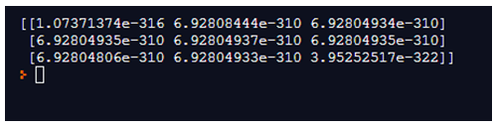

### 2. Using NumPy Zeros Array Function

In this method we implement a numpy array function in an efficient way and after that we are able to insert data row by row. Let’s see an example for better understanding.

##### Example #1

**import numpy as np  
A = np.zeros([3, 4])  
print(A)**

**Explanation:**We import numpy functions and use them as . We declared variable A and assigned values with zeros numpy function. Finally we try to print the value of variable

In the above method we implemented numpy zero function and it returns all zeros. Illustrate the end result of the above declaration by using the use of the following snapshot.

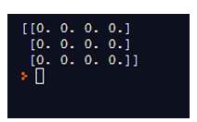

##### Example #2

**import numpy as np  
A = np.empty([4, 4], dtype=float)  
print(A)**

**Explanation:**In the above example we follow the same syntax but the only difference is that here we define shape and data type of empty array means we can declare shape and data type in the first example we only declared shape. Illustrate the end result of the above declaration by using the use of the following snapshot.

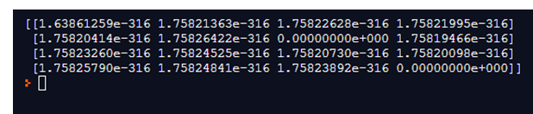

##### Example #3 – For Order C

**import numpy as np  
A = np.empty([3, 3], dtype=float, order='C')  
print(A)**

**Explanation:** We import numpy functions and use them as.We declared variable A and assigned values with an empty numpy function. Here we passed shape, data type and order in the function. Finally we try to print the value of variable

In this example we passed order in function. Illustrate the end result of the above declaration by using the use of the following snapshot.

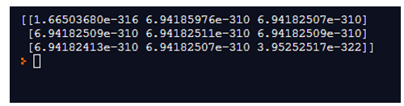

##### Example #4 – For Order F

**import numpy as np  
A = np.empty([2, 2], dtype=float, order='F')  
print(A)**

**Explanation:**In the above example we have only changed the order of the array. Illustrate the end result of the above declaration by using the use of the following snapshot.

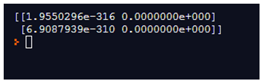

##### Example #5 – For 1- Dimensional Empty Numpy Array

**import numpy as np  
A = np.empty(shape= 2)  
print(A)**

**Explanation:** In the above example we create a 1- dimensional empty array. Here only we use a single parameter shape. Illustrate the end result of the above declaration by using the use of the following snapshot.

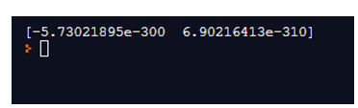

Same example we can execute without parameters.

**import numpy as np  
A = np.empty(3)  
print(A)**

**Explanation:** In this example we only pass shape size without any parameter, still the result is empty that means python allows us to do this. Illustrate the end result of the above declaration by using the use of the following snapshot.

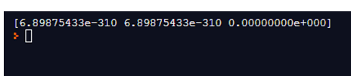

##### Example #6 – For 2- Dimensional empty numpy array

**import numpy as np  
B = np.empty(shape= [3,4],dtype=int)  
print(B)**

**Explanation:**We import numpy functions and use them as. We declared variable B and assigned values with an empty numpy function. Here we passed shape, data type in the function. Finally we try to print the value of variable

In this example we passed order in function. Illustrate the end result of the above declaration by using the use of the following snapshot.

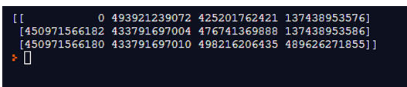

##### Example #7 – To obtain exact data type of empty numpy array

**import numpy as np  
X=np.empty(shape = [4,3], dtype = int)  
print(X)**

**Explanation:**In this example, we passed shape size and specific data type of empty numpy array in the function. Illustrate the end result of the above declaration by using the use of the following snapshot.

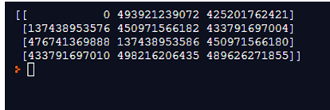

### Conclusion

We hope from this article you have understood about the numpy empty array function. From the above article, we have learned the basic syntax numpy empty arrays. We have also learned how we can implement them in python with different example empty arrays as well as zeros function. From this article, we have learned how we can handle numpy empty arrays in python.

<https://www.educba.com/numpy-ndarray-tolist/>

## Introduction to NumPy ndarray tolist

numpy ndarray tolist() is a function that converts an array to a list. A nested list will be returned if the array that is considering is multi-dimensional whereas a list that contains array elements will be returned if the array is one-dimensional. The method tolist() is considered as the easiest method to convert array to list and it does not permit any argument. In python, there are various libraries present to perform several functions and NumPy is one such python library that is used for array functionalities. Moreover, much linear algebra, matrix operations, and Fourier transform operations can also be used using this library.

### Syntax

Following is the syntax of the tolist function in numpy.

**ndarray.tolist( )**

This function returns the input array as a list that can be nested or not based on the dimension of the input array.

Parameters of the function are: NONE

Return value: List which is nested if the array is 2-d. Else, the normal list with array elements.

### How ndarray tolist function work in NumPy?

Let us see the working of NumPy tolist using an example.

Suppose there is an array as shown below.

**( [ [  '1' , ' 2 ', ' 3 ', ' 4 ']  ,  [ ' 5 ' , ' 6 ' ,  ' 7 ' , ' 8 ' ] ] )**

Here, the array is 2-dimensional. If the array has to be converted to list, use the function tolist() in numpy as mentioned below.

**arr1.tolist( )**

**Notes:**

The input array may be reconstructed using a = np.array(a.tolist()), even though this may lose the precision at times.

### Examples of NumPy ndarray tolist

To understand more about the working of Numpy tolist(), let us see some sample programs.

#### Example #1

Python Program that demonstrates the tolist function by converting 1-dimensional string array to list.

**Code:**

**# Python Program that demonstrates the tolist function by converting 1-d array to list  
# import the numpy library and set alias name as np  
import numpy as np  
# Declare an array with few elements  
arr1 =np.array( [ 'Walk' , 'Talk', 'Call', ' Small'] )  
print( " Array that is converted to list: " )  
print(arr1.tolist())**

**Output:**

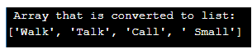

In this program, first, import the numpy library and set the alias name as np. After that, declare a 1-dimensional array with four elements such as [‘Walk’, ‘Talk’, ‘Call’, ‘ Small’]. Here the elements are of string type. Then, convert the 1-dimensional array to list using the tolist() method and print it using the print() method.

#### Example #2

Python Program that demonstrates the tolist function by converting 2-dimensional string array to list.

**Code:**

**# Python Program that demonstrates the tolist function by converting 2-d array to list  
# import the numpy library and set alias name as np  
import numpy as np  
# Declare an array with few elements  
arr1 =np.array( [['Walk' , 'Talk', 'Call', ' Small'] , ['Smile' , 'like', 'fake', ' stop']] )  
print( " Array that is converted to list: " )  
print(arr1.tolist())**

**Output:**



In this program also, first, import the numpy library and set the alias name as np. After that, declare a 2-dimensional array with eight elements such as [[‘Walk’ , ‘Talk’, ‘Call’, ‘ Small’], , [‘Smile’ , ‘like’, ‘fake’, ‘ stop’]]. Here also, the elements are of string type. Then, convert the 2-dimensional array to list using the tolist() method.

#### Example #3

Python Program that demonstrates the tolist function by converting a 2-dimensional numerical array to list.

**Code:**

**# Python Program that demonstrates the tolist function by converting the 2-d array to list  
# import the numpy library and set alias name as np  
import numpy as np  
# Declare an array with few elements  
arr1 =np.array( [['1' , '2', '3', ' 4'] , ['5' , '6', '7', '8']] )  
print("Array that is converted to list: ")  
print(arr1.tolist())**

**Output:**

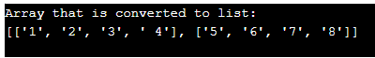

In this program, first, import the numpy library and set the alias name as np. After that, declare a 2-dimensional array with eight elements such as [[‘1’ , ‘2’, ‘3’, ‘ 4’] , [‘5’ , ‘6’, ‘7’, ‘8’]]. Here the elements are of numerical type. Then, convert the 2-dimensional array to list using the tolist() method. On executing the code, a list that consists of array elements gets printed as shown in the result.

#### Example #4

Python Program that demonstrates the tolist function by converting a 1-dimensional numerical array to list.

**Code:**

**# Python Program that demonstrates the tolist function  
# import the numpy library and set alias name as np  
import numpy as np  
# Declare an array with few elements  
arr1 =np.array( [['1' , '2', '3', ' 4'] ] )  
print("Array that is converted to list: ")  
print(arr1.tolist())**

**Output:**

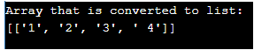

Import the numpy library and set the alias name as np. After that, declare an 1-dimensional array with four elements such as [[‘1’ , ‘2’, ‘3’, ‘ 4’]]. Here the elements are of numerical type. Then, convert the 2-dimensional array to list using the tolist() method.

#### Example #5

Python Program demonstrates the tolist function by converting a 2-dimensional array with string and numerical elements to list.

**Code:**

**# Python Program that demonstrates the tolist function  
# import the numpy library and set alias name as np  
import numpy as np  
# Declare an array with few elements  
arr1 =np.array( [['1' , '2', '3', ' 4'] , ['Smile' , 'like', 'fake', ' stop']] )  
print("Array that is converted to list: ")  
print(arr1.tolist())**

**Output:**

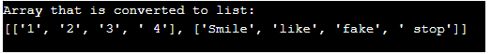

In this program also, import the numpy library and set alias name as np. After that, declare a 2-dimensional array with four elements of both the numerical and string such as [[‘1’ , ‘2’, ‘3’, ‘ 4’] , [‘5’ , ‘6’, ‘7’, ‘8’]]. Then, convert the 2-dimensional array to list using tolist() method.

### Conclusion

numpy ndarray tolist() is a function that converts the array to a list. The method tolist() is considered as the easiest method to convert array to list and it does not permit any argument. In this article, different details on numpy tolist() such as syntax, working, and examples will be discussed in detail.

## Introduction to numpy.linspace()

numpy.linspace() is a function that is used for creating numeric sequences over a specified interval. The output of the function is a ndarray containing the numeric sequence. This function is similar to np.arange() and np.geomspace() in the numpy library.

**Syntax and parameters:**

The standard syntax for writing this function is as follows :

**numpy.linspace(start, stop, num=50, endpoint=True, retstep=False, dtype=None, axis=0)**

The different parameters used in the function are :

**1. start: array_like object**

The starting value from where the numeric sequence has to be started.

**2. stop: array_like object**

The last value of the numeric sequence.

**3. num: non- negative integer**

The number of numbers or samples to be generated. If you do not mention anything for this parameter then the function uses a default value of 50. The value of this parameter must be non-negative.

**4. endpoint: boolean {True or False}**

If you mention True for this parameter, then “stop” is treated as the last sample. Otherwise, “stop” is not included in the sequence. If you do not mention anything for this parameter then the function uses True as default. Also, note that the step size changes when the endpoint is False.

**5. retstep: boolean {True or False}**

If retstep has been set to True, the function returns samples with the mentioned step as the spacing between samples.

**6. dtype : dtype, optional**

The data type of the output array. If you do not mention anything for this parameter then the function infers the data type from the other input arguments.

**7. axis: integer {0,-1, none}**

The axis along which the created samples have to be stored. If you do not mention anything for this parameter then by default 0 will be used as the axis, the samples will be along a new axis inserted at the beginning. If you want the samples at the end then use axis = -1.

The first two parameters are compulsory, other parameters are optional and can be used on the requirement basis.

np.linspace() returns an ndarray.

### Examples of numpy.linspace()

Given below are the examples mentioned:

#### Example #1

Program to illustrate np.linspace() function with start and stop parameters.

**Code:**

**import numpy as np  
#illustrating linspace function using start and stop parameters only  
#By default 50 samples will be generated  
np.linspace(3.0, 7.0)**

**Output:**

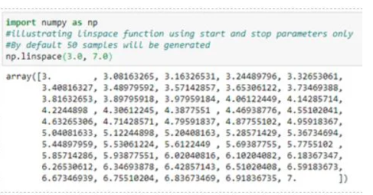

#### Example #2

Program to illustrate np.linspace() function with start, stop and num parameters.

**Code:**

**import numpy as np  
#illustrating linspace function using start, stop and num parameters  
#We can notice that the step size changes with the sample size.  
np.linspace(3.0, 7.0, num = 10)**

**Output:**

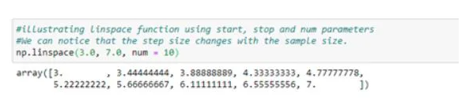

#### Example #3

Program to illustrate np.linspace() function with start, stop, num and endpoint parameters.

**Code:**

**import numpy as np  
#illustrating linspace function using start, stop,num and endpoint parameters  
#By default endpoint is set to True, i.e it returns the stop value  
np.linspace(3.0, 7.0, num = 10, endpoint = False)**

**Output:**

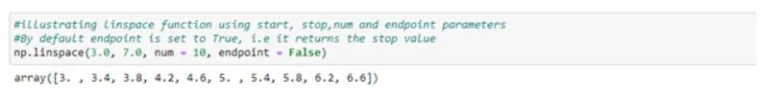

#### Example #4

Program to graphically illustrate np.linspace() function with start, stop, num, endpoint and retstep parameters.

**Code:**

**import numpy as np  
#Graphical illustration different parameters of the linspace function  
#Note : for plotting graphs in python, we require libraries like matplotlib  
import matplotlib.pyplot as plt  
y = np.zeros(10)  
x1 = np.linspace(3, 7, num = 10, endpoint=True)  
x2 = np.linspace(3, 7, num = 10 , endpoint=False)  
plt.plot(x1, y, 'o')  
plt.plot(x2, y+0.1, 'o')  
plt.show()**

**Output:**

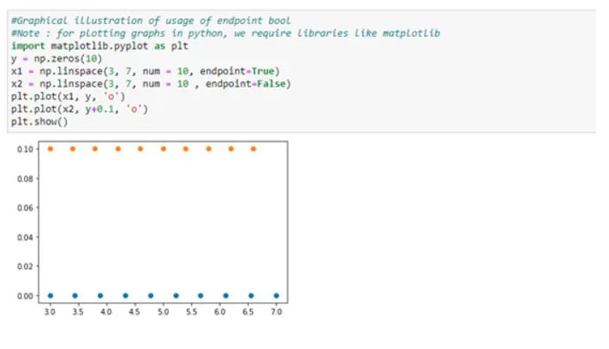

In the above output, we can see that np.linspace() generates 10 samples starting from 3 to 7. When the endpoint has been set to False, 10 samples excluding the stop value, i.e. 7 has been generated. We can also notice that the step size is different in both cases even though the start and stop values are the same.

#### Example #5

Program to illustrate np.linspace() function with start, stop, num, endpoint and retstep parameters.

**Code:**

**import numpy as np  
#illustrating linspace function using start, stop, num, endpoint and retstep parameters  
#retstep returns the samples and the step size  
#retstep has been set to True  
#stepsize when endpoint is False  
np.linspace(3.0, 7.0, num=10, endpoint = False, retstep=True)**

**Output:**

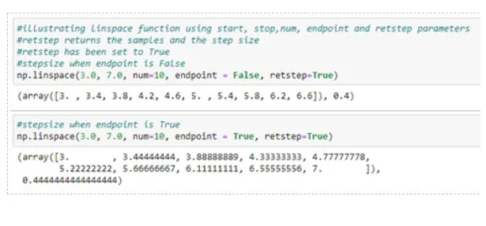

**Comparison of np.linspace() with other similar functions**

np.linspace() is similar to np.arange() and np.geomspace() functions

|  |  |
| --- | --- |
| **np.arange()** | **np.linspace()** |
| np.arange() function creates a sequence of evenly spaced numbers structured as a ndarray array. | np.linspace() function creates a sequence of evenly spaced numbers structured as a ndarray array. |
| np.arange() uses step size as a parameter | np.linspace() uses number of samples as a parameter |

#### Example #6

Program to illustrate difference between np.arange() and np.linspace()

**Code:**

**import numpy as np  
#In linspace we mention the number of samples along with start and stop values  
print("Array using linspace function :\n", np.linspace(1,10, 10))  
#In arange we mention the step size along with start and stop values  
print("Array using arange function :\n", np.arange(1,10,2))**

**Output:**

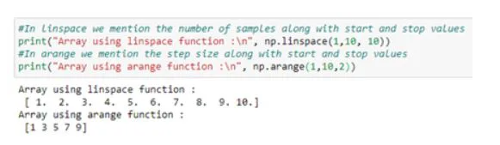

|  |  |
| --- | --- |
| **np.geomspace()** | **np.linspace()** |
| np.geompsace() function creates a sequence of evenly spaced numbers structured as a ndarray array. | np.linspace() function creates a sequence of evenly spaced numbers structured as a ndarray array. |
| In np.geomspace() the numbers are evenly spaced on a logrithmic scale. | In np.geomspace() the numbers are evenly spaced on a uniform step size. |

#### Example #7

Program to illustrate difference between np.geomspace() and np.linspace()

**Code:**

**import numpy as np  
#In linspace the sequence is evely spread over uniform step size  
print("Array using linspace function :\n", np.linspace(1,10,num = 10))  
#In geomspace the sequence is evenly spread using geometric progression/on log scale  
print("Array using arange function :\n", np.geomspace(1,1000, num =4))**

**Output:**

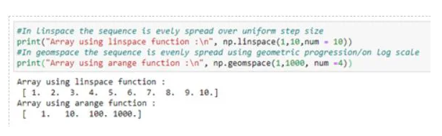

### Conclusion

np.arange(), np.linspace() and np.geomspace() can be used interchangeably. All three of the numpy functions serve the same purpose of creating a sequence of numbers. You may use any of the functions based on your requirement and comfort.

<https://www.educba.com/numpy-argmax/>

## Introduction to NumPy.argmax()

Numpy.argmax() function is used in the Python coding language in order for the system to return the indices of the elements which phase out to be the largest value. This is done with respect to the specified axis defined by the user of the court. In case the axis is not defined in a multidimensional array, then the default access is taken by the system. The function generally flattens the arrays into a linear value chain containing elements in the absence of a axis being mentioned sorting a single largest element from all the contents in the array.

**Syntax:**

Following is the syntax in which the numpy.argmax() is written in the Python programming language:

**numpy.argmax(a, axis=None, out=None)**

**Parameters for application of NumPy.argmax():**

Following is the parameters used for the numpy.argmax() function written in the Python programming language:

* **Parameters:** **a1 : array_like**  
  The array which has been entered by the user to seek through the maximum element amongst them
* **axis : integer**  
  The axis numeral which is to be selected for performing the argmax function. The default value for the function is performed over flatting the array in linear form if the specific axis is not specified by the user.
* **output : array value retuned**  
  If the parameter is mentioned in the syntax specified then the function after being performed by the system would be inserted in an array ‘output’ This array has to be of the same dimensions and dtype, as that of the original array inserted
* **Returns:** **index_array : ndarray of ints**  
  The output obtained after performing the function argmax(). This resultant array contains the indices of the maximum values element’s representative index number. This resultant array is hat of the same dimensions and shape of that of the array a1, but with the dimensions along the specified axis being removed as an exception.

### How does the NumPy.argmax () work?

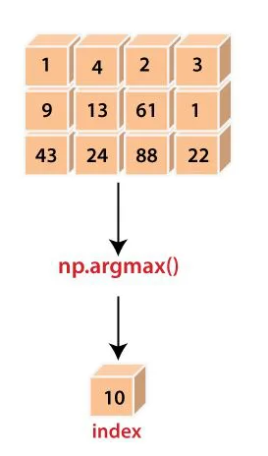

The argmax function works in a way that when the system requires its need, at first scan through the array presented to it and tries to identify if any index has been specified by the user. In case no axis is specified, the system computes that the complete array has to be used for processing the elements.

Next, the system compares every individual element which is present in the array and identifies the largest element amongst them. This element is not directly produced to the user. Rather, the system captures the index number representative of the memory section within the computer system where this element has been encrypted in.

Whenever the user calls to print the output for the given program, the index number is called upon and printed on the screen, representing the position of the element in the array.

Therefore, for each axis a different element might be opted out displaying the largest number. For instance:

Here the largest element is 88, which will have a representative index number 10 which would be displayed by the system. For the 0th axis, the number 43 is the largest and hence index 3 would be returned.

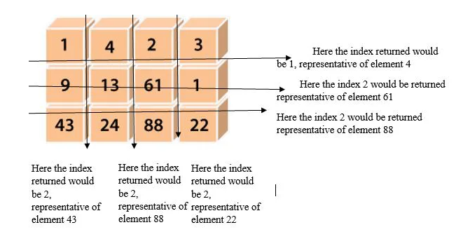

### Examples to Implement NumPy.argmax() in Python

Here are the examples mentioned:

#### Example #1

**Code:**

**# A program written using the python language used to illustrate the function argmax()  
import numpy as n1  
# The program is shown to work on a two dimensional array  
a1 = n1.arange(12).reshape(3, 4)  
print("ENTER THE ARRAY TO BE ENTERED BY THE USER : ", a1)  
# Performing the function by not specifying any axis, hence whole array to be used  
print("The largest element is: ", n1.argmax(a1))  
# Performing the function by specifying particular axis (here 0 and 1)  
print ("THE OUTPUT IS:" )  
print("The representative indices of the largest element for 0th Axis is : ", n1.argmax(a1, axis=0))  
print("The representative indices of the largest element for 0th Axis is : ", n1.argmax(a1, axis=1))**

**Output:**

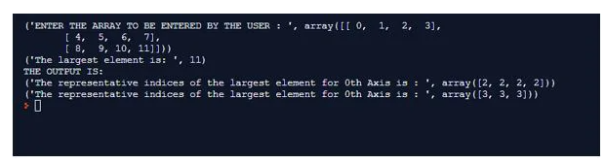

#### Example #2

**Code:**

**# A program written using the python language used to illustrate the function argmax()  
import numpy as n1  
# The program is shown to work on a two dimensional array  
a1 = n1.random.randint(6, size=(4, 4))  
print("ENTER THE ARRAY TO BE ENTERED BY THE USER : ", a1)  
# Performing the function by not specifying any axis, hence whole array to be used  
print("The largest element is: ", n1.argmax(a1))  
# the program is used for returning Indices representing the largest element  
# Performing the function by specifying particular axis (here 0 and 1)  
print ("THE OUTPUT IS:" )  
'''  
[[ 0 30 80 130] [120 110 20 110] [ 50 130 80 30] [120 150 30 40]] ^ ^ ^ ^  
120 150 80 130 - element  
1 3 0 0 - indices  
'''  
print("The representative indices of the largest element for 0th Axis is : ", n1.argmax(a1, axis=0))  
''' ELEMENT INDEX  
->[[ 0 30 80 130] 13 3  
->[120 110 20 110] 12 0  
->[ 50 130 80 30] 13 1  
->[120 150 30 40]] 15 1  
'''  
print("The representative indices of the largest element for 1st Axis is : ", n1.argmax(a1, axis=1))**

**Output:**

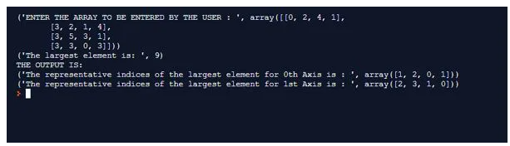

### Conclusion

The argmax() function is a very vital tool in the numerical python package that allows for using a prebuilt functionality for the seeking the index centred maximum value for arrays. It not only reduced the verbosity of the code being written but also reduces the strain being put on the overall memory of the system, by not storing data in multiple resultant arrays and being projected from the memory centred single storages which increases the processing capability of the system.

<https://www.educba.com/numpy-linear-algebra/>

## Introduction to NumPy Linear Algebra

The following article provides an outline for NumPy Linear Algebra. Linear algebra is central to almost all areas of mathematics and computer science. The data is represented by linear equations such as (a1x1 +……+anxn = b), which are presented in the form of matrices and vectors.

### Matrix and Vector Products

Here are some of the functions of matrix and vector products which are given below:

|  |  |
| --- | --- |
| **Function** | **Description** |
| dot(a, b) | Computes the dot product of two arrays. |
| vdot(a, b) | Computes the dot product of two vectors. |
| linalg.multi_dot(a,b,c,d,…) | Computes the dot product of multiple arrays at once. |
| inner(a, b) | Computes the inner product of two arrays. |
| outer(a, b) | Computes the outer product of two arrays. |
| matmul(x1, x2) | Computes the matrix product of two arrays. |
| tensordot(a, b,axes) | Computes the tensor dot product of two arrays along the specified axes. |
| linalg.matrix_power(a, n) | Raises a square matrix raised to the given power. |
| kron(a, b) | Computes the Kronecker product of two arrays. |
| einsum(subscripts,*operand) | Evaluates the Einstein summation convention on the operands. |

#### Example #1

Calculating different type of products of given arrays:

**Code:**

**import numpy as np  
#creating two arrays a and b  
a = np.array([2, 1, 2])  
b= np.array([4,5,6])  
#dot product  
print("Dot Product of a and b:", np.dot(a,b))  
#inner product  
print("Inner Product of a and b:", np.inner(a,b))  
#outer product  
print("Outer Product of a and b:", np.outer(a,b))  
#Kronecker product  
print("Kronecker Product of a and b:", np.kron(a,b))**

**Output:**

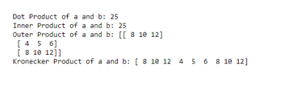

Let’s see how we calculate all the mentioned products:

Dot product is a.b = ai*bi+aj*bj+ak*bk= [2,1,2].[4,5,6] = 2*4+1*5+2*6 = 25  
Inner product is a generalization of dot product. So, it is also calculated similarly to a dot product.

Outer Product of two matrices a and b of sizes (m x 1) and (n x 1) is a resultant matrix (m x n). The product is given by a ⛒ b.

a ⛒ b = [2*4 2*5 2*6] [1*4 1*5 1*6][2*4 2*5 2*6] =[ 8 10 12] [ 4  5   6 ] [ 8 10  12]

Kronecker product is the generalization of the outer product. It is also given by a ⛒ b [k0,k1,…,kN] = a[i0,i1,…,iN] * b[j0,j1,…,jN] . The result is given in the form of a block matrix.a ⛒ b = [2*4 2*5 2*6] [1*4 1*5 1*6][2*4 2*5 2*6] = [8 10 12] [4  5 6] [8 10 12]

a ⛒ b = [2 1 2][4 5 6] = [8 10 12 4 5 6 8 10 12]

#### Example #2

This is the example of computing the matrix multiplication.

**Code:**

**#creating matrix A and matrix B  
import numpy as np  
A = np.array([[1,2,3],[4,5,6],[7,8,9]])  
B = np.array([[2,1,3],[4,1,1],[1,2,3]])  
#matrix multiplication  
print("Multiplication of A and B:", np.matmul(A,B))  
#raise matrix A to power of 2, i.e, AXA  
print("Matrix A raised to power of 2:", np.linalg.matrix_power(A,2))**

**Output:**

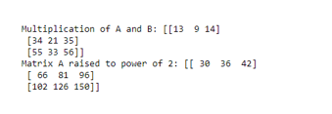

### Matrix Eigenvalues

Here are some of the functions of matrix eigenvalues which are given below:

|  |  |
| --- | --- |
| **Function** | **Description** |
| linalg.eig(a) | Computes the eigenvalue of a square matrix. |
| linalg.eigvals(a) | Compute the eigenvalues of any matrix. |
| linalg.eigh(a) | Computes the eigenvalues and eigenvectors of a complex Hermitian and a real symmetric matrix. |
| linalg.eigvalsh(a) | Compute the eigenvalues of a complex Hermitian and real symmetric matrix. |

#### Example #1

Computing Eigen Values of the given matrix.

**Code:**

**import numpy as np  
C = np.array([[1,0,0],[0,1,0],[0,0,1]])  
print("Array is:",C)  
#eigen values  
print("Eigen values of Array is:",np.linalg.eig(C))  
print("Eigen values of Array is:",np.linalg.eigvals(C))**

**Note:** eig() calculates eigen for only square matrix.

**Output:**

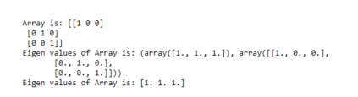

To find eigenvalues, we find the values of λ which satisfy the characteristic equation of the matrix C, where det(C − λI) = 0, here I is a 3×3 [identity matrix](https://www.educba.com/identity-matrix-in-matlab/).

[1 0 0]              [λ 0 0]              (1-λ 0 0)

[0 1 0]      –      [0 λ 0]      =     (0 1-λ 0)

[0 0 1]              [0 0 λ]              (0 0 1-λ)

Solving Equations and Inverting MatricesDet(A- λI) = 3-3λ=> 3 – 3λ = 0 => λ = 1  
Hence, [1 1 1] is the eigenvalues.

Here are some of the functions of matrix and vector products which are given below:

|  |  |
| --- | --- |
| **Function** | **Description** |
| linalg.solve(a, b) | Finds the solution of a linear equation. |
| linalg.tensorsolve(a, b) | Finds the solution of a tensor equation. |
| linalg.pinv(a) | Computes the pseudo inverse of an array/matrix. |
| linalg.tensorinv(a)  linalg.inv(a) | Computes the inverse of an array/matrix. |

#### Example #2

Solve two linear equations using the matrix.

**Code:**

**#Equation 1 : 3x+4y = 7  
#Equation 2 : 4x+3y = 7  
#creating two arrays, one for solution and one for equations  
import numpy as np  
A = np.array([[3,4],[4,3]])  
B = np.array([7,7])  
C = np.linalg.solve(A,B)  
# solution of equations  
print("Solution of given linear equations is:",C)**

**Note:** solve() works only for a square matrix.

**Output:**

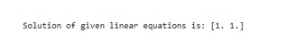

#### Example #3

This is the example of finding the inverse of a matrix.

**Code:**

**import numpy as np  
#creating a matrix A  
A = np.array([[1,1],[0,1]])  
#inverse of A  
print("Inverse of matrix A is :", np.linalg.inv(A))**

**Output:**

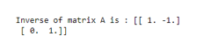

### Miscellaneous

Here are some of the functions of miscellaneous which are given below:

|  |  |
| --- | --- |
| **Function** | **Description** |
| linalg.det(a) | Computes determinant of an array. |
| linalg.slogdet(a) | Computes sign and natural log of the determinant of an array. |
| trace(a) | Computes the sum of diagonal elements of a square matrix. |
| linalg.matrix_rank(a) | Computes matrix rank of a given array. |
| linalg.norm(a) | Computes the norm of a matrix or vector. |

#### Example #1

Computing determinant, rank, and sum of diagonals of a matrix.

**Code:**

**import numpy as np  
C = np.array([[1,0,0],[0,1,0],[0,0,1]])  
print("Array is:", C)  
#determinant  
print("Determinant of Array is:", np.linalg.det(C))  
#sum of diagonal elements  
print("Trace of Array is:", np.trace(C))  
#rank of matrix C  
print("Rank of matrix C is:", np.linalg.matrix_rank(C))**

**Output:**

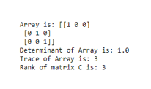

### Conclusion – NumPy Linear Algebra

In this post, we saw some of the most important numpy linear equation functions. One of the most important applications of these functions is in machine learning, where we provide input to machine models in the form of matrices, vectors, and tensors. So, in order to be a successful Machine Learning Engineer or Data Scientist, one should be comfortable with these functions.

<https://www.educba.com/numpy-dot-diff/>

## Introduction to numpy.diff()

numpy.diff() is a function of the numpy module which is used for depicting the divergence between the values along with the x-axis. So the divergence among each of the values in the x array will be calculated and placed as a new array. These difference values for the arrays can be calculated across up to n number of times. so this means the disparity between the given values can be effectively estimated across multiple levels of the arrays.

**Syntax:**

**numpy.diff(a, n=1, axis=-1, prepend=<no value>, append=<no value>)**

* a = The array which is keyed in for determining the difference across the elements of the array.
* n = Represents the entire number of times the differentiation process needs to be carried upon.
* append, prepend = If some value needs to be appended or prepended to the values in the x-axis then these parameters are been used. here the difference will be calculated just before the append or the prepend process.

### How numpy.diff() Works?

Consider an input array Test, the occurrence of the first difference for the input array is calculated using the formula out[i]=Test[i+1]-a[i]. The diff() again on this array helps to calculate the higher difference values.

The numpy is used on top of a one-dimensional numpy array. here the one-dimensional array has only a single-dimensional set of elements to it. But there could be instances where it needs to be substituted over a two-dimensional array too. from a different perception, there are situations where the numpy element need to be substituted over a two-dimensional array also. these two-dimensional arrays are in other words termed as multiple axes.

So at the point of implying diff() function over two-dimensional axis arrays then we rely on the use of the argument called an axis. here the value specified for the axis argument will be representing the columns of the two-dimensional array. so as like mentioned before at the point of applying the diff() function execution the initial column in the array undergoes a transformation which is very similar to below.

Sample array,

[0, 1, 1],

[7, 3, 15],

[8, 3, 11]

Difference value for the first row in the two-dimensional array will be taken forward as like below.

1. [0 1 1] difference = [1 0]
2. [1 0] difference = [-1]

The same process will be extended upon each and every row in the array,

### Examples of numpy.diff()

Following are the examples are given below:

#### Example #1

**Code:**

**import numpy as np  
Date_array = np.arange('2020-09-01', '2020-09-05', dtype=np.datetime64)  
output_diffrence = np.diff(Date_array)  
print("The difference in date value is: " + str(len(output_diffrence)) +" days ")**

**Output:**

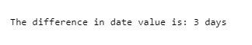

**Code Explanation:**The above program uses numpy library for determining the difference of days within two date values in an array. the program begins with an import of the numpy library using the alias name as np. the np.arrange() method is used for creating an array element, the array element formulated in the arrange function is based on the below syntax.

**numpy.arange([start_value, stop_value, n_value,dtype=None)**

here the first two indexes refer to the start and stop value whereas the third type mentions the data type which is been used. In this case for determining the expanded array of dates, the arrange method is filled with the start and the end date values. Both the date values are maintained in the YYYY-MM-DD format. so all dates falling within this are determined and formulated as an array. the formulated array is passed as input to the np.diff() function. so the np.diff() function is responsible for determining the difference in date values between each and every item in the formulated array. so once the difference value is determined it is depicted as an array. we have additionally used the len() function to determine the length of the array. based on the length of the array the number of days is determined. The determined number of days is populated in the print console as output.

#### Example #2

**Code:**

**import numpy as np  
array_var = np.array([1,2,5])  
print("Array value:",array_var)  
output_diffrence = np.diff(array_var)  
print("The diffrence value is: ",output_diffrence )**

**Output :**

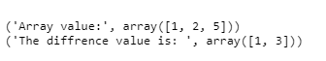

**Code Explanation:**The given program is used for determining the difference of value between a given set of the array, So the program starts with a header import of numpy module as alias name np.

Next, the array variable is passed as input to the np.diff() function. As we already know this np.diff() function is primarily responsible for evaluating the difference between the values of the array. the degree of difference can be depicted next to this parameter. based on the degree of difference mentioned the formulated array list will get hierarchal determined for its difference. the derived output is printed to the console by means of the print statement.

#### Example #3

**Code:**

**import numpy as np  
array_var = np.array([[1, 7, 4, 12], [4, 2, 4, 8]])  
print("Array value:",array_var)  
output_diffrence = np.diff(array_var,n=2)  
print("The diffrence value is: ",output_diffrence )**

**Output :**

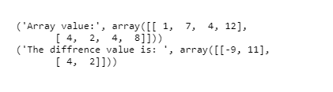

**Code Explanation:**The given program is used for formative the disparity of value between a given set of two different arrays, So the program starts with a header import of numpy module as alias name np. the array function is used for creating an array with the necessary set of values and data types are handily specified. Again as like before here too the returned value of the array function is stored in a variable of name ‘array’. This particular variable is accountable for holding the array values and the value held by this array set of the variable is displayed in the console. The necessity for performing the array function conversion in these diff() function processing is because there is a need to convert a list of values passed into a-axis oriented representation.

### Conclusion

The above content nicely mentions the necessity of np.diff() function in python oriented programming for axis level difference calculation. Also additionally a set of three different techniques for implementing np.diff() is also discussed.

<https://www.educba.com/numpy-dot-unique/>

## Introduction to numpy.unique()

Numpy unique() gets utilized in order to identify the exclusive elements present in an array. The function returns the exclusive elements in a sorted manner for the given array. Additionally, three outputs can be derived when running the numpy.unique() which can return the following:

* The function can return the absolute times the unique elements contained in an array which has been input by the user.
* The function can return the respective indices representative of the unique values contained in the array which has been input by the user.
* The function can return the respective indices of the unique elements for the array which will help in the reconstruction of the array originally entered by the user.

### Syntax and Parameters

Syntax and Parameters of numpy.unique( ) are given below:

#### Syntax

**numpy.unique(ar, return_index = False ,return _ inverse = False, return_counts = False, axis = None)**

#### Parameters

* **ar: array_like**

The input array entered – It will be flattened in the case it is not one dimensional.

* **return_index: bool,(optional)**

If the parameter is true the indices of the input array ar would be returned which results to form a unique array with no repetitive elements.

* **return_ inverse: bool, (optional)**

If the parameter entered is true, the indices of the input array ar would be returned which results to form a unique array used for reconstructing the array ar.

* **return_ counts: bool, (optional) – found in version 1.9.0**

New in version 1.9.0. If the parameter entered is true, the number of instances when the unique elements have been repeated in the input array ar is returned.

 Return

* **unique: ndarray**

The sorted unique elements of the input array ar.

* **unique_indices: ndarray, (optional)**

When the return_index is validated as true the returned value contains the indices of primary occurrence of the distinct values which were present in the input array (which has to be flattened)

* **unique a _ a inversea: a ndarray, (optional)**

The indices are retuened which can be used for reconstruction of the originally input array which can be constructed using the distinct values.

* **unique a _ a countsa: a ndarray, a (optional) present in the newer version 1.9.0**

The number of times each of the unique values comes up in the original array. Only provided if return_counts is True.

### Example of numpy.unique()

Example of using numpy.unique() function are:

**Code:**

**import numpy as np  
a1= np.array([5, 2, 6, 2, 7, 5, 6, 8, 2, 9])  
print '1st a array to be entered:'  
print a1  
print 'The unique values of the 1st Array:'  
u1 = np.unique (a1)  
print u1  
print 'Displaying the Unique array & Indices array:'  
i1 = np.unique(a1, return_index= True)  
print i1  
print 'Number corresponding to the index:'  
print a1  
print 'Indices of unique array:'  
u1,indices = np.unique(1, return_inverse=True)  
print u1  
print 'The indices for the given array are:'  
print indices  
print 'Reconstruction of the original array with the use of indices:'  
print u1[indices] print 'Return the count of repetitions of unique elements:'  
u1,indices = np.unique(a1, return_counts = True)  
print u1  
print indices**

**Output:**

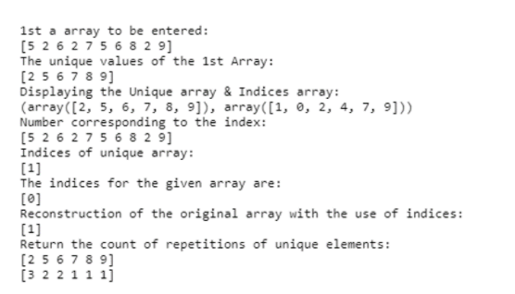

### Conclusion

Numpy provides for an exclusive function which is a very essential and constantly used function required for most data-intensive code work. In such cases, the verbosity of the code enlarges in the repetition of codes affecting the computation speed especially when the data set the id of large dimension. This function serves as a boon in such times and eases out by providing for one-liner coding solution.

<https://www.educba.com/numpy-zeros/>

## Introduction to NumPy zeros

To create a new array of the specified type and specified shape and the value of the elements in the newly created array is zero. We make use of a function in NumPy called zeros where the count of elements in each and every dimension represents the shape of the array and the data type of the shape of the array is int or tuple of ints and the zeros function takes a parameter which is optional and specifies the data type of the array and the default value of the data type of the array is float and there is another parameter called order taken by the zeros function whose value decides if the multi-dimensional array must be stored in column-major order in the memory or row-major order in the memory.

**Syntax :**

**zeros(shape, dtype=None, order='C')**

* Where the size of the array is defined by shape.
* dtype is a parameter which is optional and specifies the data type of the array and the default data type of the array is float and, the order is a parameter whose value decides if the multi-dimensional array must be stored in a column-major order which is nothing Fortran style in the memory or row-major order which is nothing but C style order in the memory.

### Working of NumPy zeros

* Whenever there is a need to create a new array of the specified type and specified shape and the value of the elements in the newly created array is zero, we make use of a function in NumPy called zeros function.
* The count of elements in each and every dimension represents the shape of the array and the data type of the shape of the array is int or tuple of ints.
* The zeros function takes a parameter that is optional and specifies the data type of the array and the default value of the data type of the array is float.
* There is another parameter called order taken by the zeros function whose value decides if the multi-dimensional array must be stored in column-major order in the memory or row-major order in the memory.
* The column-major order in the memory is also called Fortran style order in the memory.
* The row-major order in the memory is also called the C style order in the memory.

### Examples

Given below are the examples mentioned:

#### Example #1

Python program to demonstrate NumPy zeros function to create a one-dimensional array consisting of the elements whose values are zero.

**Code:**

**#importing the package numpy  
import numpy as np  
#creating a variable to store the one dimensional array created by using zeros function in NumPy  
arrayname = np.zeros(5)  
#the one dimensional array consisting of the elements whose values are zero created using NumPy zeros function is printed as output on the screen  
print("The one dimensional array consisting of the elements whose values are zero created using NumPy zeros function is:")  
print(arrayname)**

**Output:**

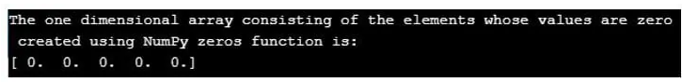

In the above program, a package called NumPy is imported to enable us to make use of zeros function. Then a variable is created to store the one-dimensional array created by using zeros function in NumPy. Then the one dimensional array consisting of the elements whose values are zero created using NumPy zeros function is printed as output on the screen.

#### Example #2

Python program to demonstrate NumPy zeros function to create a multi-dimensional array consisting of the elements whose values are zero.

**Code:**

**#importing the package numpy  
import numpy as np  
#creating a variable to store the mutli dimensional array created by using zeros function in NumPy  
arrayname = np.zeros((5,3))  
#the multi dimensional array consisting of the elements whose values are zero created using NumPy zeros function is printed as output on the screen  
print("The multi dimensional array consisting of the elements whose values are zero created using NumPy zeros function is:")  
print(arrayname)**

**Output:**

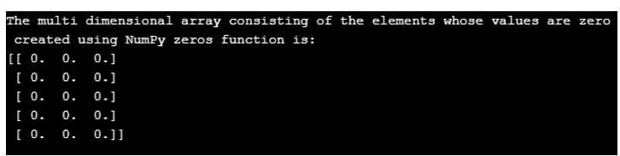

In the above program, a package called NumPy is imported to enable us to make use of zeros function. Then a variable is created to store the multi-dimensional array created by using zeros function in NumPy. Then the multi-dimensional array consisting of the elements whose values are zero created using function is printed as output on the screen.

#### Example #3

Python program to demonstrate function to create a multi-dimensional array consisting of the elements whose values are zero and the data type of the elements of the array is int.

**Code:**

**#importing the package numpy  
import numpy as np  
#creating a variable to store the mutli dimensional array, the data type of whose elements are specified to be of type int created by using zeros function in NumPy  
arrayname = np.zeros((5,3), dtype=int )  
#the multi dimensional array consisting of the elements whose values are zero and the data type of the elements is int created using NumPy zeros function is printed as output on the screen  
print("The multi dimensional array consisting of the elements whose values are zero and the data type of the elements is int created using NumPy zeros function is:")  
print(arrayname)**

**Output:**

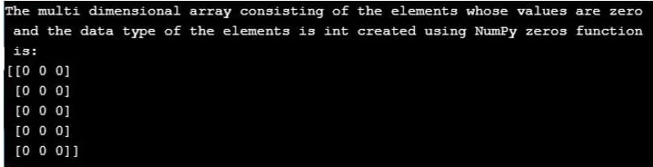

In the above program, a package called NumPy is imported to enable us to make use of zeros function. Then a variable is created to store the multi-dimensional array created by using zeros function in NumPy. Then the multi dimensional array consisting of the elements whose values are zero and the data type of the elements of the array is int, created using function is printed as an output on the screen.

<https://www.educba.com/numpy-mean/>

## Introduction to numpy.mean()

Numpy.mean() is function in Python language which is responsible for calculating the arithmetic mean for the all the elements present in the array entered by the user. Simply put the functions takes the sum of all the individual elements present along the provided axis and divides the summation by the number of individual calculated elements. The axis along which the calculation is made has to be prespecified or else the default value for axes will be taken.

**Syntax :**

The following is the syntax that displays how to implement numpy.mean().

numpy.mean (**a**, **axis** **=None**,**dtype = None**,**out = None**,**keepdims** **=<no value>**)

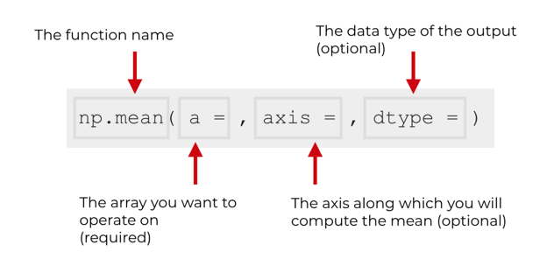

The syntax entered by the user is sent in terms of **float * 64** intermediate and there by returns the value for the associated integers corresponding for the mean value.

**The parameter used in the Syntax for using numpy.mean()**

* **a *: *array *_ *like \***

The array is being entered by the user or prompted to be entered. In case the array entered is not of an integer data type, then the conversion of the form is tried on the data entered.

* **axis : None *, *  *int *, *  *tuple * (optional parameter)**

The computation of the axis along the elements of the specified array entered by the user is done. By default, the mean of the pre-flattened array is computed. In case the array entered is a tuple, in such a case the mean is computed over various axes of the array.

* **dtype * *: * *data *– *type *, (parameter is optional)**

For the computation of the mean the parameter type is utilized. By default, the float 64data type is used for arrays with integer data sets. In case the data being input is floating it remains the same as the dtype entered.

* **out : ndarray, (parameter is optional)**

It is an alternative array which is made to record the resultant mean. By default, the parameters stay None. In case it is provided the array is needed to have the same ascertained shape as that of the output which is expected.

* **keepdims: bool, (parameter is optional)**

If the parameter specified is True, the axis or axes which are deduced are kept in the expected result as the dimensions having size one. The option enables the result to be broadcasted correctly in response to the array which has been entered. In case value by default, a parameter is passed then the keepdims parameter would not be passed on to the method-specific for mean with respect to the array and its sub-classes. However, it must be noted that for non-default values passed the keepdims parameter would be applicable to raising exceptions if any.

* **m : ndarray**

If the parameter out=None, then in such a case a new array is returned which contains the mean values. Else, in such cases, the reference values with respect to the elements if retuned.

### Example for Implementation of the NumPy.mean()

Below are the examples mentioned:

**Code:**

**import numpy as n1  
a1 = n1.array([[10,20,30],[30,40,50],[40,50,60]])  
print 'The new array entered by the user is:'  
print a1  
print 'Application of the Numpy.mean() function on the array entered:'  
print n1.mean(a1)  
print 'Application of the mean() function alongside the axis - 0:'  
print n1.mean(a1, axis = 0)  
print ' Application of the mean() function alongside the axis - 1:'  
print n1.mean(a1, axis = 1)**

The following output would be produced for the code specified above:

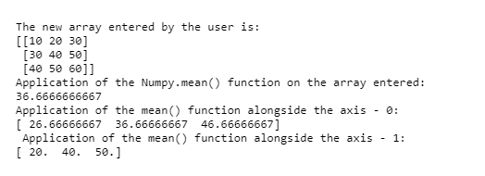

### How Does the numpy.mean() Work?

The function scans through the values which are specified in the array which is provided by the user. It firstly tries to flatten the resultant array before the computation of the arithmetic mean on the same. The below diagrammatic systemic representation shows the function actually executes the calculation:

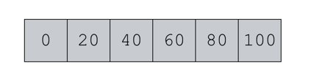

We can use the NumPy mean function to compute the mean value:

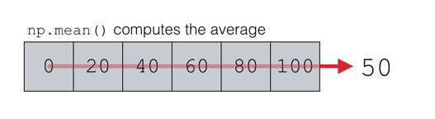

* As the function for mean travels through various axis or axes provided by the user, it scan through and tries to integrate the arithmetic mean functionality for all integral values, Where the elements do not match up to be integral data type, it tries to convert such numbers.
* Here you can see for a single dimensional array with six specified elements, the functions scans each of the elements and then divides the total summation of the elements by the total number of elements present in the array (here 6).
* This way for arrays with multiple dimensions all or specified axis is mentioned along which the mean is calculated which is displayed in an array form for more than one-dimensional arrays.

### ****Conclusion****

The function mean() in NumPy is very useful for calculating the arithmetic average of elements especially in terms of data given in array subsets. This being calculated through manual code impacts the verbosity of the code and thus impacts on the computation time for long codes with large data sets.

<https://www.educba.com/numpy-dot/>

## What is numpy.dot()?

Numpy.dot() function Is it a tool that is responsible for returning the dot equivalent product for two different areas that had been entered by the user. In the case of a one-dimensional array, the function returns the inner product with respect to the adjudicating vectors. On the contrary, for two-dimensional arrays, the function returns the value which is equal to the resultant output returned on the multiplication of two arrays. Assuming the coder is not aware of the dimensions of the array (in case the address entered by the user) the output is equivalent to the sum-product derivative of the 2nd last axis of an array ‘b1’ and last access of the first array ‘a1’.

**Syntax for NumPy.dot()**

The following sentence is used for the functional operation of Numpy.dot() in a python programming language:

**numpy *. * dot * (a, *  * b *, *  *  * out * = * None *) * * * * * * * * * * * * * * \***

The function is responsible for returning the dot-product of arrays while keeping the following projections in perspective:

* For a 1-D array, the function returns the inner product with respect to the adjudicating vectors
* In the case of a 2-D array, the function returns the value which is equal to the resultant output returned on the multiplication of two arrays.
* In case, the arrays are dimensionless or 0-D (i.e., scalar entities) the resultant output is the sum-product of the last axis
* In the case of N-D arrays, where the users are not aware of the dimensions of the array, the output is equivalent to the sum-product derivative of the 2nd last axis of an array ‘b1’ and last access of the first array ‘a1’.

The format of syntax in such condition would be:

**Numpy*\**.*\**dot*\**(a1*\**,*\** b1*\**)*\**[i1*\**,*\**j1,*\**k1,*\**m1]*\*  *  \**=*\*  *  \**sum*\**(*\**a1*\**[*\**i1*\**,*\**j1,:]*\** *\**\**\** b1[k1*\**,:,m1)**

### Parameters for Using Numpy.dot()

Understanding the parameter:

|  |  |
| --- | --- |
| **Parameters** | **a : array_like:** First array of argument which has been entered by the user  **b : array_like:** The second array or argument which has been entered by the user.    **out: ndarray, optional:** Output which would be derived after the execution of the function. The parameter ‘kind’ for the implementation in this function has to be exactly the same in the areas which have been entered by the user. Particularly speaking, the parameter ‘type’ has to be correct and must be of the C-contagious type. Moreover, it must be noted that the data type which is returned from the output must be the same as the dtype parameter entered for the function numpy.dot(a1, b1).  This is an indicator feature that is relevant to the performance of the function. Thus it has to be understood that under circumstances weather conditions have not been met there is a chance of an exception being raised, rather than the function trying to given output which is flexible in terms of the data which is entered and the parameters. |
| **Returns** | **output: ndarray:** The parameter is responsible for returning the dot product for the Arrays (a1 and b1 here) which have been entered by the user. In case the areas entered are scalar values for a single dimension then the return value is scalar. On the contrary in the air is our 2D or above the resultant output is an array. |
| **Raises** | **ValueError:** In case the indicative last-dimension of the first array entered by the user (here a1) is not equal to the indicative second the last dimension of the secondary entered by the user (here b1) a value error in generated by the system. |

### Examples of Using Numpy.dot()

Below are the examples:

#### Example #1

**Code:**

**# Program which illustrates using NuPy.dot() in python language  
import numpy as n1  
# Code written for Scalar Values entered by the user  
output1 = n1.dot(50, 40)  
print("The output generated for dot-product of the provided values (scalar) is  : ", output1)  
# Code for 1D array  
v_a1 = 20 + 30j  
v_b1 = 40 + 50j  
output2 = n1.dot(v_a1, v_b1)  
print("The output generated for dot-product of the provided values (single dimensional values) is  : ", output2)**

**Output:**

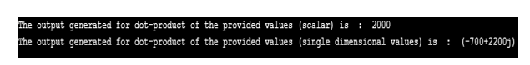

#### Example #2

**Code:**

**# Program which illustrates using NuPy.dot() in python language**

**# Code for 2-D array**

**import numpy as n1**

**v_a1 = n1.array([[10, 40], [50, 60]])**

**v_b1 = n1.array([[20, 40], [50, 20]])**

**ans1 = n1.dot(v_a1, v_b1)**

**print("The output generated for dot-product of the provided values (two dimensional array A and B) is: \n", ans1 )**

**ans2 = n1.dot(v_b1, v_a1)**

**print("The output generated for dot-product of the provided values (two dimensional array B and A) is: \n", ans2 )**

**Output:**

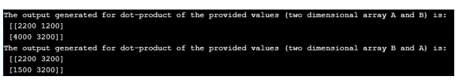

### How does the Function work for One Dimensional Array?

For the code provided with 1-D arrays being:

**v_a1 = 20 + 30j  
v_b1 = 40 + 50j**

Performing computational analysis on the arrays to give the dot product

* = 20 (40 + 50j) + 30j (40 – 50j)
* = 80 + 100j + 120j – 150
* Answer is = -70 + 220j

The function similarly works with arrays provided to give a resultant output which is a factor of the two vector values provided and thus the sum-product for array and array B will have different outputs when compared to array B and array A, due to changes in their indices and cross positional multiplication of individual elements.

### Conclusion

The NumPy.dot() function is a very essential tool in the numpy class it allows for small single line driven code for cross functional multi-liner programs which increases the turn-around time and decreases the verbosity for the function, serving as a very essential tool for large data driven coding.

<https://www.educba.com/numpy-argsort/>

## Introduction to Numpy.argsort()

argsort function is a pre-built function present in the Numpy which works in a way that it returns the indices that would be responsible for sorting an array. The array which is returned is arranged in a specified order. The NumPy argsort() function is also used to do a sort which is indirect in nature along the specifies axis (at time the when axis is not specified the default is executed) using a set of algorithms. This algorithm is stipulated by a keyword i.e., ‘kind’. This aids in a way that the resultant array is maintaining the exact shape as the array which was entered maintaining the data that are sorted along the axis.

**Syntax**

Following is the representation in which code has to be drafted in the Python language for the application of the numpy argsort function:

argsort**(axis=-1,kind=None,order=None)**

**Parameter for Argsort()**

These are the parameters used in numpy.argsort() have been listed below:

|  |  |
| --- | --- |
| **Parameters for Argsort** | **Application of Argsort Parameter** |
| The variable a: array_like | The parameter ‘a’ is used to define the array that the user wants to be sorted |
| axis: int (integer) or None (not defined) (this parameter is optional) | The parameter ‘axis’ is used to define the axis alongside which the arranging has to be performed. When nothing is specified for the axis parameter, the default axis taken to be -1. If the axis is set as None, the array which is flattened is processed for performing the sort. |
| kind: {‘quicksort’, ‘stable’,’heapsort’,’merge**\***sort’}( this parameter is optional) | The parameter ‘kind’ is very essential. It is used to define the algorithm to be sorted. The default parameter for kind is set to “quick sort” unless the user defines another kind. The time sort is used by both **stable** I and **mergesort** on the background, but the difference and variety of the data types used of the input array defines their implementation. |
| order: str (string) or*list of str (this parameter is optional) | For an array ‘a’ which has defined fields, the order argument plays the role of defining which field has to be compared first and so on. As all fields do not have be necessarily specified, a single field itself is specified in form of a string. But in such cases, the unspecified fields present would still be used by the function which are used by the d | type and aid in breaking the ties in order related functionalities |

Returned argument on execution of the argsort() function:

* **index_array:(nd array, int)**

The argsort function is utilized to return and the indices representative of the array where the array ‘a’ is sorted along the axis which has been specified by the user.

### Sorting the Algorithms for NumPy

Following are the properties of the three variables with respect to the arguments for argsort():

|  |  |  |  |  |
| --- | --- | --- | --- | --- |
| **Kind of argument** | **Pace** | **worst case of computation** | **Occupancy** | **Stability** |
| Quicksort * | 1 | O * (* n * ^ * *2 *) * | 0 * | Unstable * |
| Mergesort * | 2 | O * (* n * * * log * (n) *) * | ~n * / * 2 * | Stable * |
| Heapsort * | 3 | O * (* n * * * log * (n) *) * | 0 * | Unstable * |

### Example

Let us take some examples to understand n1.argsort() on various dimensionally oriented arrays to understanding the mechanism of sorting used:

**Code:**

**import numpy as n1  
num=n1.array([564, 11, 321])  
n1  
b1=n1.argsort(num)  
b1**

**Explanation**

an array ‘num’ as been created using the function n1 * . * array() which contains the integer values of 564, 11 and 321 whose values are then sorted using the function. In the output we can see an nd_array has been visualized which is shown to be containing the indices that indicate the actual sequential position of each of the element of the array that has been sort along with the dtype. The Following Output is observed:

**Comment:**The order of the indices 1, 2, and 0 represent the ascending order of the numeral in the array.

### Examples of Numpy.argsort()

Below are the examples

#### Example #1

Sorting a Two-Dimensional (2-D) Array

**Code:**

**import numpy as n1  
ar1 = n1.array([[0, 2], [5, 4]])  
i1 = n1.argsort(ar1, axis=0)  
i1**

**Explanation**

This variable ‘ar1’ is used in the above code to assign and store the value of the 2D array, defining its axis is used for assigning as well as sorting the values after the array has been assigned to store the value of the functional execution of sorting done along its first axis by the ar1.argsort function

#### Example #2

FOR an n-Dimensional Array

**Code:**

**import numpy as AP  
OA=AP.array([300, 100, 200])  
print('The elements in our array are :')  
print (OA)  
print('Using the argsort() function to the array:')  
NA = AP.argsort(OA)  
print (NA)  
print('Sorting our array in ascending order:')  
print (OA[NA])  
print('Using a loop for reconstruction of our array:')  
for x in NA:  
print (OA[x]),**

### Conclusion

The argsort provides for an exclusive function which is a very essential and frequently used functionality for most data intensive code work.  Therefore, in a way reduces the verbosity of the code increases the speed of computation especially when the data set which are being processed are very large and may be of a large dimension. It saves time and complexity for other viewers who would be externally use it.

<https://www.educba.com/numpy-pad/>

## Introduction to numpy.pad()

numPy.pad() is function present in the Python language tool pack which primarily is used to perform the padding of an array which has been entered by the user. It is a very necessary functionality and it comes packed with the functionality of performing padding of the arrays entered by the user. To simplify put, padding is transformational process which is aimed at setting a dimension in an array to enable is compensate a new size.

**Syntax for numpy.pad()**

Given below is the syntax which is used for numpy.pad() to be implemented into the python coding language programs:

**Numpy *. *pad (*array *, *  *pad *_ *width *, * *mode *= *'constant' *, ***kwargs *) \***

**Parameters**

Below are the respective parameter:

**1. array: array_like of any rank:**The array entered by the user which has to be padded.

**2.** **pad_width: {sequence, array_like, int}:**The total number of values that have to be padded upfront the edges with respect to different axis of the array which is designed uniquely for each of them. The parameter ((before N, after N)) generate specified N padding in front and beyond the values for the specified axis. The parameter before = after = padding can be used as a shortcut for the arrays where padding has to be done requiring same with for all axes.

**3. mode: str or function, optional:**The following keyword have be used for the parameters ‘mode’.

This can be predefined by the coder or be entered as per the preference of the user.

* **‘constant’ (default):**Padding with the value that remain constant.
* **‘edge’:**Pads which have the edge values defined for the array.
* **‘linear *_ *ramp’:**Pads having the linear ramp in between the edge value & the end value.
* **‘maximum’:**Padding has to be done across the array for each axis where the edge value is maximum.
* **‘mean’:**Padding has to be done across the array for each axis where the edge value is mean throughout the array.
* **‘median’:**Padding has to be done across the array for each axis where the edge value is median throughout the array.
* **‘minimum’:**Padding has to be done across the array for each axis where the edge value is minimum.
* **‘reflect’:**This is used where padding is needed with respect to the arrays which have mirror-like reflective structure on the last and first value for the vector along the specified axis
* **‘symmetric’:**This is used where padding is needed with respect to the arrays which have mirror-like reflective structure alongside the array’s edge.
* **‘empty’:**Padding where the values are undefined. This is present in the newer version of Python (1.7.1).

**4. stat *_ *length : int , sequence ; the parameter is optional:**The default value for the parameter is None which is used throughout all axis. This parameter is used with respect to minimum, maximum, mean and median parameters which aids in calculations with respect to static or non-dynamic values.

**5. constant_values : sequence, scalar, the parameter is optional:**This parameter is used along side the constant parameter which aids in laying out different pads before or after the arrays automatically for various sets of such data.The default value for constant_values is taken to be 0 unless specifies by the user.

**6. end_values : sequence, scalar, the parameter is optional:**The parameter is used when the ‘liner_ramp’ parameter is used which enables in padding the edges of the array. The default value for constant_values is taken to be 0 unless specifies by the user.

**7. reflect_type : {‘even’, ‘odd’}, optional:**The parameter is used when the ‘symmetric’ or ‘reflect’ parameters are used which enables in padding the edges of the array. The odd subjective makes the array’s extended portion to be made by subtraction of the reflected-out values with double the edge value limit.

**8. pad: ndarray:** The final output is stored in the array which is padded after processing through the various parameters having a differentiated size.

### Examples of numpy.pad()

The following examples demonstrate the use of pad() in the codes:

#### Example #1

Program which illustrates using numpy.pad() in python language.

**Code:**

**import numpy as n1  
a1 = [10, 30, 20, 50, 40] b1 = n1.pad(a1,(3, 2), 'constant', constant_values = (60, 40))  
print("The output generated for the provided values (using constant_values) is :\n", b1)**

**Output:**



#### Example #2

Program which illustrates using numpy.pad() in python language.

**Code:**

**import numpy as np  
a1 = [10, 30, 20, 50, 40] b1 = np.pad(a1,(3, 2), 'edge')  
print("The output generated for the provided values (using edge) is:\n", b1)**

**Output:**

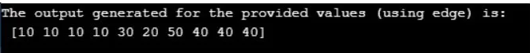

#### Example #3

**Code:**

**import numpy as n1  
a1 = [10, 30, 20, 50, 40] b1 = n1.pad(a1,(3, 2), 'linear_ramp', end_values = (-40, 50))  
print("The output generated for the provided values (using linear ramp) is:\n", b1)**

**Output:**



### Conclusion

The pad() function is very vital for specific coding and turns to be widely used tool. The function enables the transformation of the array in order to reduce the numerous conflicts occurring with the memory system. The numpy.pad() function is widely applied to the AST in full functionality. This enable the user to specify the new size or also give the system the option to automatically compute the size for the same. This thereby specialized the memory resource optimization ability to reduce the processing time for the system.

<https://www.educba.com/numpy-dot-ravel/>

## Introduction to numpy.ravel()

NumPy.ravel() is a function present in the Numpy toolset which enables the array entered by the user to be contiguously flattening the array. The ravel function in the numpy tool is one of the most essential and commonly used functionalities which helps in unravelling the data which has been presented by the user. In simple words, the ravel function is used to flatten or present the data given in a linear manner, which was previously presented in a dimensional form. Thereby, we can see that it can simplify the structural presentation of an array.

### Syntax and Parameters of numpy.ravel()

Following is the syntax in which the numpy.ravel() is written in the Python programming language:

**Syntax:**

**numpy.ravel(a, order='C'/ 'F' / 'A' / 'K’)**

In accordance with the current version (i.e., Python 1.10) the output returned is of the same type as the array which had been entered by the user. For instance, for an input wear a masked array had been entered by the user, the array which is returned it’s also masked.

**Parameters:**

The following are the parameters used for the numpy.ravel() function written in the Python programming language:

* a1: array_like
* The array has been entered by the user. The array a1 (here), where the elements have been specified by the user are read by the programming system in the same order as it has been specified and that in the form of a one-dimensional array Order used: { * ‘* C *’ *, *’ * F *’ *, * * ‘* A *’ *, * ‘* K *’ * }, the parameter is optional.
* All the elements that are present in the array a1, when need to be read by the system while using the parameters ‘C’. In such a case, the index of the elements is read on the row-major bases. This means that the index of the last axis change is the fastest while the first axis changes slowest in speed.
* When using the parameter F, the system identifies the respective index number of each of the elements present in the array in the Fortran style. This means that the system identifies the first index to be changing at the fastest pace while the last one would be the slowest in terms of index changing.
* It must be noted that both the parameters F and C do not take any account for the memory layout with respect to the array which has been entered by the user. They only refer to the order in which the axis of the respective array has been indexed.
* While using the parameter A, the system reads the elements of the array a1 in the index order of Fortran only if the array has a Fortran like contagious memory. Otherwise, when parameter A is used the elements are read in a similar way like parameter C.
* While using the parameter K, the elements present in the array given by the user I read in accordance with their occurrence in the memory of the system. The exception being reversal being done in the order in case strides occurring in the data are negative.
* The default parameter when no parameter is specified is C.

**Returns:**

* y1 : array_like
* y1 is the array with a similar subtype as that of the array a1, with the shape being the same, we have to note that matrices are specially cased with respect to the compatibility when spiralling backwards. Note that matrices are special cased for backward compatibility, Example if a1 represents the matrix, then y1 is a one-Dimensional ndarray.

### Examples of Using numpy.ravel() in Python

Following are the example as given below:

#### Example #1

**Code:**

**# Python Program illustrating the implementation of numpy.ravel() function  
import numpy as n1  
a1 = n1.arange(15).reshape(3, 5)  
print("The array entered by the user is :", a1)  
# Code flattens the array which was entered creating a one dimensional sequence  
# Output for the array is displayed  
print("Unravelling the array entered by the user : ", a1.ravel())  
# The output array is rechecked for configuring if the order and shape is persistant  
print("Reshaping the unravelled array == numpy.reshape(-1)")  
print("The reshaped array is : ", a1.reshape(-1))**

**Output:**

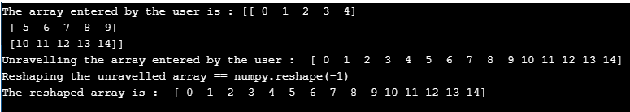

#### Example #2

**Code:**

**# Python Program illustrating the implementation of numpy.ravel() function  
import numpy as n1  
a1 = n1.arange(15).reshape(3, 5)  
print("The array entered by the user is :\n", a1)  
# Code flattens the array which was entered creating a one dimensional sequence  
# Output for the array is displayed  
print("Unravelling the array entered by the user :\n", a1.ravel())  
# Using the Parameters for maintaining both 'A' and 'F' order  
print("Output using the parameter A for specified order:\n", a1.ravel(order = 'A'))  
# Using the Parameters ‘K’ for maintaining both neither of 'A' order nor 'F' order  
a2 = n1.arange(12).reshape(2,3,2).swapaxes(1,2)  
print("The newly order array which has been remodelled is:\n", a2)  
print("Maintaining A order for newly constructed array:\n ", a2.ravel(order = 'K'))**

**Output:**

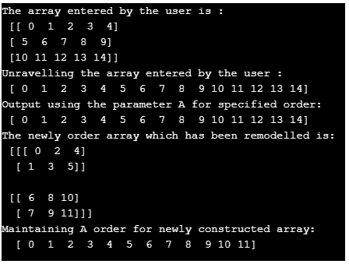

### Conclusion

The function ravel() serves as a very vital tool for programmers dealing with big data problems who have to deal with arrays and data sets with multitudes of dimensions and executing them needs to linearize them in order to separate the elements. This reduces the verbosity and efficiency of the code by presenting an inbuilt function.

<https://www.educba.com/numpy-stack/>

## Introduction to NumPy stack

The following article provides an outline for NumPy stack. Python provides different functions to the users. To work with arrays, the python library provides a NumPy function. The stack() characteristic is used to be a part of a sequence of equal dimension arrays alongside a new axis. The axis parameter of array specifies the sequence of the new array axis in the dimensions of the output. For example, suppose axis=0 that means it determines the first dimension and if axis=-1 that means it determines the last dimension. NumPy is an acronym for numerical python. Basically, NumPy is an open source project. NumPy performs logical and mathematical operations of arrays. Therefore, processing and manipulating can be done efficiently.

**Syntax:**

**numpy.stack(Arr, Axis)**

**Explanation:**

* **Arr:**In the above syntax the first parameter is Arr means array, it is used to define a sequence of equal dimension arrays with the same shape of array.
* **Axis:**It is the final output array along with the input array.

### How stack Function work in NumPy?

* We must install Python on our system.
* We must install numpy using the pip command.
* We required basic knowledge about Python.
* We required basic knowledge about stack function with parameters.
* We required basic knowledge about arrays.
* We can perform different operations using a numpy stack function.

### Examples of NumPy stack

Given below are the examples of NumPy stack:

#### Example #1

For if Axis=0 and Axis=1.

**Code:**

**import numpy as snp  
A_x = snp.array([ 2, 3, 4] )  
print ("First Input Array: \n", A_x)  
A_y = snp.array([ 5, 6, 7] )  
print ("Second Input array  :       \n", A_y)  
A = snp.stack((A_x, A_y), axis = 0)  
print ("\n ", A)  
B = snp.stack((A_x, A_y), axis = 1)  
print ("\n ", B)**

**Explanation:**

* We import NumPy functions and use them as snp.
* We declared variable two input arrays such as A_x and A_y with array values.
* We tried to print the value of the input array with their values respectively.
* Then we used a stack function with both input arrays along with axis values 0 and 1 respectively.
* Finally we have printed both resultant output arrays with axis value.
* In the above example we implemented a stack function with axis values 0 and 1.

**Output:**

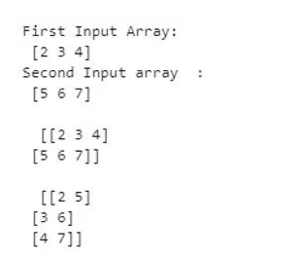

#### Example #2

For if Axis= 0, Axis=1 and Axis=-1.

**Code:**

**import numpy as snp  
A_x = snp.array([[ 2, 3, 4], [ -2, -3, -4]] )   #input array  
print ("First Input Array  : \n",A_x)  
A_y = snp.array([[ 5, 6, 7], [ -5, -6, -7]] ) #input array  
print ("Second Input array   : \n", A_y)  
A  = snp.stack((A_x,A_y), axis = 0)       # Array with axis=0  
print ("   0:  \n ", A)  
B = snp.stack((A_x, A_y), axis = 1)  # Array with axis=1  
print ("   1:   \n ", B)  
C = snp.stack((A_x, A_y), axis = -1)  # Array with axis=-1  
print (" -1: \n ", C)**

**Explanation:**

* We import NumPy functions and use them as snp.
* We declared variable two input arrays such as A_x and A_y with array values.
* We tried to print the value of the input array with their values respectively.
* Then we used a stack function with both input arrays along with axis value 0, 1 and -1 respectively.
* Finally we tried to print both resultant output arrays with axis value.
* In the above example we implemented a stack function with axis values 0, 1 and -1.

**Output:**

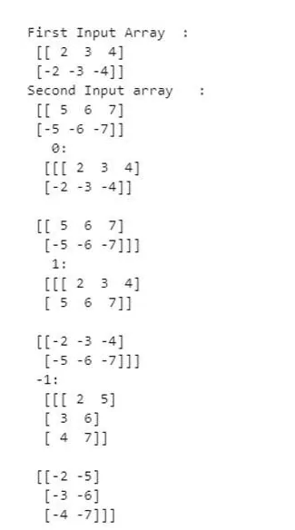

#### Example #3

For if Axis = 1 and Axis = 2.

**Code:**

**import numpy as snp  
A_x = snp.array([ 1, 2, 3] )   #input array  
print ("First Input Array : \n",A_x)  
A_y = snp.array([ 4, 5, 6] )     #input array  
print ("Second Input array  : \n",A_y)  
A = snp.stack((A_x, A_y), axis = 1)   #  Array  with axis=1  
print ("     \n ", A)  
B = snp.stack((A_x, A_y), axis = 2) # Array  with axis=2  
print ("     \n ", B)**

**Explanation:**

* We import NumPy functions and use them as snp.
* We declared variable two input arrays such as A_x and A_y with array values.
* We try to print the value of the input array with their values respectively.
* Then we used a stack function with both input arrays along with axis values 1 and 2 respectively.
* Finally we try to print both resultant output arrays with axis value.
* In the above example we implemented a stack function with axis values 1 and 2. See in this example it only executes an array with axis 1 and when we assign axis 2 at that time it shows an error message as axis 2 is out of bounds for array dimension 2.

**Output:**

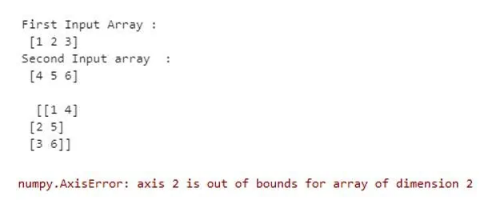

#### Example #4

For if Axis= 1 , Axis=2 and Axis=-1 with shape function.

**Code:**

**import numpy as np  
arrays = [np.random.randn(4, 5) for _ in range(10)]    #input array  
A_x = snp.stack(arrays, axis=0).shape     #Array with axis=0  
print("\n", A_x)  
A_y = snp.stack(arrays, axis=1).shape  #Array with axis=1  
print("\n", A_y)  
z = np.stack(arrays, axis=2).shape #Array with axis=2  
print("\n", z)**

**Explanation:**

* We import numpy functions and use them as snp.
* We declared a random array.
* We try to print the value of the input with their array values respectively.
* Then we used a stack function with both input arrays along with axis values 1 and 2 respectively.
* Finally we try to print both resultant output arrays with axis value.
* In the above example we implemented numpy stack with shape function.

**Output:**

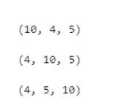

### Conclusion

From the above article we saw basic syntax of NumPy stack functions. We also saw how we can implement them in python with different examples. From this article we also saw how we can handle NumPy stack functions in python.

<https://www.educba.com/numpy-vstack/>

## Definition of NumPy vstack

In python, numpy.vstack()is a function that helps to stack the input array sequence vertically in order to create a single array. The arrangement will be in row-wise. It is similar to concatenation along the axis 1 after 1-Dimensional arrays of (N) shape have been reshaped to the format (1,N). This function can be used to create arrays with up to 3- dimensions. Let us see more of this function in the following sessions.

**Syntax:**

Below is the syntax of numpyvstack function.

**numpy.vstack(tup)**

**Parameters:**

* **tup:**It is a sequence of n arrays. This tuple consists of arrays that have to be stacked. Arrays should have the shape same along all but the axis 1.
* **Return Value of This Function:**Return value will be stacked in an array. That is an array that is stacked of the input arrays.

### How does vstack Function Work in NumPy?

Using the vstack() function, items of arrays are arranged vertically. Suppose array 1 has elements [22, 32, 43] and array 2 has elements [546, 55, 556]. The two arrays can be arranged vertically using the function vstack(( arr1 , arr2 ) ) where arr1 and arr2 are array 1 and array 2 respectively.

### Examples of NumPy vstack

Let us see some sample programs on the vstack() function using python.

#### Example #1

Python program to arrange two arrays vertically using vstack.

**Code:**

**import numpy as np  
arr1 = np.array( [ 22 , 32 , 43 ] )  
print ("array 1 is : \n", arr1)  
arr2 = np.array( [ 546 , 55 , 556 ] )  
print ("array 2 is  : \n", arr2)  
arrout = np.vstack( ( arr1 , arr2 ) )  
print ( "arrays arranged vertically :\n ", arrout)**

**Output:**

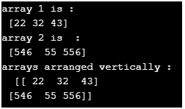

In this program, two arrays are created and they are arranged vertically using the vstack function.

#### Example #2

Python program to arrange two arrays with multiple elements vertically using vstack.

**Code:**

**import numpy as np  
arr1 = np.array( [ [ 22 , 32 , 43 ] , [11 , 52 , 67 ] ] )  
print ("array 1 is : \n", arr1)  
arr2 = np.array( [ [ 546 , 55 , 556 ] , [131 , 252 , 167 ] ] )  
print ("array 2 is  : \n", arr2)  
arrout = np.vstack( ( arr1 , arr2 ) )  
print ( "arrays arranged vertically :\n ", arrout)**

**Output:**

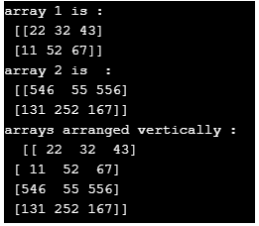

Unlike program 1,in this program, two arrays are created with different elements and they are arranged vertically using the vstack function.

#### Example #3

Python program to arrange two arrays given as input by the user where array 1 is input and array 2 is already in the program.

**Code:**

**import numpy as np  
# create an empty list  
li = [] n = int(input("Enter the no. of elements to be given as input: "))  
for it in range(0, n):  
items = int(input())  
li.append(items)  
print ("array 1 is : \n", li)  
arr2 = np.array( [ 546 , 55 , 556 ] )  
print ("array 2 is  : \n", arr2)  
# arranging two arrays vertically  
arrout = np.vstack( ( li , arr2 ) )  
print ( "arrays arranged vertically :\n ", arrout)**

**Output:**

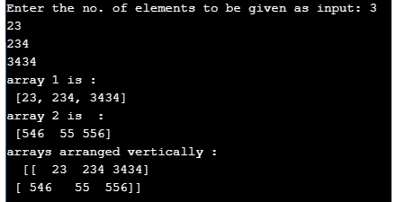

In this program, the first array is given as input by the user, and the second array is already available in the program. Then, it is arranged vertically using the function vstack().

#### Example #4

Python program to arrange two arrays given as input by the user.

**Code:**

**import numpy as np  
# array 1 creation  
li = [] n = int(input("Enter the no. of elements to be given as input to array 1: "))  
for it in range(0, n):  
items = int(input())  
li.append(items)  
print ("array 1 is : \n", li)  
li2 = [] # no: of elements to be given as input  
nn = int(input("Enter the no. of elements to be given as input to array 2: "))  
# iterate the loop till the given range  
for itr in range(0, nn):  
itemss = int(input())  
li2.append(itemss)  
print ("array 2 is  : \n", li2)  
# arranging two arrays vertically  
arrout = np.vstack( ( li , li2 ) )  
print ( "arrays arranged vertically :\n ", arrout)**

**Output:**

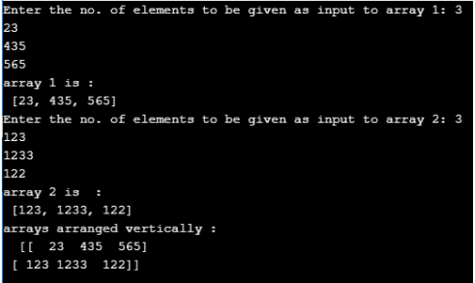

In this program, both the first array and second array is given as input by the user. Then, it is arranged vertically using the function vstack().

#### Example #5

Python program to arrange multiple arrays given as input by the user.

**Code:**

**import numpy as np  
# array 1 creation  
# create an empty list  
li = [] # no: of elements to be given as input  
n = int(input("Enter the no. of elements to be given as input to array 1: "))  
# iterate the loop till the given range  
for it in range(0, n):  
items = int(input())  
li.append(items)  
print ("array 1 is : \n", li)  
# create an empty list  
li2 = [] # no: of elements to be given as input  
nn = int(input("Enter the no. of elements to be given as input to array 2: "))  
# iterate the loop till the given range  
for itr in range(0, nn):  
itemss = int(input())  
li2.append(itemss)  
print ("array 2 is  : \n", li2)  
# create an empty list  
li3 = [] # no: of elements to be given as input  
no = int(input("Enter the no. of elements to be given as input to array 3: "))  
# iterate the loop till the given range  
for itrt in range(0, no):  
itemms = int(input())  
li3.append(itemms)  
print ("array 3 is  : \n", li3)  
# arranging two arrays vertically  
arrout = np.vstack( ( li , li2, li3 ) )  
print ( "arrays arranged vertically :\n ", arrout)**

**Output:**

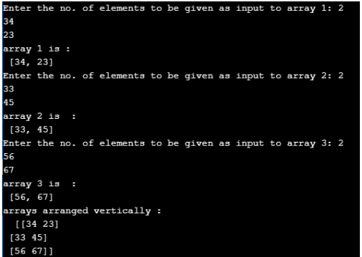

In this program, multiple arrays are given as input by the user. Then, it is arranged vertically using the function vstack().

### Conclusion

numpy.vstack()is a function that helps to stack the input array sequence vertically in order to create a single array. In this article, different aspects such as syntax, working, and examples of the vstack function is explained in detail.

<https://www.educba.com/numpy-hstack/>

## Introduction to NumPy hstack

Whenever there we have more than one arrays and we wish to display the values present in those arrays together sequentially or stack them horizontally one after the other in a single array, we make use of a function called hstack function in NumPy.This hstack function in NumPy returns a horizontally stacked array from more than one arrays which are used as the input to the hstack function and this hstack function takes a tuple as an argument which represents the input arrays those are to be stacked resulting in a single array and the input arrays passed to this hstack function in NumPy must be of the similar shape.

**Syntax:**

**numpy.hstack(tuple)**

where tuple represents the input arrays those are to stacked resulting in a single array.

### Working of NumPy hstack

Working of NumPy hstack is as follows:

* Whenever there we have more than one arrays and we wish to display the values present in those arrays together sequentially or stack them horizontally one after the other in a single array, we make use of a function called hstack in NumPy.
* The hstack function in NumPy returns a horizontally stacked array from more than one arrays which are used as the input to the hstack function.
* The hstack function takes a tuple as an arguments which represents the input arrays that are to be stacked resulting in a single array.
* The input arrays passed to this hstack function in NumPy must be of a similar shape.

### Examples of NumPy hstack

Following are the examples as shown below

#### Example #1

Python program to demonstrate NumPyhstack function to horizontally stack the given two input arrays into a single array and display the resulting array as the output on the screen:

**Code:**

**#importing the package numpy  
import numpy as num  
#Creating an array by making use of array function in NumPy and storing it in a variable called firstarray  
firstarray = num.array([[1,2,3],[4,5,6]])  
#Displaying the elements of firstarray followed by one line space by making use of \n  
print 'The elements of the first array are:'  
print firstarray  
print '\n'  
#Creating an array by making use of array function in NumPy and storing it in a variable called secondarray  
secondarray = num.array([[7,8,9],[10,11,12]])  
#displaying the elements of second array followed by one line space by making use of \n  
print 'The elements of the second array are:'  
print secondarray  
print '\n'  
print 'The elements of the array after stacking the given two arrays horizontally by making use of hstack function are:'  
#creating an array by horizontally stacking the elements of firstarray and secondarray by making use of hstack function and storing it in a variable called resultingarray  
resultingarray = num.hstack((firstarray,secondarray))  
#displaying the elements of the resultingarray followed by one line space by making use of \n  
print resultingarray  
print '\n'**

**Output:**

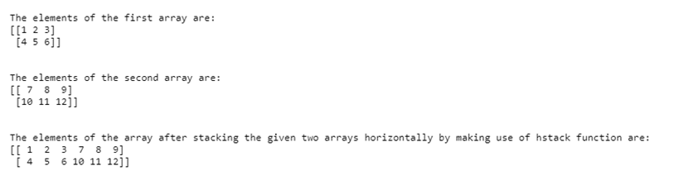

In the above program, a package called NumPy is imported to enable us to make use of hstack function. Then an array is created by making use of the array function in NumPy and storing it in a variable called firstarray. Then the elements of the firstarray are displayed on the screen. Then another array is created by making use of array function in NumPy and storing it in a variable called secondarray. Then the elements of the secondarray are displayed on the screen. Then an array is created by horizontally stacking the elements of firstarray and secondarray by making use of hstack function and storing it in a variable called resultingarray. Then the elements of the resultingarray is displayed on the screen.

#### Example #2

Python program to demonstrate NumPyhstack function to horizontally stack the given two input arrays into a single array and display the resulting array as the output on the screen:

**Code:**

**#importing the package numpy  
import numpy as num  
#Creating an array by making use of array function in NumPy and storing it in a variable called firstarray  
firstarray = num.array([[1,2,3,13],[4,5,6,14]])  
#Displaying the elements of firstarray followed by one line space by making use of \n  
print 'The elements of the first array are:'  
print firstarray  
print '\n'  
#Creating an array by making use of array function in NumPy and storing it in a variable called secondarray  
secondarray = num.array([[7,8,9,15],[10,11,12,16]])  
#displaying the elements of second array followed by one line space by making use of \n  
print 'The elements of the second array are:'  
print secondarray  
print '\n'  
print 'The elements of the array after stacking the given two arrays horizontally by making use of hstack function are:'  
#creating an array by horizontally stacking the elements of firstarray and secondarray by making use of hstack function and storing it in a variable called resultingarray  
resultingarray = num.hstack((firstarray,secondarray))  
#displaying the elements of the resultingarray followed by one line space by making use of \n  
print resultingarray  
print '\n'**

**Output:**

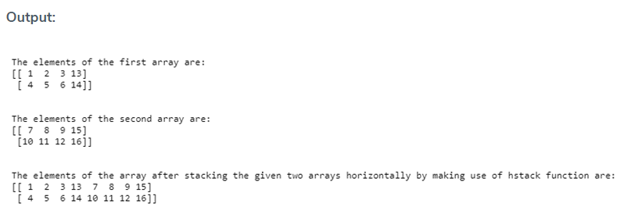

In the above program, a package called NumPy is imported to enable us to make use of hstack function. Then an array is created by making use of array function in NumPy and storing it in a variable called firstarray. Then the elements of the firstarray are displayed on the screen. Then another array is created by making use of array function in NumPy and storing it in a variable called secondarray. Then the elements of the secondarray are displayed on the screen. Then an array is created by horizontally stacking the elements of firstarray and secondarray by making use of hstack function and storing it in a variable called resultingarray. Then the elements of the resultingarray is displayed on the screen.

### Conclusion

In this tutorial, we understand the concept of NumPyhstack function in Python through definition, the syntax of NumPy hstack function, and the working of NumPyhstack function in Python through programming examples and their outputs.

<https://www.educba.com/numpy-sum/>

## Introduction to NumPy sum

In this article, NumPy sum in Python is defined as a Python library which is specially designed for working on the multi-dimensional array and matrices and NumPy sum() is a function provided by the NumPy Python library that is mainly used to calculate the total sum of the elements present in the given array or the total sum of elements in each row and sum of elements in each column if it in the given matrices or multi-dimensional array and the value returned by the sum() function results in the form of an array object.

### Working of NumPy sum() Function in Python with Examples

In this article, we will see the NumPy Python library’s function sum(). In Python, the NumPy sum() function is used for computing the summation of the total number of items present in the given array which means the elements are taken within the NumPy array as an array object and sums up the items of a given array.

**Syntax and parameters taken by sum() function of NumPy in Python:**

**Numpy.sum(in_array, axis, dtype, out, keepdims, initial)**

**Parameters:**

* **in_array:** This parameter is to specify the array name of the input array so that the elements are used to calculate the sum.
* **axis:** This value can be either none or int or tuple of ints, where this parameter is used for defining the axis for which the sum needs to be computed and the default value specified is none where it will compute the sum of all the elements of the given array.
* **dtype:** This parameter is used for defining the type of accumulator and to specify the returned data type of the output.
* **out:** This parameter is used to specify another extra array to store the result or output and the size of this array must be the same as the size of the input array.
* **keepdims:** This specifies the Boolean value where it is set to true where if the axes are reduced are left in the output result having the dimensions as size one.
* **initial:**It is used to specify the starting or initial value for calculating the sum.

Now lets see the demonstration of how to use the NumPy sum() function in the python program:

#### Example #1

**Code:**

**import numpy as np  
print("Program to demonstrate numpy sum() function: ")  
print("\n")  
in_arr = np.array([0,1,3,5,34,10])  
print("The given array is as follows:")  
print(in_arr)  
print("\n")  
print("The sum of the given array is:")  
sum_res = np.sum(in_arr)  
print(sum_res)**

**Output:**

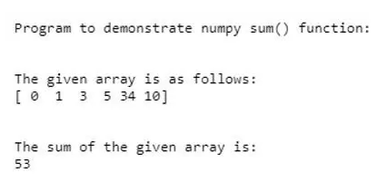

In the above program, we can see we have imported NumPy module and then we have created an array using NumPy object np and then using sum() function and passing this given array as input array to the function and the returns the sum of the element values in the given input array. Usually, the sum of the empty array is a neutral value that is 0. In the above we saw how to add elements of the one-dimensional array.

#### Example #2

Let us see how to add the elements of the two-dimensional array in the below example along with different other parameters of the sum() function such as axis, data type.

**Code:**

**import numpy as np  
print("Program to demonstrate numpy sum() function for 2D array: ")  
print("\n")  
in_arr = np.array( [[8,1,9], [6,4,1]])  
print("The given input 2-D array is as follows:")  
print(in_arr)  
print("\n")  
res_arr_1 = np.sum(in_arr, axis=1, dtype=float)  
print("Sum of elements at axis 1 row wise with the specified data type is")  
print(res_arr_1)  
print("\n")  
res_arr_2 = np.sum(in_arr, axis=0, dtype=int)  
print("Sum of elements at axis 0 column wise with the specified data type is")  
print(res_arr_2)  
print("\n")  
res = np.sum(in_arr, axis=1, keepdims =  True)  
print("Keeping the dimensional of the output array same as input array")  
print(res)  
print("\n")  
print("Sum of the total elements in the 2-D array is as follows:")  
tot_res = np.sum(in_arr)  
print(tot_res)**

**Output:**

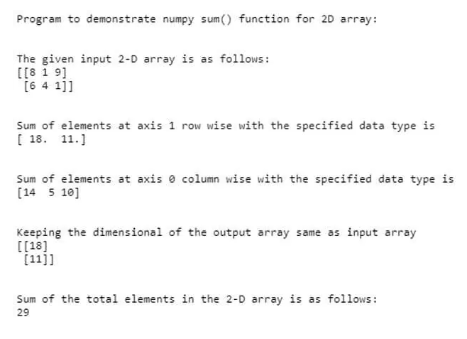

In the above program, we can see we are declaring a 2-D array using the NumPy object np. In this, we have two rows and 3 columns where we have specified axis value as 1 which means we are calculating the sum of the elements row-wise and data type as the float is specified where it gives the result in the floating value of the result. If we specify the axis value 0 then it will calculate the summation of elements in column-wise having data type as an integer value and this can also be seen in the above screenshot. Therefore, we can see in the screenshot where the sum of the elements of the first row is 18 and second row is 11 and the result is printed in the form of another array row-wise and if the axis is 0 then result will be of the form of [14, 5, 10] in the floating value. We can also see in the output the sum of the total elements in the given array as 29 which is the total value of elements added together.

In the above section, we saw how to calculate the sum of elements row-wise and column-wise using the axis parameter. From the above example, we can notice that the elements will be reduced to lesser dimensions after calculating the sum() by the axis specified. In general, when we use the axis parameter then by default the function sum() collapses or reduces the input array dimensions ad results in the lesser or lower dimensional array. Suppose if we don’t want the resulting array dimension to reduce to the lesser dimension of the input array then we need to use the keepdims parameter in the sum() function to keep the dimension of the output array the same as the input array. In the above example we can see in line 20 we have specified keepdims as “True” so only it displays the output array also as in a 2-D array.

### Conclusion

In this article, we conclude that the NumPy module in Python is a module used in working in the data science field for working on a multidimensional array. In this article, we also saw how to calculate the sum of the elements in the given array. In this, we saw examples of a one-dimensional array, two-dimensional array, and also saw the use of sum() function parameters and how it can be used.

<https://www.educba.com/numpy-cumsum/>

## Introduction to NumPy cumsum

Whenever we want to calculate the cumulative sum of the elements present in a given array, as in the second elements in the array is the sum of first element and second element, the third element in the array is the sum of first element, second element and third element and so on. We make use of a function called cumsum in numpy which takes four parameters namely arrayname, axis, datatype and output where arrayname represents the name of the array whose cumulative sum of the elements must be calculated, axis represents the axis along which the cumulative sum of the elements must be calculated and if this parameter is not defined, the given array is flattened and then the cumulative sum of the elements will be calculated, datatype is the datatype of the   elements in the output array represented by output which  is optional.

**Syntax:**

**numpy.cumsum(arrayname, axis, datatype, output)**

Where,

* arrayname is the name of the array whose cumulative sum of the elements must be found.
* axis represents the axis along which the cumulative sum of the elements must be calculated and if this parameter is not defined, the given array is flattened and then the cumulative sum of the elements will be calculated.
* datatype is the datatype of the values resulting in the output array.
* output represents the output array which stores the cumulative sum of the elements from the given input array represented by arrayname and this parameter is optional.

### Working of NumPy cumsum Function

* Whenever we want to calculate the cumulative sum of the elements present in a given array, as in the second elements in the array is the sum of first element and second element, the third element in the array is the sum of first element, second element and third element and so on, we make use of a function called cumsum in numpy.
* Axis represents the axis along which the cumulative sum of the elements must be calculated and if this parameter is not defined, the given array is flattened and then the cumulative sum of the elements will be calculated.
* arrayname represents the name of the array whose cumulative sum of the elements must be calculated.
* datatype is the datatype of the values resulting in the output array.
* Output represents the output array which stores the cumulative sum of the elements from the given input array represented by arrayname and this parameter is optional.

### Examples of NumPy cumsum

Given below are the examples :

#### Example #1

Python program to demonstrate NumPy cumsum function to create an array using array function in numpy and then using cumsum function to find the cumulative sum of the elements of the given array and represent it in an output array.

**Code:**

**#importing the package numpy  
import numpy as nump  
#Creating an array by making use of array function in NumPy and storing it in a variable called initialarray  
initialarray = nump.array([[8,9],[2,3]])  
#Displaying the elements of intialarray followed by one line space by making use of \n  
print 'The elements of the given array are:'  
print initialarray  
print '\n'  
#using cumsum function of NumPy and passing the created array as the parameter to that function to find the cumulative sum of all the elements in the array and store it in a variable called cumsumarray  
cumsumarray = nump.cumsum(initialarray)  
#Displaying the array consisting of cumulative sum of all the elements in the array  
print 'The array consisting of cumulative sum of all the elements of the given array using cumsum function is as follows:'  
print cumsumarray**

**Output:**

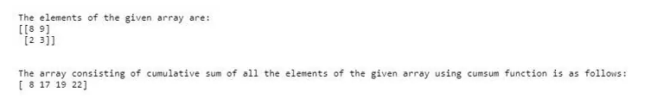

In the above program, a package called numpy is imported which allows us to make use of functions called array and cumsum. Then an array called initialarray is created by making use of array function. Then the elements of initialarray are displayed on the screen. Then cumsum function is used to find the cumulative sum of all the elements in initialarray and stored in a variable called cumsumarray. Then the cumsumarray consisting of cumulative sum of all the elements is displayed on the screen.

#### Example #2

Python program to demonstrate NumPy cumsum function to create an array using array function in numpy and then using cumsum function to find the cumulative sum of the elements of the given array along the axis=0 and along the axis=1 and represent it in an output array.

**Code:**

**#importing the package numpy  
import numpy as nump  
#Creating an array by making use of array function in NumPy and storing it in a variable called initialarray  
initialarray = nump.array([[8,9],[2,3]])  
#Displaying the elements of intialarray followed by one line space by making use of \n  
print 'The elements of the given array are:'  
print initialarray  
print '\n'  
#using cumsum function of NumPy and passing the created array as the parameter to that function to find the cumulative sum of all the elements in the array and store it in a variable called cumsumarray  
cumsumarrayalongaxis0 = nump.cumsum(initialarray, axis=0)  
#Displaying the array consisting of cumulative sum of all the elements along the axis=0 in the array  
print 'The array consisting of cumulative sum of all the elements along the axis=0 of the given array using cumsum function is as follows:'  
print cumsumarrayalongaxis0  
cumsumarrayalongaxis1 = nump.cumsum(initialarray, axis=1)  
#Displaying the array consisting of cumulative sum of all the elements along the axis=1 in the array  
print 'The array consisting of cumulative sum of all the elements along the axis=1 of the given array using cumsum function is as follows:'  
print cumsumarrayalongaxis1**

**Output:**

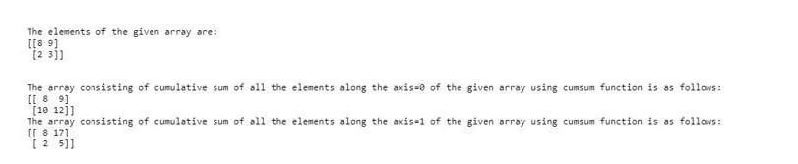

In the above program, a package called numpy is imported which allows us to make use of functions called array and cumsum. Then an array called initialarray is created by making use of array function. Then the elements of initialarray are displayed on the screen. Then cumsum function along with the axis specified is used to find the cumulative sum of all the elements in initialarray and stored in a variable called cumsumarray. Then the cumsumarray consisting of cumulative sum of all the elements along the axis=0 and along the axis=1 is displayed on the screen.

<https://www.educba.com/numpy-max/>

## Introduction to NumPy max

Whenever we wish to find the maximum value of all the elements present in the array created using NumPy function, we are going to make use of another NumPy function called max function and this max function returns the maximum value of all the elements present in the array and the name of the array consisting of all the elements stored in it and whose maximum value must be found is passed as a parameter to the max function and max function in NumPy is a built in function in Python to easily find the maximum value of the elements present in the given array.

**Syntax:**

**maximum_value = numpy.max(arrayname)**

**Parameter –**

* arrayname: It is name of the array from which the maximum value of all the elements must be found.
* maximum_value: Maximum value of all the elements in the array found by using the max function in NumPy and returned by the max function.

Another syntax is:

**NumPy.max( array, axis, out, keepdims )**

**Parameters –**

* **array –** This is not an optional parameter, which specifies the array whose maximum value is to find and return.
* **axis –** This is an optional parameter, which specifies the axis on which along which to calculate the max value.
* **out –** This is an optional parameter, which specifies the output array where we can store the output of the NumPy.max() function.
* **keepdims –** This is an optional parameter, which specifies to keeps the dimensions of an output array the same as an input array.
* **Return value –** The return value of this function is the max value from the NumPy array.

### Working of NumPy max

Working of NumPy max is as follows:

* Whenever we wish to find the maximum value of all the elements present in the array created using function, we are going to make use of another NumPy function called max function.
* The max function in NumPy returns the maximum value of all the elements present in the array.
* The name of the array consisting of all the elements stored in it and whose maximum value must be found is passed as a parameter to the max function.
* The max function is a built in function in Python to easily find the maximum value of the elements present in the given array.

### Examples of NumPy max

Following are the examples given below:

#### Example #1

Python program to demonstrate NumPymax functionto display the maximum value of all the elements stored in the array created using array function.

**Code:**

**#importing the package numpy  
import numpy as num1  
#Creating an array by making use of array function in NumPy and storing it in a variable called namarray  
namarray = num1.array([[2,3],[4,5]])  
#Displaying the elements of namarray followed by one line space by making use of \n  
print 'The elements of the given array are:'  
print namarray  
print '\n'  
#using max function of NumPy and passing the created array as the parameter to that function to find the maximum value and store it in a variable called maxval  
maxval = num1.max(namarray)  
#Displaying the maximum value stored in maxval variable  
print 'The maximum value of all the elements of the array is:'  
print maxval**

**Output:**

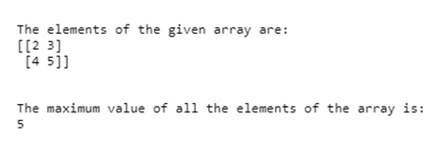

In the above program, apackage called NumPy is imported to enable us to make use of array and max function. Then an array is created by making use of array function and storing it in a variable called namarray. Then the elements of the namarray are displayed on the screen. Then by making use of max function of NumPy and passing the created array as the parameter to that function to find the maximum value and and the value is stored in a variable called maxval. Then displaying the maximum value stored in maxval variable as the output on the screen.

#### Example #2

Python program to demonstrate NumPy max function to display the maximum value of all the elements stored in the array created using array function in Numpy:

**Code:**

**#importing the package numpy  
import numpy as num1  
#Creating an array by making use of array function in NumPy and storing it in a variable called namarray  
namarray = num1.array([[0.3,0.7, 0.2],[0.4,0.5, 0.8]])  
#Displaying the elements of namarray followed by one line space by making use of \n  
print 'The elements of the given array are:'  
print namarray  
print '\n'  
#using max function of NumPy and passing the created array as the parameter to that function to find the maximum value and store it in a variable called maxval  
maxval = num1.max(namarray)  
#Displaying the maximum value stored in maxval variable  
print 'The maximum value of all the elements of the array is:'  
print maxval**

**Output:**

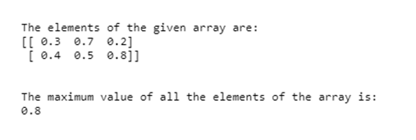

In the above program, apackage called NumPy is imported to enable us to make use of array and max function. Then an array is created by making use of array function in NumPyand storing it in a variable called namarray. Then the elements of the namarray are displayed on the screen. Then by making use of max function and passing the created array as the parameter to that function to find the maximum value and and the value is stored in a variable called maxval. Then displaying the maximum value stored in maxval variable as the output on the screen.

#### Example #3

Python program to demonstrate NumPy max function to display the maximum value of all the elements stored in the array created using array function.

**Code:**

**#importing the package numpy  
import numpy as num1  
#Creating an array by making use of array function in NumPy and storing it in a variable called namarray  
namarray = num1.array([[0.3556, 0.3500],[0.3554,0.3551]])  
#Displaying the elements of namarray followed by one line space by making use of \n  
print 'The elements of the given array are:'  
print namarray  
print '\n'  
#using max function of NumPy and passing the created array as the parameter to that function to find the maximum value and store it in a variable called maxval  
maxval = num1.max(namarray)  
#Displaying the maximum value stored in maxval variable  
print 'The maximum value of all the elements of the array is:'  
print maxval**

**Output:**

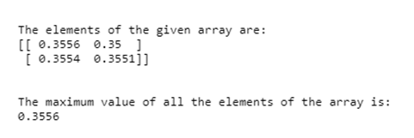

In the above program, a package called NumPy is imported to enable us to make use of array and max function. Then an array is created by making use of the array function in NumPy and storing it in a variable called namarray. Then the elements of the namarray are displayed on the screen. Then by making use of the max function and passing the created array as the parameter to that function to find the maximum value and the value is stored in a variable called maxval. Then displaying the maximum value stored in maxval variable as the output on the screen.

#### Example #4

Example of max() function to find max value in the 1-D array –

**Code:**

**# import numpy package as np  
import numpy as np  
# creating 1d number array  
array = np.array([ 10, 20, 30, 35, 40, 50, 60, 37 ])  
print("The number array is : ", array )  
max_value = np.max( array )  
print( "The max value in an array is : ", max_value )**

**Output:**

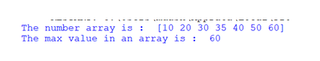

As in the above program, the max() function is used to find the max value from the array. So the max() function returns 60 which is the maximum number in an array, as we can see in the above output.

#### Example #5

Example of max () function to find max value in the 2-D array with axis and keepdims –

**Code:**

**# import numpy package as np  
import numpy as np  
# creating 2d number array  
array = np.array([ [11, 89, 76], [40, 55, 23], [76, 56, 60] ])  
print("The number array is : ")  
print(array)  
max_value = np.max( array )  
print( "The max value in an array is : ", max_value )  
# calculate max along column  
max_value = np.max( array, axis=0, keepdims = True )  
print( "The max value with aix = 0 and keepdims = True in an array is : ", max_value )  
# calculate max along row  
max_value = np.max( array, axis=1, keepdims = False )  
print( "The max value with aix = 1 and keepdims = False in an array is : ", max_value )**

**Output:**

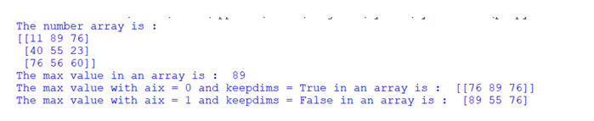

As in the above program, the max() function is used to find the max value from the 2D array. The max value is found in three ways, the first way where the axis and keepdims parameters are not passed and the max value return is 89, second way where the axis and keepdims parameters are passed as axis=0, keepdims=True(keeps the output array dimension same as input dimension array) and the max values return are [[76, 89, 76]], the third way where the axis and keepdims parameters are passed as axis=1 and keepdims=False(not keeps the output array dimension same as input dimension array) and the max values return are [89, 55, 76], as we can see in the above output.

<https://www.educba.com/numpy-squeeze/>

## Introduction to NumPy squeeze

Whenever we want to remove one dimension from the given multi-dimensional array, we make use of a function called squeeze() in NumPy.For example, if we want to change the shape of three dimensional array to two-dimensional array, we make use of the squeeze() function in NumPy which takes the two parameters arrayname and axis. Where arrayname represents the array whose dimensions are to be changed and the axis represents the shape of single-dimensional entries subset and its value cannot be more than one and if it is more than one, in any case, an error is thrown and the squeeze() function returns the input array with the subset of the dimension having a length equal to one removed from the array.

**Syntax:**

**numpy.squeeze(arrayname, axis=None)**

where arrayname is the name of the array represents the array whose dimensions are to change an axis represents the shape of single dimensional entries subset and its value cannot be more than one and if it is more than one, in any case, an error is thrown.

### Working of NumPy squeeze

Working of NumPy squeeze is as follows:

* Whenever we want to remove one dimension from the given multi-dimensional array, we make use of a function called squeeze() in NumPy, for example, if we want to change the shape of three dimensional array to two dimensional array, we make use of squeeze() function in NumPy.
* The squeeze() function in NumPy takes the two parameters arrayname and axis.
* arrayname represents the array whose dimensions are to be changed.
* axis represents the shape of a single dimensional entries subset and its value cannot be more than one and if it is more than one in any case, an error is thrown.
* The squeeze() function returns the input array with the subset of the dimension having a length equal to one removed from the array.

### Examples of NumPy squeeze

Following are the examples as given below:

#### Example #1

Python program to demonstrate NumPysqueeze function to create a three dimensional array and change the shape of the created three dimensional array to a two dimensional array:

**Code:**

**#importing the package called numpy to enable us to use array function, shape function and squeeze function  
import numpy as nump  
#Creating a three dimensional array by making use of array function in NumPy and storing it in a variable called namearray  
namearray = nump.array([[[ 0, 9, 8, 7],[ 6, 5, 4, 3],[ 2, 1, 0, 9]]])  
#Displaying the elements of namearray followed by one line space by making use of \n  
print 'The elements of the given array are:'  
print namearray  
print '\n'  
#displaying the shape of the newly created array using shape function  
print 'The shape of the given array is:'  
print namearray.shape  
print '\n'  
#using squeeze function in NumPy to squeeze the newly created three dimensional array to a two dimensional array  
squeezedarray = nump.squeeze(namearray,axis=0)  
#displaying the elements of the squeezed array  
print 'The elements of the squeezed array are:'  
print squeezedarray  
print '\n'  
#Displaying the shape of the squeezed array using shape function  
print 'The shape of the squeezed array is:'  
print squeezedarray.shape**

**Output:**

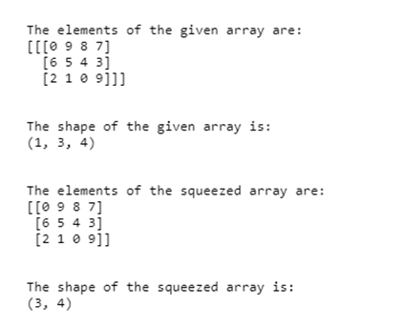

In the above program, a package called numpy is imported which allows us to make use of array function, shape function and squeeze function in NumPy. Then a three dimensional array is created by making use of the array function in NumPy and storing it in a variable called namearray. Then the elements of the array namearray are displayed followed by one line space by making use of \n. Then the shape of the newly created array is displayed using shape function. Then squeeze function in NumPyis used to squeeze the newly created three dimensional array to a two dimensional array. Then the elements of the squeezed array are displayed. Then the changed shape of the squeezed array is displayed using shape function.

#### Example #2

Python program to demonstrate NumPy squeeze function to create a three dimensional array and change the shape of the created three dimensional array to a two dimensional array:

**Code:**

**#importing the package called numpy to enable us to use array function, shape function and squeeze function  
import numpy as nump  
#Creating a three dimensional array by making use of array function in NumPy and storing it in a variable called namearray  
namearray = nump.array ([[[ 5, 4, 3, 2],[ 1, 6, 7, 8],[ 9, 0, 5, 4]]])  
#Displaying the elements of namearray followed by one line space by making use of \n  
print 'The elements of the given array are:'  
print namearray  
print '\n'  
#displaying the shape of the newly created array using shape function  
print 'The shape of the given array is:'  
print namearray.shape  
print '\n'  
#using squeeze function in NumPy to squeeze the newly created three dimensional array to a two dimensional array  
squeezedarray = nump.squeeze(namearray,axis=0)  
#displaying the elements of the squeezed array  
print 'The elements of the squeezed array are:'  
print squeezedarray  
print '\n'  
#Displaying the shape of the squeezed array using shape function  
print 'The shape of the squeezed array is:'  
print squeezedarray.shape**

**Output:**

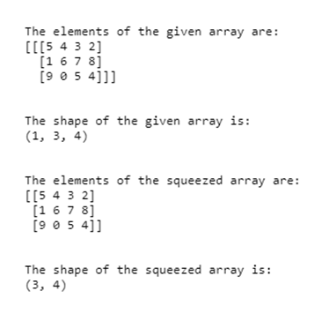

In the above program, a package called numpy is imported which allows us to make use of array function, shape function, and squeeze function in NumPy. Then a three dimensional array is created by making use of the array function in NumPy and storing it in a variable called namearray. Then the elements of the array namearray is displayed followed by one line space by making use of \n. Then the shape of the newly created array is displayed using shape function. Then squeeze function in NumPyis used to squeeze the newly created three dimensional array to a two dimensional array. Then the elements of the squeezed array are displayed. Then the changed shape of the squeezed array is displayed using shape function.

<https://www.educba.com/numpy-median/>

## Introduction to NumPy median

NumPy median function is a function in a [python programming language](https://www.educba.com/what-is-python/)which is used for computation of median values in the defined NumPy Array. NumPy function works well with the array like objects in Python. These Arrays can be combined with other arrays or can be restructured accordingly. NumPy is a module used for data manipulation in Python programming language. It provides user an ability to work with large set of numeric data like arrays in Python. Creation of Array and storing of numeric data with respect to NumPy median is called as NumPy Array.

**Syntax:**

The syntax flow is represented as:

**np.median( a= , axis= , keepdims= )**

* **np:** It represents the fact the NumPy modules are being imported.
* **np.median:** This represents the fact that the NumPy median function is called once it is imported with NumPy median.

NumPy median function passes these parameters which includes:

* **a:** This parameter represents and specifies the data that needs to be operate on.
* **axis:** This parameter represents the axis along which the median function will revolve around and will get computed.
* **keepdims:** This parameter is used for representing the dimensions of the output same as the input provided by the NumPy median.

### How NumPy median Function works?

Every function is a working flow so does the NumPy median function. It is one of the most important function in python programming language. [NumPy is a very](https://www.educba.com/what-is-numpy-in-python/) useful module used in python programming language which is widely used for data manipulation. It gives user the flexibility and versatility to play around with the vast scale of array in terms of numeric data. Creation and simultaneous storing of data in arrays are the types of arrays which will be further used by it and are known as NumPy Arrays. NumPy Arrays religiously gets used by NumPy median function.

NumPy comprises of many computational tools which once combined with arrays of numeric data provides arrays of numeric data, when combined with other data provides split arrays into multiple arrays and then reshape and restructure the combined array or considered array into set of multiple arrays. If NumPy array is reshaped and restructured array is considered, then that NumPy Array will be considered as arrays with new set of rows and columns. Thus, function gets very well with the NumPy Array.

Let’s peek into the working where NumPy array thoroughly contributes to the NumPy median function.

* NumPy median function starts working as soon as the NumPy module gets imported from the standard library and then the NumPy module gets called easily wherever is the requirement.
* It is the function which is used for computing the median value in the NumPy array.
* NumPy median function in the NumPy array works very well with the array-like objects in Python.
* It depends on the requirement and user how they want to import this NumPy function to make it little easier to understand we have used np referring NumPy for median to work well with the function at the time of call.
* The NumPy function involves many parameters which are like mandatory to get passed without them the function will start behaving in an abnormal behavior thus some parameters are considered as mandatory.
* Syntax defining the parameter involves four parameters namely a, axis, keepdims, out. Without these parameters functioning won’t be smooth.
* A is one of the most important and mandatory argument passed in the NumPy median function which is used for specifying the type of data that a user need to be operated on. This is the data on top of which computation and manipulation will happen.
* Another argument to be considered is Axis which is again an optional argument and is used for maintaining and keeping a control along the axis using this function the median value will get computed for NumPy array. This field appears to be confusing for many new users, so coder tries to keep it as an option and make use of it in terms of complex requirement and usage.
* The out parameter enables user to specify some different output array thus is an optional parameter.
* Keepdims is an optional argument which is used to enable the dimensions of the output parameter same as the input parameter along with the axis.
* Once import and parameter is done in the function then it is needed to compute the median using one dimensional array.
* Reshaping and restructuring of data from one dimensional array help in computing using 2D array.
* Computation of the numeric data can also be performed using the axis which is used for determining values with respect to median functions.
* It is also used for making data compressed and easy for manipulation.

### Examples of NumPy median

Given below are the examples mentioned:

#### Example #1

This program demonstrates the implementation of NumPy.median() function where the first NumPy array is the flattened array median and then all the median along the axis with value 0 and value 1 respectively.

**Code:**

**import numpy as np  
m_a = [[3, 2, 5], [1, 6, 4],[5, 0, 9]] print("\n With_median, axis_val = No: ", np.median(m_a))  
print("\n With_median, axis_val = 0 ", np.median(m_a, axis = 0))  
print("\n With_median, axis_val = 2 ", np.median(m_a, axis = 1))**

**Output:**

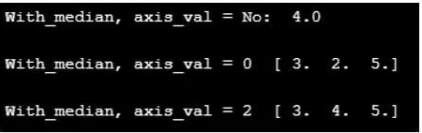

#### Example #2

This program demonstrates the function which is used for creating 1D arrays by comparing with the other array as shown in the output.

**Code:**

**import numpy as np  
z_a = [5, 15, 30, 55, 24, 36, 24, 17, 12] print("z_a : ", z_a)  
print("median of z_a : ", np.median(z_a))  
z_a2 = [5,16,20,19,20] print("z_a2 : ", z_a2)  
print("median of z_a2 : ", np.median(z_a2))**

**Output:**

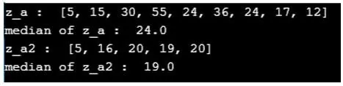

#### Example #3

This program illustrates the function which is used for counting the number of balls in the given NumPy array and then counting the number of balls by calculating the median as shown in the given output.

**Code:**

**import numpy  
balls = [12,18,20,65,100,86,59,13,10,88,23,63,79] x_count_balls = numpy.median(balls)  
print(x_count_balls)**

**Output:**

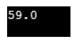

### Conclusion

NumPy median function is a very important function with NumPy module which gives user the flexibility and versatility to manipulate and play around with the huge values of Arrays. Even creation and restructuring of Arrays is also possible using it and its associated functionalities. It simplified the complexity present to play around with data structure naming array.

<https://www.educba.com/numpy-round/>

## Definition of NumPy Round

A Random Round is a function that works mathematically and performs a rounding off operation when we provide an input array of different float or decimal elements that we wanted to round the digits off to our desired number of positions and numpy round function by default do not need a decimal position argument by default it rounds off and we option if we wanted to declare the number of decimal positions we wanted to round.

**Syntax:**

The basic syntax of the numpy round function is,

**numpy.round(array, decimals = 0, out = None)**

* numpy.round represents the mathematical rounding off function in numpy.
* array represents the input array in which we wanted to perform the round off function.
* Decimals is an optional argument if wanted to declare the number of positions we wanted to round off.
* Out is the output array as a result of rounding off.

### Examples of NumPy Round

Following are the examples as given below:

#### Example #1

Let us discuss a basic example for understanding how the numpy round function works.

**Code:**

**import numpy as np  
array1 = [0.25, 1.3, 3.5, 4.4, 5.5, 9.3] print ("Input array1 : ", array1)  
round_array1 = np.round_(array1)  
print ("Rounded values : ", round_array1)  
array2 = [.23, 1.04, 0.571] print ("Input array2 : ", array2)  
round_array2 = np.round_(array2)  
print ("Rounded values : ", round_array2)**

**Output:**

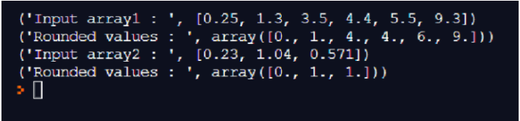

Here in the above example, we have declared two arrays, array1 & array2 as input for the numpy round function. We have printed the input arrays without rounding off and output arrays after rounding off. We can see the numpy round function on default rounds to single decimals when we give multiple digits after a decimal point. When we have 0.5 and above after the decimal point the numpy round functions rounds it to the next number in the series.

#### Example #2

In this example well discuss how we can use the decimal argument which allows us to round off to our desired values.

**Code:**

**import numpy as np  
array1 = [0.252, 1.354, 3.155, 4.345, 5.551, 9.23] print ("Input array1 : ", array1)  
round_array1 = np.round_(array1, decimals = 2)  
print ("Rounded values : ", round_array1)  
array2 = [.2356, 1.554, 0.8571] print ("Input array2 : ", array2)  
round_array2 = np.round_(array2, decimals = 3)  
print ("Rounded values : ", round_array2)**

**Output:**

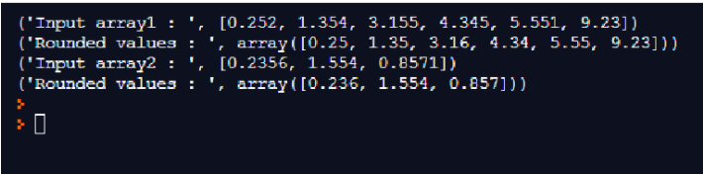

We have declared two input arrays, array1 & array2 with digits more than 2 decimal points and for the first array we have declared the decimal round off point to be 2 and for the second array we have declared the decimal round off point to be 3 so that digits should not be generated in the output outside the decimal limits we have declared and the corresponding outputs has been printed in which we can clearly see the values getting rounded off before 2nd and 3rd digits in the 1st and 2nd outputs.

#### Example #3

Let’s try with different decimal position argument and check the output for better understanding.

**Code:**

**import numpy as np  
array1 = [0.25122, 1.31454, 31.6255, 41.4345, 25.5551, 39.8723] print ("Input array1 : ", array1)  
round_array1 = np.round_(array1, decimals = 1)  
print ("Rounded values : ", round_array1)  
array2 = [112.23156, 210.53654, 90.85571] print ("Input array2 : ", array2)  
round_array2 = np.round_(array2, decimals = 2)  
print ("Rounded values : ", round_array2)**

**Output:**

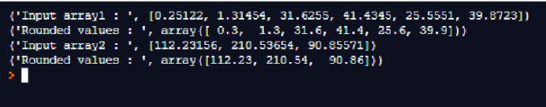

#### Example #4

Let us see in this example how the numpy round function works on integer values without decimal points and also how the decimal point argument can be used for whole numbers.

**Code:**

**import numpy as np  
array1 = [20, 10, 40, 100, 150] print ("Input array1 : ", array1)  
round_array1 = np.round_(array1, decimals = 1)  
print ("Rounded values : ", round_array1)  
array2 = [120, 110, 40, 95, 150] print ("Input array2 : ", array2)  
round_array2 = np.round_(array2, decimals = -2)  
print ("Rounded values : ", round_array2)  
array3 = [110, 140, 96, 75, 130] print ("Input array2 : ", array3)  
round_array3 = np.round_(array3, decimals = -3)  
print ("Rounded values : ", round_array3)**

**Output:**

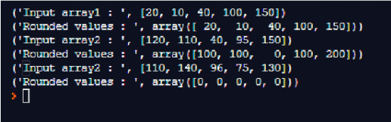

In this example, we have three input array with integer values and in the first output statement, we have declared the decimal value to be 1 since the input array contains integer elements without any decimal values the numpy round function doesn’t work. So the output array is the same as the input since there is no scope to round the whole integers. In the second output we have declared the input array similar to the 1st array with all integers values without any decimal numbers and in the numpy round function, we have declared the decimal point value is negative (-2).

This negative two denotes the rounding off of two digits in reverse order so the resultant output printed is the nearest value with negative two digits rounding off. When the input has only two digits the negative rounding off gives 0 as the output.

Similarly in the 3rd output statement, we have declared the decimal point value to be rounded off as negative 3 (-3) so the resulting output will be negative 3 digits rounding off. Since the values in the array have all 3 digit elements the output array becomes all 0.

#### Example #5

Let’s try giving different inputs and perform the negative decimal value rounding off techniques to have a clear idea of the numpy round function. Depending upon the number of digits before and after the decimal points, we need to declare the positive and negative decimal value to be rounded off to get our expected result.

**Code:**

**import numpy as np  
array1 = [0.25122, 1.31454, 31.6255, 41.4345, 25.5551, 39.8723] print ("Input array1 : ", array1)  
round_array1 = np.round_(array1, decimals = -1)  
print ("Rounded values : ", round_array1)  
array2 = [112.23156, 210.53654, 90.85571] print ("Input array2 : ", array2)  
round_array2 = np.round_(array2, decimals = -2)  
print ("Rounded values : ", round_array2)**

**Output:**

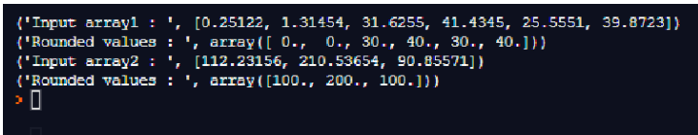

### Conclusion

In this article, we have discussed the Numpy round function in detail using various examples to get a clear understanding of numpy round function and its uses. We have also discussed how to round values using different whole integers, float value arrays. We also discussed the techniques used for declaring the decimal points that we wanted to round off this would be really helpful when working with arrays with decimal values.

<https://www.educba.com/numpy-nan/>

## Introduction to NumPy NaN

In Python, NumPy NAN stands for not a number and is defined as a substitute for declaring value which are numerical values that are missing values in an array as NumPy is used to deal with arrays in Python and this can be initialized using numpy.nan and in NumPy NaN is defined automatically to replace the value in a data frame in which the values are missing or not mentioned in such cases in the data frame we can write as NaN or nan as a placeholder to represent the missing data in a data frame which is a floating-point number.

### Working of NumPy NaN in Python with Examples

In Python, NumPy with the latest version where nan is a value only for floating arrays only which stands for not a number and is a numeric data type which is used to represent an undefined value. In Python, NumPy defines NaN as a constant value. As we know in numeric data type we can use to represent only real numbers therefore whenever we want to compute any value such as the square root of negative numbers which would result in imaginary values and therefore we can use nan to represent such values in data frames.

In NumPy uses nan to assign variables which do not have any values and are needed to be computed. But we should note that in Python NaN is not similar to infinity and we can create NaN values also using float and numpy.nan.

Examples of how to create or initialize the array with nan values in Python programs.

#### Example #1

We can create nan using float data type and can found in the math module also but only in the Python 3.5 plus version.

**Code:**

**print("The nan can be created using float data type as follows")  
ex_a1 = float("NaN")  
print("\n")  
print("The nan value will be printed as")  
print(ex_a1)  
print("\n")  
print(type(ex_a1))**

**Output:**

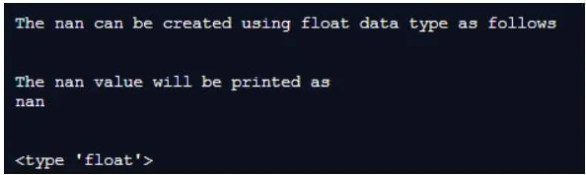

In the above program, we can see we have created a variable with float type and specified it as “nan”. We can see in the above screenshot the value of the variable is shown as “nan”. We should note that when we are specifying nan value in this float type its value is not case sensitive which means when we are specifying the nan value it can be written as “NaN” or “Nan” or “nan” or “NAN” will result in only “nan” value.

As we can also assign or create nan using math module in Python 3.5 and above version we can write the code as below:

**Code:**

**import math  
print("program to demonstrate the assigning nan values using math module")  
print("\n")  
ex_n = math.nan  
print(ex_n)  
print("\n")  
if(math.isnan(ex_n)):  
print("Yes it is nan")**

**Output:**

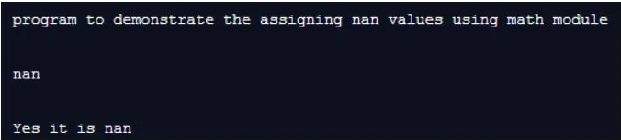

In the above program, we can see we are first importing the math module, then we have created a variable and assigning nan value using the math module and printing the value of that variable. Then we are trying to cross-check if the variable contains nan value and that can be done using math module isnan() which returns true if the value is nan, else it returns false. We should remember these functions of math is only available in Python 3.5 and above versions.

#### Example #2

Now let us see how we can use nan or assign nan in an array using the NumPy module in Python with the example below.

**Code:**

**import numpy as nn  
print("program to demonstrate numpy array to assign the item values as nan")  
print("\n")  
nn_arr = nn.array(["educba", "Python", nn.nan])  
print(nn_arr)  
print(type(nn_arr))  
print("\n")  
nn_arr1 = nn.array([45, 7, 67, nn.nan])  
print(nn_arr1)  
print(type(nn.nan))**

**Output:**

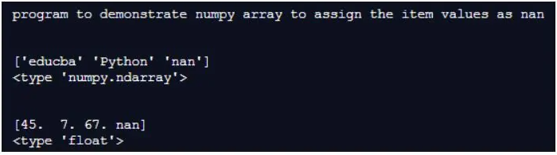

In the above program, we can see we have firstly imported the NumPy module, then we are using the alias name of NumPy to initialize nan value in the array items when creating an array using NumPy.array() function. We can observe in the above screenshot when we have created an array with integer item values are converted and we get the array in the output as float item values and hence we can say nan is a floating data type when we create these nan values in an array. Therefore we can see when we are printing the type of nn.nan we can in the above screenshot results in float data type.

#### Example #3

Now let us see what will be the impact of nan on the mathematical operations when we are trying to get the sum of the elements of the array containing a nan value and also the product of the elements having nan value. Let us demonstrate this in the below program using the NumPy module.

**Code:**

**import numpy as nn  
a_res = nn.sum(nn.array([10, 20, nn.nan]))  
print("The sum of the elements in the given array is as follows:")  
print(a_res)  
print("\n")  
nn_arr = nn.array([2, 3, nn.nan])  
p_res = nn.multiply(nn_arr[0], nn_arr[2])  
print("The product of the elements in the given array is as follows:")  
print(p_res)  
print("\n")**

**Output:**

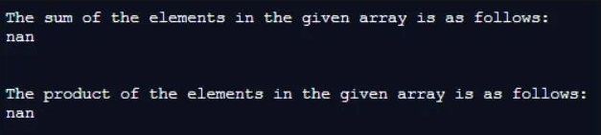

In the above program, we can see when we are having nan values in any data frames or arrays in Python using NumPy we can assign nan values and now when we are calculating the sum of the elements in an array having a nan value as one of the elements in the array then we get the sum as “nan” and even when we are trying to find the product of any elements with nan valued element in an array then it also results in “nan” as product value as seen in the above screenshot.

#### Example #4

As we can use isnan() function in math module to check for nan values of the created variable in a similar way we can also check for the array elements if it nan value or not using the same isnan() function in NumPy module.

**Code:**

**import numpy as nn  
nn_arr = nn.array([2, 3, nn.nan])  
print("The array is as follows:")  
print(nn_arr)  
print("\n")  
print("hecking for the values of the elements in an array if it is nan ")  
print(nn.isnan(nn_arr))**

**Output:**

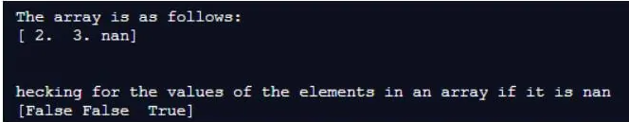

In the above program, we can see that we have created an array with the third element as a nan value in it. Therefore when we are checking for the item values in an array for nan value we get true at the third index and the other indexes we get false as seen in the above screenshot.

### Conclusion

In this article, we conclude that the nan which is “not a number” value assigned when we are not knowing the value of the items or variables declared. This nan value is used when there are missing values in any data frames or arrays. In this article, we saw how we can assign nan in NumPy and we also saw in the NumPy module it is a floating data type in Python. In this article, we also saw other than NumPy we can also use the math module but only in Python 3.5 and above version and hence we use the NumPy module in python for arrays and we also saw how the nan value affect in the mathematical operation on the array using NumPy in Python.

<https://www.educba.com/numpy-divide/>

## Introduction to NumPy divide

Whenever there is a need to perform division among the elements of first array by the elements of the second array in python, we make use of the function divide in numpy and this process takes place with each element in the two arrays. And hence the two arrays must be of the same shape to perform division between the elements of the first array and the elements of the second array and as well know, division by zero is not possible and    hence we need to make sure the second array whose elements are to be divisor of the elements of the first array are never zero.

**Syntax of NumPy divide function in Python:**

**numpy.divide(arrayname1,arrayname2,)**

Where,

arrayname1 is the name of the first array whose elements are to be divided by the elements of the second array represented by the name arrayname2 and both the arrays must be of the same shape to perform division between the elements of the first array and the elements of the second array.

### Working of NumPy divide Function

* Whenever there is a need to perform division among the elements of first array by the elements of the second array in python, we make use of the function divide in numpy.
* The process of division takes place with each element in the two arrays and hence the two arrays must be of the same shape to perform division between the elements of the first array and the elements of the second array.
* As well know, division by zero is not possible and hence we need to make sure the second array whose elements are to be divisor of the elements of the first array are never zero.
* The numpy divide function takes two parameters as arguments namely arrayname1 and arrayname2.
* arrayname1 is the name of the first array whose elements are to be divided by the elements of the second array represented by the name arrayname2 and both the arrays must be of the same shape to perform division between the elements of the first array and the elements of the second array.

### Examples of NumPy divide

Given below are the examples of NumPy divide:

#### Example #1

Python program to demonstrate NumPy divide function to create two arrays of the same shape and then use divide function to divide the elements of the first array by the elements of the second array.

**Code:**

**#importing the package numpy  
import numpy as n  
#creating an array using the array function and storing it in the variable array1  
array1 = n.array([[10,20,30,40]])  
#displaying the elements of the newly created array  
print 'The elements of the first array are:'  
print array1  
print '\n'  
#creating an array using the array function and storing it in the variable array2  
array2 = n.array([[10,20,30,40]])  
#displaying the elements of the newly created array  
print 'The elements of the second array are:'  
print array2  
print '\n'  
#using divide function to divide the elements of the first array by the elements of the second array and storing it in a variable called resultarray  
resultarray = n.divide(array1,array2)  
#displaying the elements of the resultant array  
print 'The elements of the resultant array after dividing the elements of the first array by the elements of the second array:'  
print resultarray  
print '\n'**

**Output:**

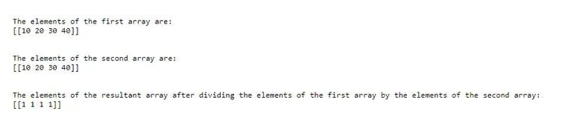

**Explanation:**

* In the above program, we are importing the package called numpy using which we are able to make use of array function to create new arrays and divide function to divide the elements of the first array by the elements of the second array.
* Then an array called array1 is created using the array function whose elements are to be divided by the elements of another newly created array using array function called array2.
* Then divide function is used to divide the elements of the first array array1 by the elements of the second array array2. Then the elements of the resultant array are displayed.

#### Example #2

Python program to demonstrate NumPy divide function to create two arrays of the same shape and then use divide function to divide the elements of the first array by the elements of the second array.

**Code:**

**#importing the package numpy  
import numpy as n  
#creating an array using the array function and storing it in the variable array1  
array1 = n.array([[5,10,15,20]])  
#displaying the elements of the newly created array  
print 'The elements of the first array are:'  
print array1  
print '\n'  
#creating an array using the array function and storing it in the variable array2  
array2 = n.array([[5,5,5,5]])  
#displaying the elements of the newly created array  
print 'The elements of the second array are:'  
print array2  
print '\n'  
#using divide function to divide the elements of the first array by the elements of the second array and storing it in a variable called resultarray  
resultarray = n.divide(array1,array2)  
#displaying the elements of the resultant array  
print 'The elements of the resultant array after dividing the elements of the first array by the elements of the second array:'  
print resultarray  
print '\n'**

**Output:**

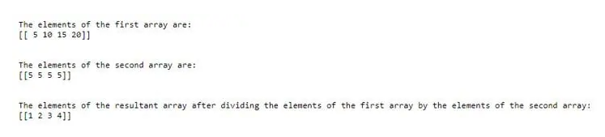

**Explanation:**

* In the above program, we are importing the package called numpy using which we are able to make use of array function to create new arrays and divide function to divide the elements of the first array by the elements of the second array.
* Then an array called array1 is created using the array function whose elements are to be divided by the elements of another newly created array using array function called array2.
* Then divide function is used to divide the elements of the first array array1 by the elements of the second array array2. Then the elements of the resultant array are displayed.

<https://www.educba.com/numpy-square/>

## Introduction to NumPy square

The following article provides an outline for NumPy square. This function is also from the NumPy library which is used for the computation on the array and single elements. As the name suggests this function is used when we want to calculate the square of the array elements or a single element value can also be calculated. This function will return the new array containing the square value of array element it does not modify the original array, it will be an unchanged array only.

**Syntax:**

By the use of the square function, we can calculate square of Float, Integer, and complex number type in python. This function takes array as the input parameter. In order to use this we need to have NumPy package as the import in our program.

This is the syntax as per the python doc:

**numpy.square(x[, out])**

This above function takes array as the input and returns a new array without being modified the original array.

### How square Function work in NumPy?

As now we know that the NumPy square function is used to calculate the square of the value and NumPy is used to calculate the numeric value of array element in python, this is the library that makes the computation easy and clean. This function works in the same way like we have learnt in school.

This function takes 4 argument:

* **arr (first param):** This parameter is array that contains various elements that we want to calculate. This is required parameter.
* **dType (second param):** This parameter is optional and this parameter specifies the type of array we want to return.
* **out (third param):** This parameter is also optional. This parameter is used when we want to place our resultant output into an array. In short it represent an resultant array with result.
* **where (fourth Parma as condition on elements):** This parameter specifies that which element needs to be taken into consideration while calculating the square of the array elements.

**Return Type (array as the return type):**

* This function return an array which is an Newley formed array only. Square function does not modify the original array.

In order to use this function we have to have the NumPy package should be imported in our program otherwise we will not be able to use this function.

Start using the function by following the below steps:

1. Import the package and specify the alias name for more convenient way to access and call the computation functions.

**Example:**

**import NumPy as name**

2. After this step we can directly call any function which is available in the NumPy library. For now we will look how to use square function.

**Example:**

**myNum.square(array)**

In the above line of code we are using the alias name to call the square function and inside we are passing the array which need to be calculate.

Now we will see one example and its working:

**Example:**

**import numpy as myNum  
arr = [2, 5, 6, 8, 9] result  =  myNum.square(arr)  
print (result)**

In the first line you can see the import statement with name ‘myNum’. After that we have declared one array with various elements. In the next line we are calling the square function and try to passing the array inside it. Then this function will return us the new array which is going to be hold the ‘result’ variable and on the next line we are just printing our result. We can also calculate the square of the single element by passing the single variable inside the square function.

**np.sqaure(20)**

Like this it will calculate the square of the single element.

**Points to remember while working with square function in NumPy:**

* This function takes 4 parameters out of which three are optional.
* This will always return as new array and the source array will not be changed anyway round.
* Square function can take single param also and part of NumPy library.

### Examples of NumPy square

Given below are the examples of NumPy square:

#### Example #1

In this example we are trying to get the square of the single element using square function.

**Code:**

**import numpy as myNum  
val1 = 20  
print("value is :", val1)  
#calling numpy function here.  
result  =  myNum.square(val1)  
print("result is  ::")  
print (result)**

**Output:**

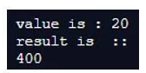

#### Example #2

In this example we are calculating the square of integer array elements by using the square function.

**Code:**

**import numpy as myNum  
#defining the array  
arr = [1, 2, 3,3, 4, 5, 6, 7, 8] print("array value is :", arr)  
#calling numpy function here.  
result  =  myNum.square(arr)  
print("result is  ::")  
print (result)**

**Output:**

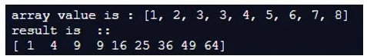

#### Example #3

In this example we are calculating the square of the float array elements by using the square function.

**Code:**

**import numpy as myNum  
#defining the array  
arr = [2.4, 3.5, 1.5, 3.2, 9.1] print("array value is :", arr)  
#calling numpy function here.  
result  =  myNum.square(arr)  
print("result is  ::")  
print (result)**

**Output:**

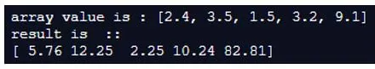

#### Example #4

In this example we are trying to calculate the square of the complex number type. Which is an array nu using the square function.

**Code:**

**import numpy as myNum  
#defining the array  
arr = [-2, -3, -4, -5] print("array value is :", arr)  
#calling numpy function here.  
result  =  myNum.square(arr)  
print("result is  ::")  
print (result)**

**Output:**

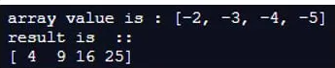

#### Example #5

In this example we are calculating square of multiple array with different values by using square function from NumPy library.

**Code:**

**import numpy as myNum  
#defining the array  
#first array  
arr1 = [-2, -3, -4, -5] #second array  
arr2 = [-6, -7, -8 , -9] print("array value is :", arr1)  
print("array value is :", arr2)  
#calling numpy function here.  
result1  =  myNum.square(arr1)  
result2  =  myNum.square(arr2)  
print("result is  ::")  
print (result1)  
print (result2)**

**Output:**

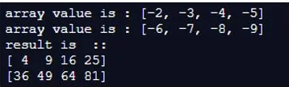

### Conclusion

By using the square function, we can calculate the square of array elements without being iterating the elements this also reduced the line of code and optimized it. This function is also available inside the NumPy library. We can also specify the optional parameter of this function if needed.

<https://www.educba.com/numpy-ones/>

## Introduction of Numpy ones

Numpy is a python library used for working with Arrays. NumPy.Ones is a method used with NumPy that returns a new Array with shapes given size where the element value is set to 1. It creates an Array and fills the value 1 to it. We can also define the Shape and the datatype being the optional parameter. We can create a multidimensional Array with the NumPy and insert the elements in it.

**Syntax:**

**ones(shape, dtype=None, order='C')**

* This is the syntax for the ones method in NumPy.
* The shape defines the size of the parameter to be used.
* The dtype is used to define the data type of the Array, by default the value is Float.
* The order defines to which order we need to insert the data. Columnar approach or row level approach.
* So by import the NumPy Library and calling this method will create the array of the desired size with values 1 over it.

### Working of NumPy Ones with Examples

The ones function basically inserts the value 1 over the array. So it starts with first creating an array with the size and data types given and then inserts the value 1 to it. It stores the array in a continuous place in memory so relatively is faster.

#### Example #1

**import numpy as np  
aa = np.ones(5)  
print(aa)  
b = np.ones((5,), dtype=int)  
print(b)  
c = np.ones((2, 1))  
print(c)**

The Output for this will create an Array with size 5. The first output has the default data type that is double.

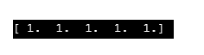

The Second one we declared as Integer so the output comes as Integer.

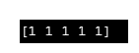

The third one create a array with a definite size.

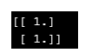

**Code Snippet:**

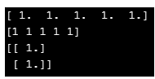

**d = np.ones((3,3))  
print(d)**

**Output:**

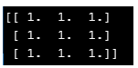

We can change the data type for the Array which we are making and use it accordingly in our code.

#### Example #2

**import numpy as np**

The default data type is Double. So explicitly passing the value to Int.

**a = np.ones(2,dtype = int)  
print(a)**

**Output:**

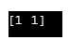

**To Float:**

**b = np.ones(2,dtype = float)  
print(b)**

**Output:**

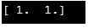

**The Complex Data Type:**

**c = np.ones(2,dtype = complex)  
print(c)**

**Output:**

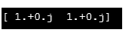

**The DictType:**

**d = np.ones(2,dtype = dict)  
print(d)**

**Output:**

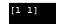

**The Type List:**

**e = np.ones(2,dtype = list)  
print(e)**

**Output:**

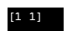

**Code Snippet:**

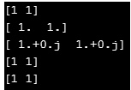

Even we can change the size of the array also to 1D, 2D or multidimensional Array.

So the same code while changing the Array size will be like:

**1D Array:**

**a = np.ones(3,dtype = int)  
print(a)**

**Output:**

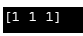

**2D Array:**

**b = np.ones((2,2),dtype = float)  
print(b)**

**Output:**

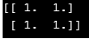

**MultiDimensionalArray:**

**c = np.ones((3,2),dtype = complex)  
print(c)**

**Output:**

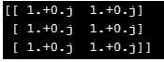

**3d Array:**

**d = np.ones((3,3),dtype = dict)  
print(d)**

**Output:**

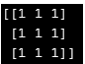

**Code Snippet:**

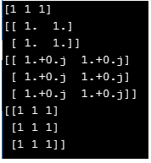

We can also have a mixture of Datatype in the array. This means there is no limitation that the data type we are using will be of the same data type.

#### Example #3

We will create an Array of size for that numpy.ones and change the data type for that.

**b = np.ones((2,2),dtype = [('x','int'),('y','float')])  
print("The data type ")  
print(b)**

**Output:**

Here we can see that one is type Int others type being Float.

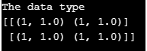

**c = np.ones((2,3),dtype = [('x','int'),('y','complex')])  
print("The data type ")  
print(c)**

**Output:**

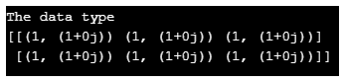

One more parameter that is used with numpy.ones() is the order in which the data is to inserted. The parameter it uses is Row Major or Column Major. And the value it takes is C style and F style.

#### Example #4

**d = np.ones((2,2),dtype = [('x','int'),('y','float')], order= 'C')  
print("The data type Order ")  
print(d)**

**Output:**

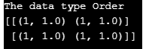

The C is used for Row Major Insertion, whereas F for Column.

**e = np.ones((2,2),dtype = [('x','int'),('y','float')], order= 'F')  
print("The data type ")  
print(e)**

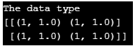

**Code Snippet:**

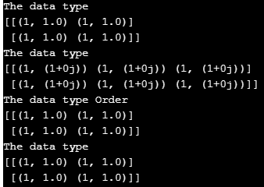

**d = np.ones((3,3),dtype = [('x','int'),('y','float')], order= 'C')  
print("The data type Order ")  
print(d)  
e = np.ones((3,2),dtype = [('x','int'),('y','float')], order= 'F')  
print("The data type ")  
print(e)**

**Output:**

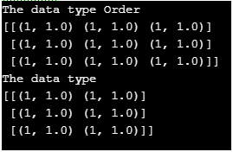

### Conclusion

So From the above article, we saw the use of ones function in numpy we also saw the Syntax and various methods from which we can create use the ones function and create arrays with it. We also saw how it is used and is important for Python Programming. So numpy. Ones is an important method used in python for array operations.

<https://www.educba.com/numpy-meshgrid/>

## Definition of NumPy Meshgrid

In python, meshgrid is a function that creates a rectangular grid out of 2 given 1-dimensional arrays that denotes the Matrix or Cartesian indexing. It is inspired from MATLAB. This meshgrid function is provided by the module numpy. Coordinate matrices are returned from the coordinate vectors. In this, we will discuss more about meshgrid function in detail.

### Syntax

Below is the syntax of meshgrid function in numpy.

**numpy.meshgrid(*xi, **kwargs)**

Four parameters of this function are:

**1. x1, x2,…, xn**

* Required parameter
* The parameter that denotes the coordinates of the grids in the 1-D arrays.

**2. indexing**

* Optional parameter
* The parameter that denotes the cartesian(‘xy’, default) or matrix indexing of result.

**3. Sparse**

* Optional parameter
* Takes Boolean value
* A sparse grid is returned for conserving memory if ‘True’ is passed.
* Default value: False

**4. Copy**

* Optional parameter
* Takes Boolean value.
* The original array’s view is returned for conserving memory if ‘false is passed.
* Default value: False

If the parameters sparse and copy are set to False, non-contiguous arrays will be returned. Moreover, 1 or more elements of a broadcast array can point to a single memory location. Copies of the arrays have to be made first if writing has to be done into the arrays. The return value is: Length of the coordinate from the coordinate vectors.

### How does Meshgrid Function Work in NumPy?

In order to understand the working of meshgrid function in numpy, let us see an example.

Steps for creating meshgrid:

* Import the module numpy.

**importnumpy as np**

* Create two variables.

**n1, n2 = (5, 3)**

* Create two arrays

**a = np.linspace(0, 1, n1)  
b = np.linspace(0, 1, n2)**

* Call the meshgrid function with the arrays as parameters.

**aa, bb = np.meshgrid(a, b)**

* Display the result

**print(aa)  
print(bb)**

### Examples of NumPy Meshgrid

Let us see some sample programs of meshgrid function.

#### Example #1

Python program to print the meshgrid coordinates of two arrays.

**Code:**

**import numpy as np  
n1, n2 = (5, 3)  
a = np.linspace(0, 1, n1)  
b = np.linspace(0, 1, n2)  
aa, bb = np.meshgrid(a, b)  
print(aa)  
print(bb)**

**Output:**

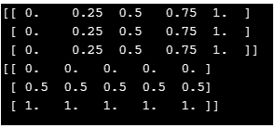

In this program,numpy modules has to be imported with alias name as np. Then, two variables n1 and n2 are created where the values assigned are 5 and 3. Once this is done, two arrays a and b are also created with the help of linspace() function. Then two variables aa and bb are used for assigning the return value of meshgrid. In the function, both the arrays a and b are passed. Atlast, the value of aa and bb are printed. On executing the code, two arrays will be displayed that consists of coordinate length and coordinate vectors as well. The coordinates given as output by meshgrid can also be used to plot functions that is given in the coordinate range.

#### Example #2

Python program to print the meshgrid coordinates of two arrays that are between specified values.

**Code:**

**import numpy as np  
l = np.linspace(-7, -1, 9)  
k = np.linspace(-6, -2, 11)  
x1, y1 = np.meshgrid(l, k)  
print("x1 is : ")  
print(x1)  
print("y1 is : ")  
print(y1)**

**Output:**

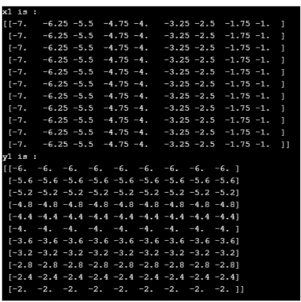

In this program also,numpy modules has to be imported with any alias name. The alias name in this program is np. Then, two arrays l and k are created with the help of linspace() function. Then two variables x1 and y1 are used for assigning the return value of meshgrid. In the function, both the arrays l and k are passed. Atlast, the value of x1 and y1 are printed. On executing the code, two arrays will be displayed that consists of coordinate length and coordinate vectors as well.

#### Example #3

Python program to print the meshgrid coordinates of two arrays where sparse is true.

**Code:**

**import numpy as np  
n1, n2 = (5, 3)  
l = np.linspace(0, 1, n1)  
k = np.linspace(0, 1, n2)  
aa, bb = np.meshgrid(l, k, sparse=True)  
print(aa)  
print(bb)**

**Output:**

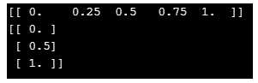

Similar to the above programs, in this program also,numpy modules has to be imported with an alias name. The alias name in this program is np. First, two variables n1 and n2 are created where values are 5 and 3 respectively. Then, two arrays l and k are created with the help of linspace() function. Then two variables x1 and y1 are used for assigning the return value of meshgrid. In addition to the above programs, sparse is true here. If sparse is true, it conserves the memory In the function, both the arrays l, k, and sparse value are passed. At last, the value of x1 and y1 are printed. On executing the code, two arrays will be displayed that consists of coordinate length and coordinate vectors as well. Here, it can be seen that the way of displaying is different from the above programs.

#### Example #4

Python program to print the meshgrid coordinates of two arrays and display contour lines.

**Code:**

**import numpy as np  
import matplotlib.pyplot as plt  
n = np.arange( -5, 5, 0.1 )  
m = np.arange( -5, 5, 0.1 )  
x, y = np.meshgrid( n, m, sparse=True )  
c = np.sin( x**2+ y**2  ) / ( x**2 + y**2 )  
z = plt.contourf( n, m, c )  
plt.show()**

**Output:**

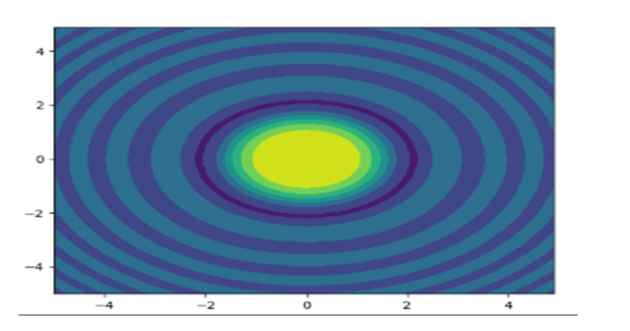

Similar to the above programs, in this program also,numpy modules has to be imported with an alias name np. First, two arrays n and m are created with the help of arange() function. Then two variables x and y are used for assigning the return value of meshgrid Moreover, sparse is true here as well. In the function, both the arrays n, m, and sparse value is passed. Then, a variable z is declared that assigns the return value of the function np.sin(). Atlast, the contour lines along with filled contours are drawn using the function plt.contourf(). On executing the code, it can be seen that the contour lines have been plotted.

<https://www.educba.com/numpy-exponential/>

## Definition of NumPy exponential

NumPy library contains various function exponential is one of them. This functions are used to perform calculations on the array or n-dimensional array. The exponential function is used to calculate the logarithm and exponential value of array elements. In python, NumPy exponential provides various function to calculate log and exp value. Functions are listed as :loglp, log1, log2, log3 for log. Expml, exp2, exp to calculate an exponential value.

**Syntax:**

To use this exponential function to need to import numPy library. After importing the package we can use the different functions to calculate the exponential values.

**import numPy as myNum  
myarr = myNum.array([100, 400, 500, 700, 800])  
myNum.exp(myarr)**

In the above syntax, we are using the exp() function to calculate the exponential value of the array elements.

e.g.

**myNum.exp(your_array)**

In short, we can pass our array inside the exponential function to calculate the values.

### How does exponential Function Work in NumPy?

As now we know that we use NumPy exponential function to get the exponential value of every element of the array. This array can be of any type single, two, three or multidimensional array. The exponential function is takes two parameters. Some other parameters are also there where and out but we will discuss more about the basic parameter it takes.let’s see the example of how to use this while programming;

**numpy_name.exp(param)**

Here this function is taking one parameter named as x. This parameter is like the input it takes to calculate the value. We just need to pass our array inside the function. This input parameter can accept anything like an array also it can accept the single values as well there is no restriction, so however we can also able to calculate the value of a single element if required. To pass any single value the syntax will be look like this see below;

1. With single value; we will see one practice example to understand it better;

**Example:**

**numpy_name.exp(your_value here ..)**

**Example:**

**import numPy as myNum  
myNum.exp(100)**

So in this case we are just passing the single element as the parameter here so this exp() function will calculate its exponential value.

2. With array as the parameter inside the function; We will also going to see one practice example for better understating;

**Example:**

**numpy_name.exp(your_array here ..)**

**Example:**

**import numPy as myNum  
myarr = myNum.array([100, 400, 500, 700, 800])  
myNum.exp(myarr)**

Inthe above lines of code we are creating one array named as myarr which is going to hold some elements inside it. For creating an array we are using array() function provided by the numPy library in python. Followed by the exp() function here inside this we are passing our newlycreated array as the parameter and this function will give us the exponential value of this array.

3. With the multi-dimensional array inside the exp() function; we will see syntax for it to understand it better;

**Example:**

**numpy_name.exp(your 2d array here ..)**

Now here we have to create one 2d array to work with it. In order to create an 2d array we have one function called as ‘arrang’ provided by the numPy library in python.

Let’s see one basic structure to create 2d array using numPy function see below;

**Example:**

**import numPy as myNum  
myArr = myNum.arange(6)  
myNum.exp(myArr)**

In the above example we are using arrange function to work with 2d array in python but in order to use it we have to import numPy in our program. This function will create one 2d array for us followed by the exp() function. we just need to pass the 2d array inside the function to get the exponential values of the array elements.

### Examples of NumPy exponential

Following are the examples are given below:

#### Example #1

In this example, we are creating a single dimension array and using the exp() function to get the exp values of elements.

**Code:**

**import numpy as myNum  
#creating array using numpy  
myarr = myNum.array([4, 9, 2, 5])  
#using exp() function to get the value  
resultarr = myNum.exp(myarr)  
#printing the result  
print(resultarr)**

**Output:**



#### Example #2

In this example we are creating a three dimensional array and calculating its value using exp() function from NumPy.

**Code:**

**import numpy as myNum  
#creating array using numpy  
myarr1 = myNum.array([4, 9, 2, 5])  
myarr2 = myNum.random.randint(0, 5, size = (2, 3, 8))  
#using exp() function to get the value  
resultarr1 = myNum.exp(myarr1)  
resultarr2 = myNum.exp(myarr2)  
#printing the result  
print(resultarr1)  
print(resultarr2)**

**Output:**

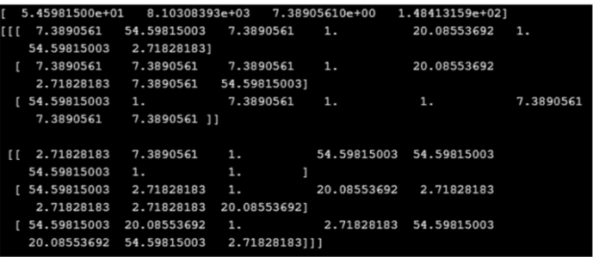

#### Example #3

In this example we are creating 2d array but now we are using exp2() function. To get the exp value of the elements.

**Code:**

**import numpy as myNum  
#creating array using numpy  
myarr1 = myNum.array([4, 9, 2, 5])  
myarr2 = myNum.random.randint(0, 5, size = (2, 3, 8))  
#priting the array value here ..  
print(myarr1)  
print(myarr2)  
#using exp() function to get the value  
resultarr1 = myNum.exp2(myarr1)  
resultarr2 = myNum.exp2(myarr2)  
#printing the result  
print(resultarr1)  
print(resultarr2)**

**Output:**

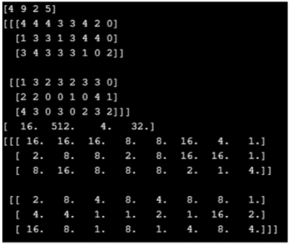

#### Example #4

In this example we are creating multi dimension array but using expm1() function from exponential function library in python.

**Code:**

**import numpy as myNum  
#creating array using numpy  
myarr1 = myNum.array([4, 9, 2, 5])  
myarr2 = myNum.random.randint(0, 5, size = (2, 3, 8))  
#priting the array value here ..  
print(myarr1)  
print(myarr2)  
#using expm1() function to get the value  
resultarr1 = myNum.expm1(myarr1)  
resultarr2 = myNum.expm1(myarr2)  
#printing the result  
print(resultarr1)  
print(resultarr2)**

**Output:**

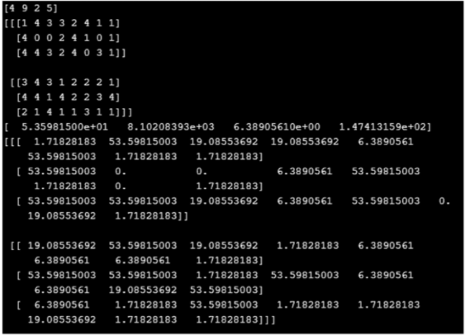

#### Example #5

In this example we are calculating the exp value of the decimal elements by using exp() function.

**Code:**

**import numpy as myNum  
#creating array using numpy  
myarr1 = myNum.array([4, 92.4, 1.0, 3.5, 8.4])  
myarr2 = myNum.random.randint(0, 5, size = (2, 3, 8))  
#printing the array value here ..  
print(myarr1)  
print(myarr2)  
#using expm1() function to get the value  
resultarr1 = myNum.expm1(myarr1)  
resultarr2 = myNum.expm1(myarr2)  
#printing the result  
print(resultarr1)  
print(resultarr2)**

**Output:**

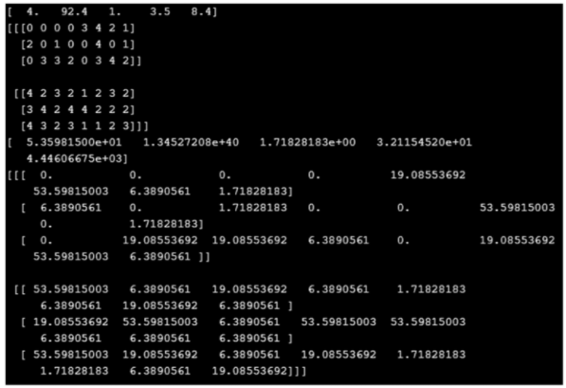

### Conclusion

NumPy library provides various functions that can be used for computation on the array. The exponential function is one of the utility we can say to get the exp value of the element. By the use of this, we can get exp value of single element as well not only array specific. So we can use these elements inside an array or a single element.

<https://www.educba.com/numpy-percentile/>

## Introduction to NumPy percentile

The numpy.percentile() is one of the function used to compute the nth number which is going to be percentile form of the user mentioned given datas or else any other array elements that can be mentioned as the axis formats like x, y and z etc. NumPy percentile is also known as centile is measured and used for the statistics purposes and it indicates the values in the given percentage format of user observations in the group for percentage below and hand waving purpose to say there are 100 equal percentile bands that denotes the user input datas it specified using the array format along with the axis.

**Syntax:**

Programming language have their own syntax and rules for to applying the logics in the both standalone and web applications also include the mobile applications. Based on that python numpy percentile have default method called np.percentile() is built-in method for python language is used for to calculate the percentile values.

**import numpy as np  
a=[] // array elements initialisation  
print(“”,np.percentile(a,integer value))**

Above codes are the basic syntax for calculating the percentage values by using default method it can calculate the percentage values by using user-defined values with the given array.

### How percentile Function work in NumPy?

* The NumPy has many useful statistical functions to find the minimum and maximum percentile standard deviations and variances from the given set of elements in the mentioned arrays. For each numpy have different set of functions like amin() and amax() that is it calculates the minimum and maximum functions from the elements in the given arrays. The NumPy percentile() method is also used to compute the ith number of percentile to provide the user input datas are supplied using the arrays format specified along the axis. The percentile is generally defined as a mathematical terms used for the statistics purposes the ith percentile set of datas is the value at which is i percent in the data using np percentile() method calculate the percentile data in python.
* The percentile data can calculated and displayed in the term like percentile ranks is used to reporting the scores from norm-referenced tests for each percentile has different set of values like 25th percentile is known as first quartile,the 50th percentile as the median or second quartile and the 75th percentile is named as the third quartile(q3). The percentiles and quartiles are the specific types of quantiles. We have a formula for calculating the percentile in the ranks format that can be relatively simple tasks and it going to be the straightforward type it knows only the distribution of scores that can be easily calculated the percentile ranks for any number of the scores in the distribution purposes.The percentile rank formula is R=P/100(N+1) where R represents the rank order of the scores.
* The percentile ranks calculates the percentages where fall on the continuum from 0 to 100 whatever number represents that can be any formats like integer, decimals, float, double and long format it shows the percentage calculation of the number scores that can be distributed among the scores fall at below score percentages. NumPy is a one kind of python packages that provides fast, reliable and also its a flexible and expressive data structures that is designed mainly working for relation a or labelled data for both easy and intuitive one and it aims to the fundamental high-level building blocks for doing both practical as well as real world data analysis in the python.

### Examples of NumPy percentile

Given below are the examples of NumPy percentile:

#### Example #1

**Code:**

**import numpy as np  
n = np.array([6,2,4,3,7])  
print("13th percentile (median):")  
p1 = np.percentile(n, 50)  
print(p1)  
print("34th percentile:")  
p1 = np.percentile(n, 40)  
print(p1)  
print("78th percentile:")  
p1 = np.percentile(n, 90)  
print(p1)**

**Output:**

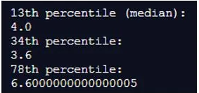

#### Example #2

**Code:**

**import numpy as np  
a = [[13, 27, 14, 31, 46],  
[12, 16, 29, 18, 17],  
[22, 21, 53, 5, 6,]] print("\narr : \n", a)  
print("\n43th Percentile of arr, axis = 1 : ",  
np.percentile(a, 43, axis =1))  
print("0th Percentile of arr, axis = 1 : ",  
np.percentile(a, 0, axis =1))  
print("\n0th Percentile of arr, axis = 1 : \n",  
np.percentile(a, 54, axis =1, keepdims=True))  
print("\n0th Percentile of arr, axis = 1 : \n",  
np.percentile(a, 0, axis =1, keepdims=True))**

**Output:**

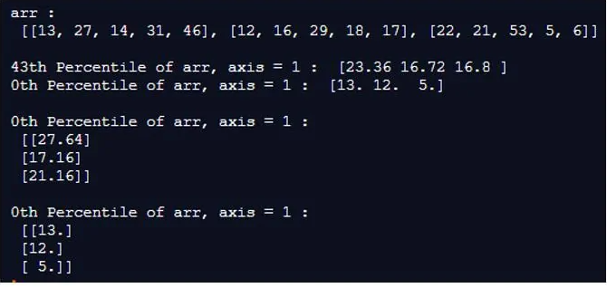

### Conclusion

The statistics measures are generally limited set of ways that can be to make about the people or objects that are actually measured in the market. For each datas cannot be used to generalize about other people datas it can be more secured especially by using python.

<https://www.educba.com/numpy-fft/>

## Introduction of NumPy fft

The function NumPy.fft()function is used in the Python coding language to enable the system to compute single dimension n-point DFT also known as discrete frontier transformation by utilizing the algorithm for fast frontier transformation. This package provides the basic functions that are necessary for the manipulation of large arrays and make cases that contain both alphanumeric and numeric data. For the utilization of the fast frontier transform function, another package has to be utilized which is the subset of the numpy package, the SciPy package, which is helpful in enabling the scientific functionality to increase the extension of use and calculative measures and utility.

### Syntax and Parameters

Following is the syntax which used to utilize the numpy.fft() while writing codes in the Python programming language:

**numpy * . * fft *. * fft * (* a1 *, * n1 * = * None *, * axis * = * -1 *, * norm * = * None *) \***

**Parameters:**

The following is the parameters used for the numpy.fft() function written in the Python programming language:  
Parameters:

* **a1: array_like:**Is used to represent the data that has been entered into the system by the programmer or enter by the user which is the further process with the use of the function
* **n1 int, optional:**It is used to represent the actual length of the transformed after the array has been processed in the output. The value of n1 is less than the actual length of the tree which has been entered by the user, the input value is then cropped. In case, the length of the array which has been entered by the user is comparatively smaller than the output length, then the input array is provided by the system using 0’s. If the parameter is not specified in the syntax which is being used while writing the code, the length of the value that has been entered along the specified axis is generally used.
* **axisint, optional:**The parameter represents the axis of the array over which the fast frontier transformation is to be executed. If the parameter is not specified in the syntax for the code, the last access of the input is used by default
* **norm{None, “ortho”}, optional:**This parameter is used to represent the normalisation mode, which is specifically present in the systems that are using the Python version 1.1.1.0 and above. The default value for the parameter is set as None
* **optional:**The parameter represents the axis of the array over which the fast frontier transformation is to be executed. If the parameter is not specified in the syntax for the code, the last access of the input is used by default
* **Returns:**This parameter is used to represent the truncated input or the input with no padding. The transformation is executed along the axis which was last specified (under specifically mentioned in the syntax)

### How does the NumPy fft Work Systemically?

The fft function which uses the functionality of the SciPy package works in a way that, it uses the basic data structures that are used in the numpy arrays, in order to create a module that is required for scientific calculations and programming. This package helps in utilizing the functionalities that involve using the functioning of linear algebra and calculus (differentiation and integration), utilize the complexity of differential equations and the dynamic versatility of the signalling processes.

The fft or frontier transform package is utilized in order to convert the various signal into the frequency domain that have been received from the time domain. Additionally, you also allow the user to check the in terms of its frequency and perform additional functions in the frequency domain.

 Example of NumPy fft

An example displaying the used of NumPy.save() in Python:

#### Example #1

**# Python code example for usage of the function Fourier transform using the numpy.fft() method  
import numpy as n1  
import matplotlib.pyplot as plotter1  
# Let the basal sampling frequency be 100;  
Samp_Int1 = 100;  
# Let the basal samplingInterval be 1  
# The begin time for the time sampling of the process is taken as 0  
Begin_Time1 = 0;  
# Let the endtime period be 10 seconds  
End_Time1 = 100;  
# The final frequency being recorded for the signals  
Signal_1Frequency     = 40;  
Signal_2Frequency     = 70;  
# Time points awarded are  
time1 = n1.arange(begin_Time1, end_Time1, samp_Int1);  
# Creation of2sinusoidal waves being done  
amp1 = n1.sin(2*n1.pi*signal_1Frequency*time1)  
amp2 = n1.sin(2*n1.pi*signal_2Frequency*time1)  
# Creation of a sub plot being executed  
figure1, axis1 = plotter1.subplots(4, 1)  
plotter1.subplots_adjust(hspace=1)  
# The time domain has a representation for sinusoidal wave 1  
axis[0].set_title('Sine wave with a frequency of 4 Hz')  
axis[0].plot(time, amplitude1)  
axis[0].set_xlabel('Time')  
axis[0].set_ylabel('Amplitude')  
# Time domain representation for sine wave 2  
axis[1].set_title('Sine wave with a frequency of 7 Hz')  
axis[1].plot(time, amplitude2)  
axis[1].set_xlabel('Time')  
axis[1].set_ylabel('Amplitude')  
# Add the sine waves  
amplitude = amplitude1 + amplitude2  
# Time domain representation of the resultant sine wave  
axis[2].set_title('Sine wave with multiple frequencies')  
axis[2].plot(time, amplitude)  
axis[2].set_xlabel('Time')  
axis[2].set_ylabel('Amplitude')  
# Frequency domain representation  
fourierTransform = np.fft.fft(amplitude)/len(amplitude)           # Normalize amplitude  
fourierTransform = fourierTransform[range(int(len(amplitude)/2))] # Exclude sampling frequency  
tpCount     = len(amplitude)  
values      = n1.arange(int(tpCount/2))  
time_Period1  = tpCount/samp_Fre1  
frequencies1 = values/time_Period1  
# Frequency domain representation  
Axis1[3].set_title('Fourier transform depicting the frequency components')  
Axis1[3].plot1(frequencies1, abs(fourierTransform))  
Axis1[3].set_xlabel('Frequency')  
Axis1[3].set_ylabel('Amplitude')  
plotter1.show()**

**Output:**

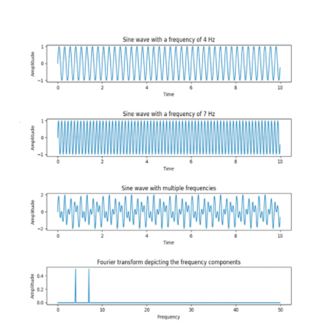

The output that is generated after using the fft() function, the sinusoidal wave which had a frequency of 4 Hz and 7 Hz respectively, were converted into a sine wave with multiple frequencies amalgamated into a single wave. This wave is then transformed into the frequency component through the utilization of the function which represents the wave frequency and amplitude with respect to the parameters for measuring the vitals of the wave in the form of frequency.

### Conclusion

The NumPy.fft() has a multifaceted functionality. The range of an occasion vary from it being used in processing voice Signals and deviant signal processing procedures, it is utilized in the processing of images and also used in processing audio signals. Bike it is one of the most utilized concepts with respect to the digital Signal Processing domain, especially when utilized in the domain of sinusoidal. Both periodic, as well as non- periodic signals, are transformed using the function’s versatile approach for conversion into frequency domain from the time domain.

<https://www.educba.com/numpy-flatten/>

## Introduction of NumPy flatten

In Python, NumPy flatten function is defined as to flatten the given array of any 2- dimensional or any other multi-dimensional array into a one-dimensional array which is provided by the Python module NumPy and this function is used to return the reduced copy of the array into a one-dimensional array from any multi-dimensional array which is known as flattening function to flatten from multidimensional array to one-dimensional array which also helps to flatten the array in a row and column-wise using the order parameters like C for row-wise flattening of the array and F for column-wise flattening of the array to one dimensional and there are many other options also.

### Working of NumPy flatten() Function with Examples

In this article, we will see how flatten() function will work in Python with numpy module and an array object defined by this module which is used for representing a multidimensional array having an immovable number of elements in it. This NumPy module and the object of an array as ndarray are used for demonstrating a flatten() function. Now in the below section let us see the syntax and examples of the flatten function.

**Syntax:**

**ndarray.flatten(order)**

In the above syntax, we have an array object as ndarray which is an input array to which the flatten() function needs to be applied. The parameter “order” is passed to the function having different values such as C, F, A, and K where C is a default value. This function returns the input array with multi-dimensional array flattens or collapsed to one dimension.

* “C” is used as the value to flatten the given multidimensional array to a single dimension in row-wise order.
* “F” is used to flatten or collapse to single dimensional array in the order of column-wise.
* “A” is optional value and it is used only when the F value is having an array as contiguous in memory with column-wise flattening, otherwise, it will flatten in the row-wise.
* “K” is also used as a value to the order parameter to flatten the array in the order the items or elements appear in the memory.

#### Example

Now let us demonstrate the flatten function with simple example in the below section.

**import numpy as nf  
print("Program to demonstrate flatten function of numpy module")  
print("\n")  
in_arr = nf.array([[2,3,8], [4,5,9], [3,0,6]])  
print("The given input array is as follows:")  
print(in_arr)  
print("\n")  
print("The flattened array is as follows:")  
print(in_arr.flatten())  
print("\n")  
print("The flattened array in C ordering is as follows:")  
print(in_arr.flatten(order = 'C'))  
print("\n")  
print("The flattened array in F ordering is as follows:")  
print(in_arr.flatten(order = 'F'))  
print("\n")  
print("The flattened array in A ordering is as follows:")  
print(in_arr.flatten(order = 'A'))  
print("\n")  
print("The flattened array in K ordering is as follows:")  
print(in_arr.flatten(order = 'K'))  
print("\n")**

**Output:**

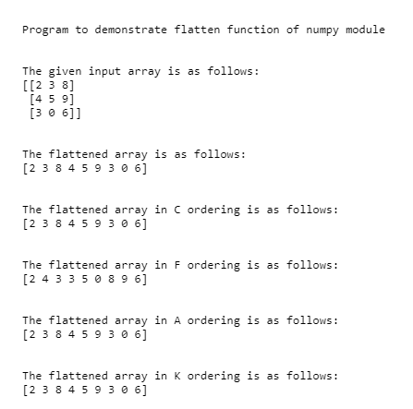

In the above program, we can see we have to first import NumPy and set its alias name as “nf” so that it becomes easy to refer it in the entire program. Then we are creating an array of 3*3 dimensional array using an array function of the NumPy module. Then we can flatten this multidimensional 3*3 array into a single dimension array using the flatten() function on the given input array “in_arr”. As C is default value so when we don’t pass any value to the flatten function then it will arrange the 3*3 dimensional array row-wise that means the first row is appended with the second row and then the second is appended wit 3rd row to form a single array. Similarly, when we have specified the value of order as “C” to arrange the multidimensional array to one dimension. Then in the next line, we have specified the value as “F” which is Fortran style to arrange the given input array column-wise as shown in the above screenshot such as the first column is appended with the second column and then it is appended with 3rd column to form 3*3 dimensional array to single dimensional array. So, therefore, as we can see in the above program, we have also used “A” value which is also arranging the elements of 3*3 dimensional array into a one-dimensional array in row-wise as F does not contain contiguous values in memory. Then lastly, we have specified value as “K” which will flatten the elements of 3*3 dimensional array into one dimension as they appear in the given input array memory and the output of all the possibilities of the parameter values are displayed in the above screenshot.

This flatten() function of NumPy which is used in dealing with huge data related to neural networks like convent then this function is very useful. In Python, there is another function provided by the NumPy module is reshape() function which is also similar to flatten() function and also have the same parameter values such as C, F, A and K with C as default for reshaping the elements in row-wise but flatten() function will reduce the multidimensional array to one dimension whereas reshape() function can be used to reduce or collapse or reshape the given array into any dimensional array which is mainly used to arrange data from wide to long.

### Conclusion

In this article, we conclude that we are using a flatten() function of the NumPy module in Python to reduce or collapse the given multidimensional array into one dimension array. In this article, we have discussed the syntax along with parameters and its values such as C, F, A, and K which is used for arranging the array elements in either row-wise or column-wise. In this article, we also an example of how to use flatten() function, and their different parameter values are demonstrated with output and screenshot.

<https://www.educba.com/numpy-concatenate/>

## Introduction of NumPy Concatenate

Numpy.concatenate() function is used in the Python coding language to join two different arrays or more than two arrays into a single array. The concatenate function present in Python allows the user to merge two different arrays either by their column or by the rows. The function is capable of taking two or more arrays that have the shape and it merges these arrays into a single array. The default value for the row wise concatenation of arrays considers the axis as zero. For concatenating two different areas that are not of the same shape they first have to be reshaped using the reshape function to convert a single dimensional array into a two dimensional allowing the final concatenated array to be a 3×3 array, with three rows and three columns.

### Syntax and Parameters

Syntax for application of NumPy concatenate

Following is the syntax which used to utilize the numpy concatenate() while writing codes in the Python programming language:

**numpy.concatenate((a1, a2, ...), axis)**

**Parameters:**

Following is the parameters used for the numpy.concatenate**\***() function written in the Python programming language:

* **a1, a2, …sequence of array_like:**The arrays that have been entered by the user that must be of the same shape (i.e., dimension) except for the consideration of the dimension that is corresponding to the specified axis. In case the axis has not been specified by the user, the default value for the axis remains as the first axis,
* **Axis: int, optional:**The parameter is responsible for representing the axis along which the error is would be joined with the other arrays. Arrays are flattened before being used if the parameter axis has been specified as None. The default value for the parameter is 0
* **Out: ndarray, optional:**The parameter enables the program to show the exact destination where the concatenated resultant array has to be placed. This parameter is not an unnecessary addition and can be skipped while writing the command. It is necessary that the shape of the array need to be correct (i.e., matching the shape or dimension of the concatenated resultant that could be returned, in case no out argument has been specified by the user.

**Returns:**

* **Res ndarray:**The concatenated resultant array which is formed after the merging of the various arrays that have been specified by the user

### How does NumPy Concatenate Work?

Here we discuss the working of NumPy concatenate:

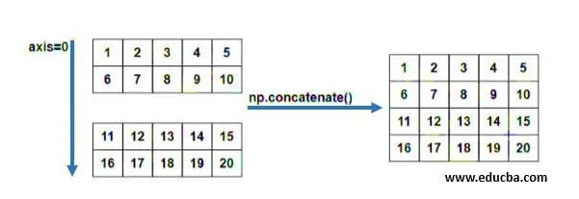

When we use the NumPy function concatenate, the system by default take the areas that have been mentioned by the user and starts them on the first axis. In case the shape of the array is not the same, and error is display because of the axis of each of These areas being different due to which a structural collaboration is not possible. In such a case, either the axis of the array has to be defined as a different axis so that a vertical or horizontal diversity happens on the data.

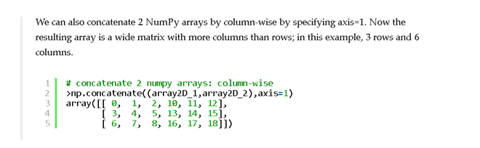

In case the shape of the areas that are to be concatenated are different there would be an error being displayed when the output is showed by the system. For such instances, the reshape function can be used to create an erase of the same shape for the desired result and shape so that arrays with different shape and dimensions can also be merged. The concatenate function can also the use to merge two arrays in a column wise manner. If the axis is specified as 1 the resultant array is subjected to be merged in a column wise manner producing a wide matrix that has more numbers than the number of columns.

An alternative function that can be used instead of using concatenate is using vstack(), which enables the stacking of arrays in a vertical sequence or row wise manner, producing the default output from the concatenate(). When we want to arrange various single dimensional arrays (more than two) we can use the concatenated function to create a list that contains all the elements that are contained in the various arrays that are being merged.

 Examples of NumPy Concatenate

An example displaying the used of numpy.concatenate() in python:

#### Example #1

Displaying concatenation of arrays with the same shape:

**Code:**

**# Python program explaining the use of NumPy.concatenate function import numpy as np1  
import numpy as np1  
A1 = np1.random.random((2,2))*10 -5  
A1 = A1.astype(int)  
print("The elements entered in the array A1 along with dimensions:")  
print(A1)  
B1 = np1.random.random((2,1))*10 -5  
B1 = B1.astype(int)  
print("The elements entered in the array B1 along with dimensions:")  
print(B1)  
C1 = np1.random.random ( (1, 2))*10 -5  
C1 = C1.astype(int)  
print("The elements entered in the array C1 along with dimensions:")  
print(C1)  
print("The resultant merged array A1 and C1 is:")  
np1.concatenate((A1, C1))**

**Output:**

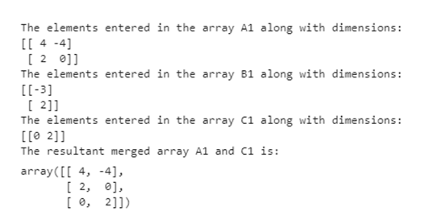

#### Example #2

Displaying concatenation of arrays with different shape:

**Code:**

**# Python program explaining the use of NumPy.concatenate function import numpy as np1  
import numpy as np1  
A1 = np1.random.random((2,2))*10-5  
A1 = A1.astype (int)  
print("The elements entered in the array A1 along with dimensions:")  
print(A1)  
B1 = np1.random.random((2,1))*10 -5  
B1 = B1.astype(int)  
print ("The elements entered in the array B1 along with dimensions:")  
print (B1)  
print ("The resultant merged array A1 and B1 is:")  
np1.concatenate((A1, B1),axis=1)**

**Output:**

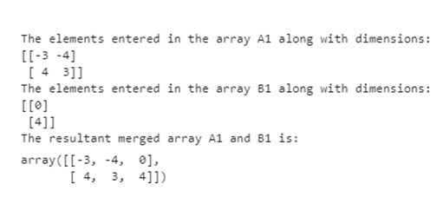

### Conclusion

The NumPy.concatenate() function is very essential in use, as it readily make the merging and listing of various air are possible without out a large code that helps in doing the same. Moreover, it provides the versatility of changing the access from where the merge is being done so that the resultant mud array can be produced both vertically and horizontally. In a general essence, it helps in reducing the verbosity of the code which enhances the turnaround speed for the program that is being run.

<https://www.educba.com/numpy-outer/>

## Introduction to NumPy Outer

Numpy outer() is one of the function in the numpy library in python language is used to compute the outer level of the products like vectors, arrays, etc. If we combine the two vectors of the outer level of the application the numpy outer() function requires the more than two level of arguments is passed into the function. It will be the array format like both single or multi-parameter arguments we can store the results in “out” parameter the vector and matrix type of calculations are performed using this np.outer()(Numpy outer) function. The scientific calculations are calculated using dot operators in the Numpy library.

### Syntax

The Numpy is a general-purpose and mainly used for the array-processing packages in the python codes. Outer() is one of the predefined function of the Numpy library and mainly it’s used for the vector and matrix calculations its basic syntax as follows below.

**import numpy as first  
x=first.ones()  
y=first.linspace()  
z=first.outer(x,y)  
print (z)**

Above basic python code, we have imported the numpy packages in the python script and it has called the pre-defined methods of the package. The vector has rows and columns for all the dimensions and it has releases both 2D and 3D vectors in matrix multiplications.

### How outer Function works in NumPy?

In the Numpy library, outer is the function or product of two coordinate vectors in the matrix calculations. We use more than one vectors that have dimensions like any variables than their variables are calculated using the “x” multiplication operator for calculating matrix outputs. If suppose we use the tensor type of datas like a multidimensional array of numbers then the outer function will give the tensor as the result. The outer function also named it as outer product and the tensor also referred it as tensor products it also called and defined it as tensor algebras. The outer function used dot products and Kronecker products also used standard matrix multiplications.

The dot products helps to take the pairs of coordinate vectors as the input and it produces a scalar and the Kronecker products take the pair of matrices as the input and it produces a block-level matrixes values. In other programming languages we have passed the two-parameter types and the functions will also return the Boolean type of values and it contains two types of single dimensional arrays and these dimensional arrays will syntactically be represented in different ways one is infix binary operators and the other is postfix adverb and outer function is passing these type of arguments as the functional values. The Matlab products used multidimensional arrays and it passes the parameters with more than two arguments in the function. The NumPy packages are the set of arrays and vectors are the building blocks for most of the NumPy operations in python script because it utilizes the logics in different parts of the applications wherever it is needed in the requirement. The NumPy arrays can be classified into different types mainly it will focus on Single-dimensional arrays and Multi-Dimensional arrays. But most important is whenever or wherever we can perform numpy operations before that we must install the NumPy library packages in the python codes. We can use some commands for installing the packages depends upon the operating systems.

The Numpy arrays have used both single and multi-dimensional arrays. If we can pass the python list to the arrays method in single or one-dimensional arrays. And if we pass the list of lists packages in the arrays method in multi or two-dimensional arrays. The matrix array multiplication in every inner list and the outer lists becomes the rows and columns and if the number of columns is equal to the number of elements in each inner list. When we use arrays in the Numpy it has some default and important pre-defined methods are arrange(), zeros(), and ones(), etc for while creating the NumPy arrays. Also if we use the arrays it takes the arguments like start index, end index, and also some number of linearly-spaced types of numbers that can be the specified ranges. The index values are different depends upon the application requirement.

 Examples of NumPy Outer

Here are the following examples as mentioned below.

#### Example #1

**Code:**

**import numpy as np  
p = np.array([3, 6, 8], float)  
q = np.array([4, 7, 13], float)  
print("The Calculation of Matrixes and vectors are.")  
print("p:")  
print(p)  
print("q:")  
print(q)  
print("The Outer function used in the p and q are:")  
print(np.outer(p, q))**

**Output:**

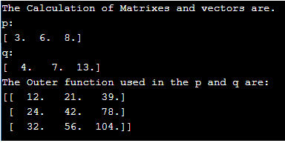

#### Example #2

**Code:**

**import numpy as np  
p = np.ones(6)  
q = np.linspace(-5, 3, 7)  
r = np.outer(p, q)  
print (r)  
x = [5, 9] y = [2, 6, 4] z = np.outer(x, y)  
print(z)**

**Output:**

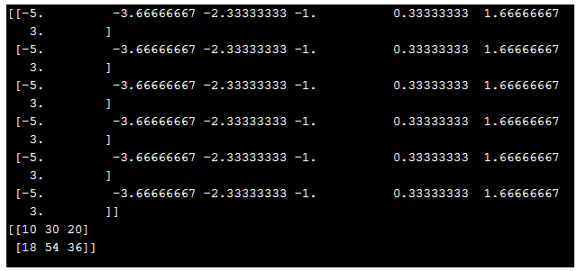

#### Example #3

**Code:**

**import numpy as np  
p = np.array([[4, 3, 2, 1, 16],  
[-7, 4, 3, 6, 15],  
[-5, 2, 19, 11, 26]])  
y = [2, 6, 4] print(p[:3, :7])  
print(p[:6,])  
print(p[:,5])  
print(A[:, 4:8])  
z = np.outer(p, y)  
prPostint(z)**

**Output:**

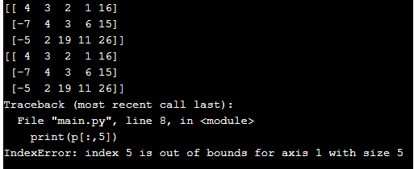

The above three examples we described the outer function in different areas, as well as the Numpy library, have used many other different methods like slicer(), inner(), ones(), etc. It can be used both vector and array indexes using this indexes the values are stored in the back end databases whenever we connect the application if the user inputs are to be entered in the many areas as well as same time multiple user entries are typed in the application the inputs are been validated in both front and back end also the inputs are typed in the number formats it will be integer, float or decimal point based on the application requirement. We must validate the user inputs when we have been included the Numpy packages because its only package calculated for the integer formats and they used the arrays and vector for matrix calculation purpose also it can be solved in complexity programming logic in the web-based applications.

### Conclusion

In this article, we have discussed some important points regarding the Numpy packages and its method, especially in the outer() function. It can be used for Mathematical calculations and concepts like Algebra, linear equations also in machine learning the inputs provided by the user in the form of matricex, vectors, and tensors in the machine models. So in the latest and future technology purpose these Numpy packages and its methods are an important part of the technology trends.

<https://www.educba.com/numpy-zip/>

## Definition of NumPy zip

As the name suggest it zipped the variable together. We can use iterable object with this function like array, list, string, dictionary etc. This function pairs the first value of the every iterable object and proceed ahead like this only. This function is also available inside the NumPy library which is used for computation on the array and single element as well. It is not mandatory to have the iterable object of the same type.

**Syntax:**

We can call this function using the ‘zip’ keyword and it takes any itearble object inside it as the input parameter. Below see the syntax to use zip function in python;

**zip(object1, object2, object3, object4,.. so on)**

Also see the syntax as per the python doc;

**zip(*iterators)**

This function takes containers or an iterable object like; string, list, array, etc.

Let’s see one practice syntax for a better understating of the function see below We will discuss its working in detail in the next section;

**arr1 = [val1, val2, val3] arr2 = [val1, val2, val3] result  = zip(arr1, arr2)**

### How does zip Function Work in NumPy?

Now we know that we use this function to zip or group the variable of different array sometimes it just remove the need of user object to be created. It just functions in the same way like its name just zipped different array or list variable values together. This can take any number of an iterable object, also the length of the iterable object is also not a constraint here. If we talk about its return type it returns single objects which contain all the value zipped form the different iterable objects. We can use this function in so many places like if we want to amp the student data based on the name, city, marks, and roll number so we can use this function without creating a class for it. Let’s take one example to understand about its syntax more in detail;

* **Return Type:** This function returns a single object. This single object contains all the variable from all the array or iterable objects we pass into the function.
* **Parameter:** This function takes an iterable object of any length and any number of parameters.

Let’s see one example to understand its working in a better way;

**arr1 = [ "amit", "sumit", "vishal", "mita", "geets", "sujata", “kavita”, ”lalita”, ”somore” ] arr2 = [ 001, 002, 003, 004, 005, 006, 007, 008, 009, 010,  so on …] result  = zip(arr1, arr2)**

In the above example, we are creating two arrays. The first array containing the name of the student and the second array containing the roll number associated with the student. IF we talk about any other programming language then we need an object which will bind both the variable of the student class or else we need to create a map that will map the value of the student as key value pair this will require a lot of code. But in python, we have a zip() function which will bind the variable of two or more different array into one single array. In the last line, we are calling the zip() function and passing both the array into it as a parameter. We are holding the data into the result variable here which will be a zipped iterable object which will contain the result. Now we will talk about the real time scenario in which we cause it.

Suppose we have a student where we need to bind the data according to with roll number, marks, city, and address so we can use this function for this we need to create three array which will contain the name, roll number, marks, city, and address of the student respectively. After that, we can pass this input parameter in the zip() function. So in the output, we will have all the student data mapped with the corresponding record of the student.

**Example:**

**studentName = [];  
rollNumber = [];  
city =[];  
address = [];  
result = zip(studentName, rollNumber, city, address)**

So in the end it will generate the object which will be going to contain the mapped object of the student object.

Pints to be remembered while working with zip() function in python;

1. Like we zip our object into the single object we can also perform unzip of the object. This operation can be performed by using the unzip() function.
2. zip() function does not bond to the length of the iterable object. The same length is not mandatory.

### Examples of NumPy zip

Following are the examples are given below:

#### Example #1

In this example, we are creating two iterable objects and just calling the zip function on them. This is for beginners to show the working.

**Code:**

**print("demo for zip function")  
#creating array object  
arr1 = [ "value1", "value2", "value3", "value4", "value5", "value6" ] arr2 = [ 1, 2, 3, 4, 5, 6 ] #calling zip function here to bind two array elements  
result = zip(arr1, arr2)  
#here mapping result to print in formte  
result =  set(result)  
#printing result  
print("result after zip function is ::")  
print(result)**

**Output:**

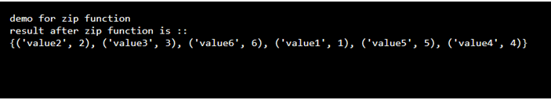

#### Example #2

In this example we are going to map the student data for name, roll number, city and grade they obtained and printing the result.

**Code:**

**print("demo for zip function")  
#creating array object  
arr1 = [ "Amit", "Sumit", "Vinit", "Kavit", "aman", "vijay" ] arr2 = [ "mumbai", "pune", "bng", "chennai", "hyd", "deilhi" ] arr3 = [ "001", "004", "003", "009", "010", "011" ] arr4 = [ 1, 2, 3, 4, 5, 6 ] #calling zip function here to bind two array elements  
result = zip(arr1, arr2, arr3, arr4)  
#here mapping result to print in formte  
result =  set(result)  
#printing result  
print("result after zip function is ::")  
print(result)**

**Output:**

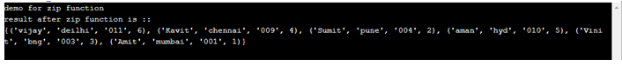

### Conclusion

If we want to bind or zip the data of different array then we can go for zip function in python of NumPy. This function eliminates the need of class object if not required. We can easily map our data with any number of the array and this can be done very easily with the use of the zip() function.

<https://www.educba.com/numpy-newaxis/>

## Introduction to NumPy Newaxis

Numpy newaxis is one of the various functions supported by python numpy library that allows us to change or expand the dimension of a numpy array in the position in which it has been entered. When we include each of the newaxis objects in the tuple of our variable or array we will get a new additional dimension for our array in the same position where we have included the newaxis object.

**Syntax**

The basic syntax of the numpy Newaxis function is,

**np.array()[numpy.newaxis]**

Numpy Newaxis is an object that is included in the array to expand the dimension of the given array. The dimension can be expanded in the position with respect to the position of the newaxis object.

### Examples of NumPy Newaxis

Here are the following examples as mentioned below:

#### Example #1

Let us discuss a basic example for understanding how the numpy newaxis function works.

**Code:**

**import numpy as np  
a = np.array(7)  
print('array: \n', a)  
print('array.ndim:', a.ndim)  
print('array.shape:', a.shape)  
b=np.array(a)[np.newaxis] print('array: \n', b)  
print('array.ndim:', b.ndim)  
print('array.shape:', b.shape)**

**Output:**

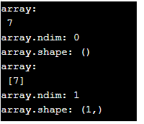

Here in the above example, we have called the numpy library for our np.newaxis function. We have declared an array ‘a’ which is a single dimension array having only one element and the corresponding value, dimension, and shape of the array ‘a’ is printed to confirm that its a zero-dimensional array 0-D. Now to convert 0-D array to one-dimensional array we use the np.newaxis function in our new array ‘b’ and the corresponding value, dimension, and shape of the array ‘a’ is printed it confirms the expansion of the 0-D array to 1-D array.

#### Example #2

In this example well discuss how to change the one-dimensional array to a two-dimensional array using the newaxis object.

**Code:**

**import numpy as np  
a=np.array([3,4,5])  
print('array: \n', a)  
print('array.ndim:', a.ndim)  
print('array.shape:', a.shape)  
b=np.array(a)[np.newaxis] print('array: \n', b)  
print('array.ndim:', b.ndim)  
print('array.shape:', b.shape)**

**Output:**

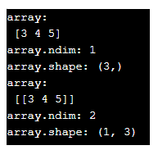

In this example, we have converted a one-dimensional array to a two-dimensional array by using the numpy newaxis function. We have created an array ‘a’ as a one-dimensional array and we have printed its value, dimension, and shape. The array ‘b’ is an extension of array ‘a’ with an expanded dimension using the np.newaxis object inside the tuple. The resulting array as we can see is a two-dimensional array and we have printed its value, dimension, and shape.

#### Example #3

In this example, we have created a zero-dimensional array and converted it into a two-dimensional array.

**Code:**

**import numpy as np  
a=np.array(5)  
print('array: \n', a)  
print('array.ndim:', a.ndim)  
print('array.shape:', a.shape)  
c=np.array(a)[np.newaxis,np.newaxis] print('array: \n', c)  
print('array.ndim:', c.ndim)  
print('array.shape:', c.shape)**

**Output:**

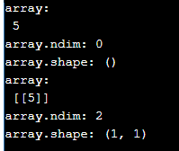

The array ‘a’ as we did in example 1 is a zero-dimensional (0-D) array and we have printed its value, dimension, and shape of the array ‘a’. Now using the numpy newaxis object in the array ‘a’ we have directly converted a one-dimensional array ‘a’ into a two-dimensional array ‘c’. We have declared the np.newaxis twice inside the tuple so it represents the expansion of dimension into two times. So the corresponding array ‘c’ which we got is a two-dimensional array.

#### Example #4

In this example, we’ll see how we can expand a zero-dimensional array into a three-dimensional array.

**Code:**

**import numpy as np  
a=np.array(5)  
print('array: \n', a)  
print('array.ndim:', a.ndim)  
print('array.shape:', a.shape)  
c=np.array(a)[np.newaxis,np.newaxis,np.newaxis] print('array: \n', c)  
print('array.ndim:', c.ndim)  
print('array.shape:', c.shape)**

**Output:**

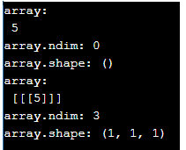

The array ‘a’ we have created is similar to previous examples which is a one-dimensional array. The array ‘c’ we have created is an expansion of array ‘a’ into a three-dimensional array and we have done that using the numpy newaxis function thrice inside the tuple along with the array ‘a’ and the resultant array is a three-dimensional array of shape (1,1,1). So using this technique we can create n-number of dimensions in an array.

#### Example #5

In this example, we’ll try to expand the dimension of a one-dimensional array into a two-dimensional array along with changing the shape of the resulting array using the newaxis object.

**Code:**

**import numpy as np  
a=np.array([5,10,15])  
print('array: \n', a)  
print('array.ndim:', a.ndim)  
print('array.shape:', a.shape)  
c=np.array(a)[:,np.newaxis] print('array: \n', c)  
print('array.ndim:', c.ndim)  
print('array.shape:', c.shape)**

**Output:**

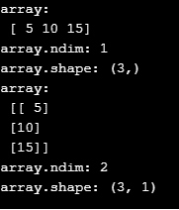

In this example, we have used the same one-dimensional array ‘a’, and using the numpy newaxis function expanded its dimension into a two-dimensional array and we have converted the shape from (3, ) to (3,1). The position of the np.newaxis object is very important in determining the shape of the array. Here we have declared the newaxis object in the 1st axis.

#### Example #6

**Code:**

**import numpy as np  
a=np.array([[2, 4, 6], [4, 8, 12]])  
print('array: \n', a)  
print('array.ndim:', a.ndim)  
print('array.shape:', a.shape)  
c=np.array(a)[np.newaxis,:,:] print('array: \n', c)  
print('array.ndim:', c.ndim)  
print('array.shape:', c.shape)**

**Output:**

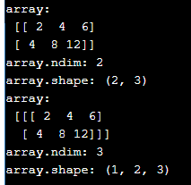

In this example the two-dimensional array ‘a’ with the shape of (2,3) has been converted into a 3-dimensional array with a shape of (1,2,3) this is possible by declaring the numpy newaxis function along the 0th axis and declaring the semicolon representing the array dimension to (1,2,3). By using this technique, we can convert any numpy array to our desired shape and dimension.

#### Example #7

**Code:**

**import numpy as np  
a=np.array([[2, 4, 6], [4, 8, 12]])  
print('array: \n', a)  
print('array.ndim:', a.ndim)  
print('array.shape:', a.shape)  
c=np.array(a)[np.newaxis,:,:] d=np.array(a)[:, np.newaxis, :] e=np.array(a)[:, :, np.newaxis] print('array: \n', c)  
print('array.ndim:', c.ndim)  
print('array.shape:', c.shape)  
print('array: \n', d)  
print('array.ndim:', d.ndim)  
print('array.shape:', d.shape)  
print('array: \n', e)  
print('array.ndim:', e.ndim)  
print('array.shape:', e.shape)**

**Output:**

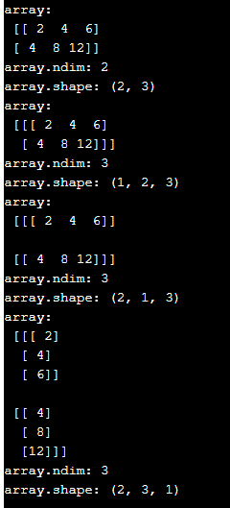

Similar to the previous example using the one-dimensional array ‘a’ we have converted three-dimensional array ‘c’, ‘d’ & ‘e’. All three resulting arrays are three dimensions with different shapes namely (1,2,3), (2,1,3) & (2,3,1) which show us the position of our newaxis object we have declared along with the array. For array ‘c’ we have declared the newaxis object at the 1st position, for the array ‘d’ we have declared the newaxis object at the 2nd position and for the array ‘e’ we have declared the newaxis object at the 3rd position which gives the corresponding shapes.

### Conclusion

In this article, we have discussed the Numpy newaxis function in detail using various examples to get a clear understanding of the numpy newaxis function and its uses. We have also discussed in detail how to use the newaxis object inside the tuple to convert the array into multi-dimensional arrays and techniques involved in changing the shape of the resulting array with examples. I hope this article helps. Thank you.

<https://www.educba.com/numpy-format/>

## Introduction to NumPy Format

If the given value must be converted into a required format as specified by the format specifier, then we make use of a built in function called format() function in python. It takes two parameters value and formatspecifier where value is the value that is to be converted into a format as specified by the second parameter formatspecifier and there are several formatspecifiers such as <, >, ^, =, +, -, _, comma, space, b, c, d, e, E, f, F, g, G, o, x, X, n and % and the first parameter specified as value can be in any format.

**Syntax:**

The syntax forNumPyformat functionin Pythonis as follows:

**format(value, formatspecifier)**

where value is the value that is to be converted into a format as specified by the second parameter formatspecifier.

### Working of Format Function in NumPy

Working of format function in NumPy is as follows:

* If the given value must be converted into a required format as specified by the format specifier, then we make use of a built in function called format() function in python.
* The format() function in python takes two parameters value and formatspecifier where value is the value that is to be converted into a format as specified by the second parameter formatspecifier.
* There are several formatspecifiers such as <, >, ^, =, +, -, _, comma, space, b, c, d, e, E, f, F, g, G, o, x, X, n and % and the first parameter specified as value can be in any format.

### Examples of NumPy Format

Following are the examples as given below:

#### Example #1

Python program to demonstrate NumPyformat functionto convert a given value into binary format:

**Code:**

**#the value to be converted to a binary format as specified by the format specifier is displayed on the screen  
value = 10  
print('The given value that is to be converted to a binary value in the format specified is')  
print value  
print '\n'  
#format function is used to convert the given value into a format as specified by the format specifier  
convertedvalue = format(value, 'b')  
print('The given value that is converted to a binary value in the format specified is')  
#the given value after converted to a binary format as specified by the format specifier is displayed on the screen as the output  
print convertedvalue  
print '\n'**

**Output:**

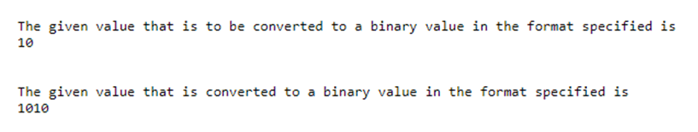

In the above program, the value to be converted to a binary format as specified by the format specifier is stored in a variable called value and is displayed on the screen. Then the format function is used to convert the given value into a binary format as specified by the format specifier. Then the given value after converted to a binary format as specified by the format specifier is displayed on the screen as the output.

#### Example #2

Python program to demonstrate NumPy format function to convert a given value into hexadecimal format of lower case:

**Code:**

**#the value to be converted to ahexa decimal format of lower case as specified by the format specifier is displayed on the screen  
value = 1000  
print('The given value that is to be converted to a hexa decimal format of lower case value in the format specified is')  
print value  
print '\n'  
#format function is used to convert the given value into ahexa decimal format of lower caseas specified by the format specifier  
convertedvalue = format(value, 'x')  
print('The given value that is converted to a hexa decimal format of lower case value in the format specified is')  
#the given value after converted to ahexa decimal format of lower case as specified by the format specifier is displayed on the screen as the output  
print convertedvalue  
print '\n'**

**Output:**

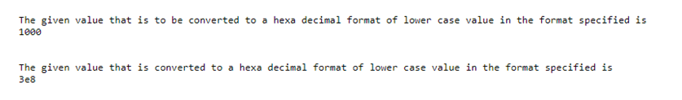

In the above program, the value to be converted to a hexa decimal format of lower case as specified by the format specifier is stored in a variable called value and is displayed on the screen. Then the format function is used to convert the given value into a hexa decimal format of lower case as specified by the format specifier. Then the given value after converted to ahexa decimal format of lower case as specified by the format specifier is displayed on the screen as the output.

#### Example #3

Python program to demonstrate NumPy format function to convert a given value into octal format:

**Code:**

**#the value to be converted to a octal format as specified by the format specifier is displayed on the screen  
value = 100  
print('The given value that is to be converted to a octal value in the format specified is')  
print value  
print '\n'  
#format function is used to convert the given value into a octal format as specified by the format specifier  
convertedvalue = format(value, 'o')  
print('The given value that is converted to a octal value in the format specified is')  
#the given value after converted to aoctal format as specified by the format specifier is displayed on the screen as the output  
print convertedvalue  
print '\n'**

**Output:**

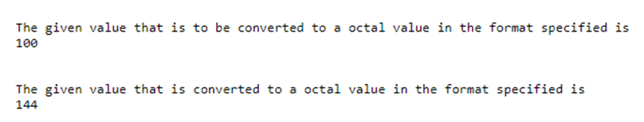

In the above program, the value to be converted to an octal format as specified by the format specifier is stored in a variable called value and is displayed on the screen. Then the format function is used to convert the given value into an octal format as specified by the format specifier. Then the given value after converted to an octal format as specified by the format specifier is displayed on the screen as the output.

<https://www.educba.com/numpy-eigenvalues/>

## Definition of Numpy Eigenvalues

Numpy Eigenvalue is a function in the numpy linear algebra package of the numpy library which is used to generate the Eigenvalues or Eigenvectors from a given real symmetric or complex symmetric array or matrix given as input to the function. Depending upon the kind of input array or matrix the numpy eigenvalue function returns two type of arrays, one dimensional array representing the eigenvalues in the position of the input and another two dimensional array giving the eigenvector corresponding to the columns in the input matrix.

**Syntax:**

The numpy eigenvalue function basically called using the syntax,

**numpy.linalg.eigvals(a)**

* Linalg.eigvals represents the linear algebra package in the numpy library which is used to perform various algebraic operations
* Parameter ‘a’ is the input array or matrix which is complex or real values.
* The function returns the eigenvalues which are not in ordered manner and represented to its own variety. If the computation of the eigenvalues does not align it throws us an error.

### Examples of Numpy Eigenvalues

Following are the examples are given below:

#### Example #1

**Code:**

**import numpy as np  
# Generating an array using numpy array function  
a = np.array([[3, -1j], [1j, 3]])  
print("Array is :",a)  
# using linear algebra package  
# eigen value function is implemented  
x, y = np.linalg.eigh(a)  
print("Eigen value is :", x)  
print("Eigen value is :", y)**

**Output:**

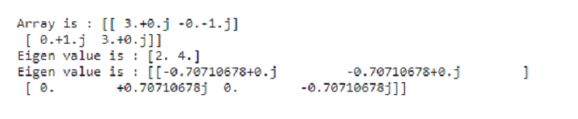

In this example we have an input array of complex value ‘a’ which is used to generate the eigenvalue using the numpy eigenvalue function. As we can see in the output we got two arrays of one dimension and two dimensions. First array is the eigenvalue of the matrix ‘a’ and the second array is the matrix of the eigenvectors corresponding to the columns.

#### Example #2

In this example we will determine the eigenvalues of the simple diagonal matrix and we will generate the corresponding eigenvector.

**Code:**

**import numpy as np  
# Generating a diagonal matrix using numpy array function  
a = np.diag((2, 4, 8))  
print("Array is :",a)  
# using linear algebra package  
# eigen value function is implemented  
x, y = np.linalg.eigh(a)  
print("Eigen value is :", x)  
print("Eigen value is :", y)**

**Output:**

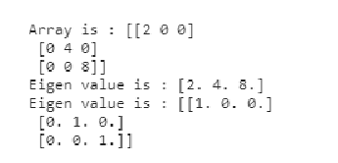

In this example we have used a real value matrix which is diagonal and we have tried to calculate the eigenvalue of that matrix. The input matrix is 3×3 diagonal matrix and hence the eigenvalues are the real numbers that are non zero in the matrix which is (2,4,8). The corresponding eigenvector for the diagonal matrix is generated.

#### Example #3

**Code:**

**import numpy as np  
# Generating an diagonal matrix using numpy array function  
a = np.diag((-1,1,-1))  
print("Array is :",a)  
# using linear algebra package  
# eigen value function is implemented  
x, y = np.linalg.eigh(a)  
print("Eigen value is :", x)  
print("Eigen value is :", y)**

**Output:**

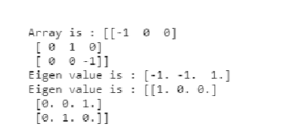

similar to the previous example we have created a diagonal matrix of values (-1,1,-1) which has real values and we calculated the eigenvalue of the matrix and all the real values in the matrix corresponds to the eigenvalue and the corresponding eigenvector for the diagonal matrix is created.

#### Example #4

**Code:**

**import numpy as np  
# Generating a 2-D matrix using numpy array function  
a = np.array([[1, -1], [1, 1]])  
print("Array is :",a)  
# using linear algebra package  
# eigen value function is implemented  
x, y = np.linalg.eigh(a)  
print("Eigen value is :", x)  
print("Eigen value is :", y)**

**Output:**

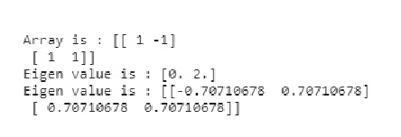

**import numpy as np  
# Generating a 2-D matrix using numpy array function  
a = np.array([[1, -1], [1, 1]])  
print("Array is :",a)  
# using linear algebra package  
# eigen value function is implemented  
x, y = np.linalg.eig(a)  
print("Eigen value is :", x)  
print("Eigen value is :", y)**

**Output:**

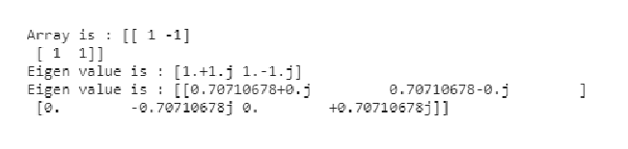

In this example we have compared the numpy linalg.eigh() and linalg.eig() functions, where the linalg.eigh() is used to generate the eigenvalues and eigenvectors of the complex conjugate matrix or real symmetric matrix. The  
linalg.eig() function is used to computing the eigenvalues and eignvectors of the input square matrix or an array.  
We have created a two dimensional array ‘a’ and used the linalg.eigh() and linalg.eig() functions to generate the eigenvalues and vectors for the input matrix ‘a’ we can see the difference in both the outputs. The linalg.eig() function returns us the complex conjugate of the input array ‘a’ and linalg.eigh() which takes the complex symmetric matrix as input gives us the eigenvalues and vectors corresponding to the input array.

#### Example #5

**Code:**

**import numpy as np  
# Generating an 2_D matrix using numpy array function  
a = np.array([[1,-1], [1, 1]])  
print("Array is :",a)  
# using linear algebra package  
# eigen value function is implemented  
x, y = np.linalg.eigvals(a)  
print("Eigen value is :", x)  
print("Eigen value is :", y)**

**Output:**

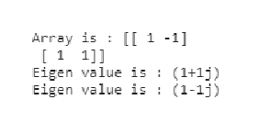

In this example we have used the linalg.eigvals() function which is different from the linalg.eig() function where the former return only the eigenvalues and does not return us the eigenvectors as we can see in the output.

#### Example #6

**Code:**

**import numpy as np  
a = np.array([[1+2j, 5-2j], [1+2j, 3-1j]])  
print("Array a is :",a)  
b = np.array([[4.+0.j, 3.-2.j], [1.+2.j, 1.-0.j]])  
print("Array b is :",b)  
# using linear algebra package  
# eigen value function is implemented  
x1,y1 = np.linalg.eig(a)  
x2,y2 = np.linalg.eigh(b)  
print("Eigen value is :", x1)  
print("Eigen value is :", y1)  
print("Eigen value is :", x2)  
print("Eigen value is :", y2)**

**Output:**

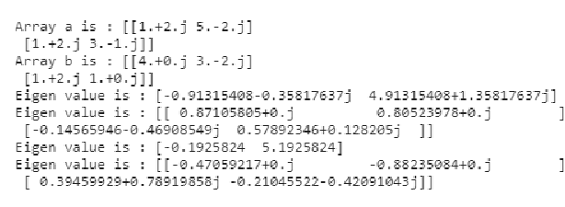

In this example for a clearer understanding of the numpy linalg.eig() and linalg.eigh() function we have created two arrays ‘a’ & ‘b’ as input array and used the linalg.eig() and linalg.eigh() function to generate the eigenvalues and eigenvectors for both the arrays. Where we can see the eigenvalues and vectors of complex or real symmetric matrices are always real values.

### Conclusion

In this article, we have discussed Numpy eigenvalues function in detail using various examples to get a clear understanding on the numpy eigenvalues function and its uses. We have also discussed in detail of how to use numpy linear algebra package to call the eigenvalues functions and also the difference in different eigenvalue functions like eig(), eigh() and eighvals() in the linear algebra package. We also discussed about the techniques involved in using real and complex arrays as input in calculating the eigenvalues and vectors.

<https://www.educba.com/numpy-random-seed/>

## Introduction to Numpy Random Seed ()

Numpy. random. seed**\***() function is used in the Python coding language which is functionality present under the random() function. This aids in saving the current state of the random function. This is done so that function is capable of generating the exactly same random number while the code is executed multiple times on either same machine it was developed in or a different machine where it is being run (referring to the specified seed value). By defining the seed value we mean in a general term the previously generated value or numbers that were processed when the code was run. It must be noted that for the time when the code is being executed first, and there is no previously processed value, the function makes utilization of the system time at the current moment.

**Syntax:**

Following is the syntax used to utilize the NumPy. random. seed**\***() while writing codes in the Python programming language:

* **numpy.random.seed(seed=None)**

**Parameters:**

Following are the parameters used for the NumPy. random. seed () function written in the Python programming language. The random seed method is called by the system initialized the RandomState. It can further be called in order for the generator to be seeded again

|  |  |
| --- | --- |
| **Parameter** | **Description of the Parameter** |
| seed: **int or 1-d array_like, optional**  This represents the input data that is being fed to the machine, this can be either integer kind of data or one dimensional array-like objects, although it is not necessary for the user or coder to define the data type. This is an optional parameter which can be used.    This parameter can be used to generate any integer ranging between 0 and infinite possibilities (up to 232 inclusive of the number), the data being generated can be an array (or other similar sequences) of integers, or the parameter can be set at None (which is the default parameter criteria).    If seed parameter is set at None (unless specified otherwise in the code), then Random State class would be trying to read the available from the Windows analogue or the dev/urandom, in case available or otherwise it will seed clock otherwise |
| **Note** | It should be noted that as a best practice it is advised not to take re-seeding the Bit generator as an option, but rather recreation of an entirely new one is recommended. Please note that legacy reasons are the core principle behind such recommendations. The example can be used in order to demonstrate the best practice to be included: |

### How can the Numpy Random Seed be utilized?

The NumPy random seed function can be used for the generation of an encryption key or pattern (which is pseudo-randomized). These will be playing a very vital role in the development in the field of data and computer security. These encryption keys would provide to be a solution to not having unauthorized access to personal devices or access over the internet in various forms.

The NumPy random seed function enables the coder to optimize codes very easily wherein random numbers can be used for testing the utility and efficiency. The output which is generated on executing the code completely depends on the random data variables that were used by the system, and hence are input dependent. This can make usage of random number for checking the correctness of the testing code-based algorithm to be a complex procedure. As the NumPy random seed function can be used in the process of generating the same sequences of random numbers on a constant basis and can be recalled time and again, this holistically simplifies the entire process of testing using the testing algorithm by implementing the usage of NumPy random seed method.

### Examples

Let us discuss examples of Numpy Random Seed ().

#### Example #1: Displaying the usage of random seed function using code

# Python program explaining the use of NumPy.random.seed function import random.

**Code:**

**import random  
for i in range(10):  
# Any number or integer value can be used instead of using '0'.  
random.seed(0)  
# Generation of random values will be between 1 to 100.  
print(random.randint(1, 100))**

**Output:**

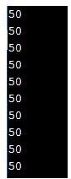

#### Example #2: Displaying the usage of random seed function using code

# Python program explaining the use of NumPy.random.seed function import random.

**Code:**

**import random  
random.seed(3)  
# print a random number between 1 and 1000.  
print(random.randint(1000, 8000))  
# the code is written in order to repeat the same random number multiple times  
random.seed(3)  
print(random.randint(1000, 8000))  
# If seed function is not used  
# The program is being used to generate unpridictible output and genrate totally random values  
print(random.randint(1000, 8000))**

**Output:**

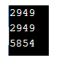

### Conclusion

The NumPy. Random. seed() function is very essential in use, as it readily makes possible for a systemic generation of an encryption key or pattern (which is pseudo-randomized). These will be playing a very vital role in the development in the field of data and computer security. These encryption keys would provide to be a solution to not having unauthorized access to personal devices or access over the internet in various forms. In a general essence, it helps in reducing the verbosity of the code which enhances the turnaround speed for the program that is being run.

<https://www.educba.com/numpy-random-choice/>

## Definition of NumPy random choice

The NumPy random choice() function is used to gets the random samples of a one-dimensional array which returns as the random samples of NumPy array. The NumPy random choice() function is a built-in function in the NumPy package of python. The NumPy random choice() function generate random samples which are commonly used in data statistics, data analysis, data-related fields, and all and also can be used in probability, machine learning, Bayesian statistics, and all.

**Syntax of the jQuery zindex() function:**

**numpy.random.choice( list , size = None, replace = True, p = None)**

**Parameters:**

* list – This is not an optional parameter, which specifies that one dimensional array which is having a random sample.
* size – This is an optional parameter, which specifies the size of output random samples of NumPy array.
* replace – This is an optional parameter, which specifies whether the sample is having to do the replacement or not.
* p – This is an optional parameter, which specifies the probability attach for every sample in an array “list”.
* Return value – The return value of this function is the NumPy array of random samples.

### Working of the NumPy random choice() function

The NumPy random choice() function accepts four parameters. The mandatory parameter is the list or array of elements or numbers. When we pass the list of elements to the NumPy random choice() function it randomly selects the single element and returns as a one-dimensional array, but if we specify some size to the size parameter, then it returns the one-dimensional array of that specified size. Note that if just pass the number as choice(30) then the function randomly select one number in the range [0,29].

### Examples

Example of NumPy random choice() function for generating a single number in the range –

Next, we write the python code to understand the NumPy random choice() function more clearly with the following example, where the choice() function is used to randomly select a single number in the range [0, 12], as below –

#### Example #1

**Code:**

**# import numpy package as np  
import numpy as np  
# Using choice() method of random class  
rdm_no = np.random.choice(13)  
print( "The output random choice sample number : " )  
# printing the generated output random samples of the choice() function  
print( rdm_no )**

**Output:**

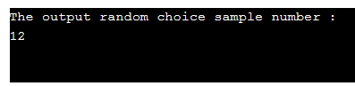

Again when we run the above program it will generate another random number, as we can see below.

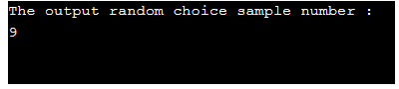

And once again when we run the above program it will generate another random number, as we can see below.

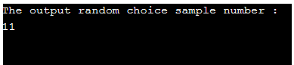

As in the above program the number 13 is passed to the choice() function, so the choice() function randomly select the single number from the range [0, 12], so in the above output if we see every time it generates the random number are in the range [0, 12].

Example of NumPy random choice() function for randomly generating specified size of numbers

Next, we write the python code to understand the NumPy random choice() function, where the choice() function is used to randomly generating 10 sizes of numbers in the range [0, 49], as below –

#### Example #2

**Code:**

**# import numpy package as np  
import numpy as np  
# Using choice() method of random class  
rdm_no = np.random.choice( 50, 10 )  
print( "The output of the random choice function for 10 sample numbers are : " )  
# printing the generated output random samples of the choice() function  
print( rdm_no )**

**Output:**

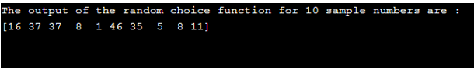

Again, when we run the above program it will generate another random number, as we can see below –

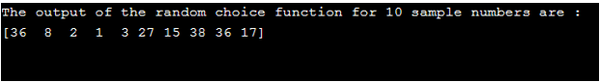

And once again when we run the above program it will generate another random number, as we can see below –

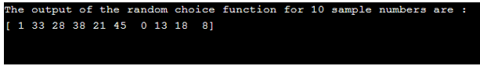

As in the above program the number 50 and 10 are passed to the choice() function, where the 50 is for the random number range (now range is [0, 49]) and the 10 is the size of the output array of random numbers, so the choice() function randomly select the 10 number from the range [0, 49], so in the above output if we see every time it generating the random numbers of 10 size which are in the range [0, 49].

Example of NumPy random choice() function for a randomly select element from a given list with replace –

Next, we write the python code to understand the NumPy random choice() function, where the choice() function is used to randomly select an element from a given list with replacing true, as below:

#### Example #3

**Code:**

**# import numpy package as np  
import numpy as np  
# List of movies  
list_movie = [ 'The Godfather', 'The Shawshank Redemption', 'The Wizard of Oz', 'Citizen Kane', 'Pulp Fiction' ] # Using choice() method of random class  
rdm_no = np.random.choice( list_movie, size = 3, replace = False )  
print( "The output of the random choice function for the 2 movie sample numbers are : " )  
# printing the generated output random samples of the choice() function  
print( rdm_no )**

**Output:**

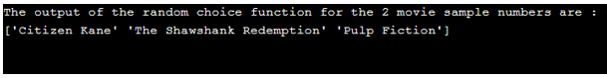

Again, when we run the above program it will generate another random number, as we can see below –

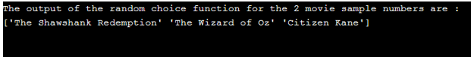

And once again when we run the above program it will generate another random number, as we can see below –

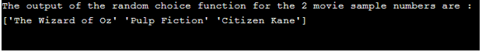

As in the above program the list of movies is created which is passed to the choice() function along with the size=3 and replace=True, so the choice() function randomly select the 3 elements from the list with replace which means the selected elements may be repeat, as we can see in the above output few elements are repeated in the random selected array. Whereas if replace=False then the elements will not repeat in the random selected array.

### Conclusion

The NumPy random choice() function is a built-in function in the NumPy package, which is used to gets the random samples of a one-dimensional array.

<https://www.educba.com/numpy-random-normal/>

## Definition of NumPy random normal

The NumPy random normal() function is used to gets the random samples from a normal distribution. The NumPy random normal() function is a built-in function in NumPy package of python. The NumPy random normal() function generate random samples from a normal distribution or Gaussian distribution, the normal distribution describes a common occurring distribution of samples influenced by a large of tiny, random distribution or which occurs often in nature. The normal distribution also called a bell curve because of its shape and these samples of distribution are commonly used in data statistics, data analysis, data-related fields, and all and also can be used in probability, machine learning, Bayesian statistics, and all. It is the most important distribution.

**Syntax:**

**NumPy. random.normal(loc = 0.0, scale = 1.0, size = None)**

**Parameters:**

* loc – This is an optional parameter, which specifies the mean (peak) of distribution. The default value is 0.0.
* scale – This is an optional parameter, which specifies the standard deviation or how flat the distribution graph should be. The default value is 1.0.
* size – This is an optional parameter, which specifies the shape of the resultant array. The default value is 1.
* Return value – The return value of this function is the NumPy array of random samples from a normal distribution.

### Working of the NumPy random normal() function

The NumPy random normal() function accepts three parameters (loc, scale, size) and all three parameters are not a mandatory parameters. If we pass nothing to the normal() function it returns a single sample number. If we pass the specific values for the loc, scale, and size, then the NumPy random normal() function generates a random sample of the numbers of specified size, loc, and scale from the normal distribution and return as an array of dimensional specified in size.

### Examples

Example of NumPy random normal() function for generating samples from a normal distribution –

Next, we write the python code to understand the NumPy random normal() function more clearly with the following example, where the normal() function is used to generating samples of size six from a normal distribution, as below –

#### Example #1

**Code:**

**# import numpy package as np  
import numpy as np  
# Using normal() method of random class  
ndis_no = np.random.normal(size = 6)  
print( "The output of random normal for loc=0.0, scale=1.0 and size=6 is : " )  
# printing the size 6 normal distribution random samples of the normal() function  
print( ndis_no )  
print("\n")  
ndis_no = np.random.normal( loc=0.5, scale=1.5, size = 6)  
print( "The output of random normal for loc=0.5, scale=1.5 and size=6 is : " )  
print( ndis_no )**

**Output:**

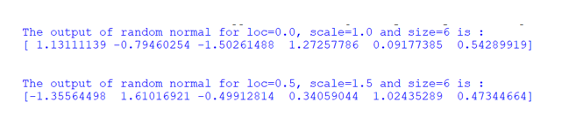

Again when we run the above program it will generate another sample random number, as we can see below –

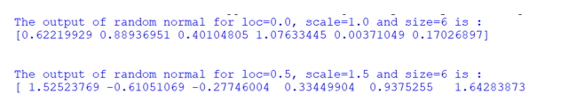

As in the above program, the loc, scale, and size(single-dimensional) values are passed to the normal() function, so the normal() function is generating the random samples from the normal distribution according to the passed values. In the above output if we see every time it generating the different random samples.

Example of NumPy random normal() function for generating multidimensional samples from a normal distribution –

Next, we write the python code to understand the NumPy random normal() function, where the normal() function is used to generating multidimensional samples of size (3, 5) and (2, 5) from a normal distribution, as below –

#### Example #2

**Code:**

**# import numpy package as np  
import numpy as np  
# Using normal() method of random class  
ndis_no = np.random.normal(size = (3,5))  
print( "The output of random normal for loc=0.0, scale=1.0 and size=(3, 5) is : " )  
# printing the size 6 normal distribution random samples of the normal() function  
print( ndis_no )  
print("\n")  
ndis_no = np.random.normal( loc =0.5, scale =1.5, size =(2,5))  
print( "The output of random normal for loc=0.5, scale=1.5 and size=(2, 5) is : " )  
print( ndis_no )**

**Output:**

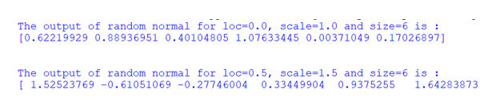

Again, when we run the above program it will generate another sample random number, as we can see below –

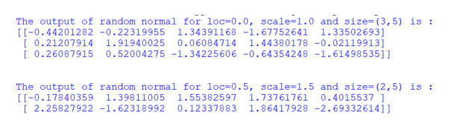

As in the above program, the loc, scale, and size(two dimensional(3, 5), where 3 is the number of rows and 5 is the number of columns) values are passed to the normal() function, so the normal() function is generating the random samples from the normal distribution according to the passed values. In the above output if we see every time it generating the different random samples.

Example of NumPy random normal() function for generating samples from a normal distribution and plot them-

Next, we write the python code to understand the NumPy random normal() function, where the normal() function is used to generating multidimensional samples of size five hundred from a normal distribution and plot them, as below –

#### Example #3

**Code:**

**# import numpy package as np  
import numpy as np  
# import pyplot as plt  
from matplotlib import pyplot as plt  
# Using normal() method of random class  
mean_value = 0.0  
std_value = 1.0  
ndis_no = np.random.normal( mean_value, std_value, size = 500 )  
print( "The output of random normal for loc=0.0, scale=1.0 and size = 500 is : " )  
# printing the size 6 normal distribution random samples of the normal() function  
print( ndis_no )  
count, bins, ignored = plt.hist( ndis_no, 50)  
plt.show()**

**Output:**

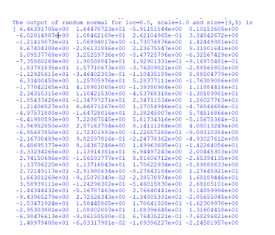

And the plot of above five hundred numbers, as we can see below –

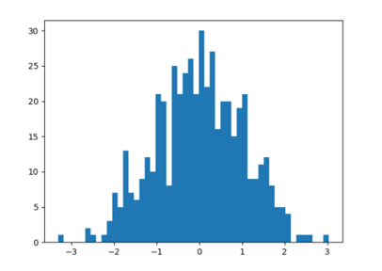

As in the above program, the normal() function is generating the five hundred random sample numbers from the normal distribution according to the passed values and which are plotting as well using the matplotlib package In the above output if we see the distribution of the sample numbers is normal distribution as it is having bell shape.

### Conclusion

The NumPy random normal() function is a built-in function in the NumPy package, which is used to gets the random samples of a specified dimensional array from the normal distribution.

<https://www.educba.com/numpy-unravel_index/>

## Introduction to NumPy unravel_index

In Python, NumPy provides a function unravel_index() function to make flatten indexed array into a tuple of elements or coordinates of each item of the multidimensional arrays which gives us the row and column coordinates together in the means of the output of this function, which in general gives us the idea of where the items of the elements are present with the exact position of row and column. In general, we can define the unravel_index() a function of NumPy to result in the element’s coordinates of the given array which converts any flatten index to get a tuple which consists of coordinates array.

### Working of NumPy unravel_index() Function

In this article, we will discuss the unravel_index() method provided by the NumPy module in Python programming language for converting the array of flat indices into coordinates consisting in a tuple holding the coordinates of each element of the array. In general, the unravel_index() method takes in the array indices the shape or size of the array along with the specification of the row or column-wise arrangement of elements in the array. There is another function that does the opposite of this function known as ravel_multi_index which converts the multidimensional array to a dimensional array which takes both input and output as indices. In the below section let us see the syntax and example for the unravel_index() function.

**Syntax:**

**import numpy  
numpy.unravel_index(ind_arr, shp_arr, order);**

In the above syntax, we can see this function takes 3 parameters which are

* **Ind_arr –** In this parameter, we specify the indices of the array elements which is an integer value which is already flattened values of size of array’s dimensional.
* **Shp_arr –** This parameter to specify the size or shape of the array to store the unraveling indices obtained after applying the function.
* **Order-** This parameter is optional and specifies the ordering of the elements in row-wise then specify it as “C” style if column-wise then specify “F” (Fortan-style). By default, if we do not specify the order it will take C style.

### Examples

In the below section let us consider an example of the unravel_index() function of the Numpy module.

#### Example #1

**Code:**

**import numpy as ed  
print("Program to demonstrate unravel_index() function")  
print("\n")  
print("The elements of the array are:")  
a = [9, 17, 28] print(a)  
print("\n")  
print("The size of the array it should be used for conversion is ")  
b= (6,5)  
print(b)  
print("\n")  
res = ed.unravel_index(a, b)  
print("The output of the unravel_index() is")  
print(res)**

**Output:**

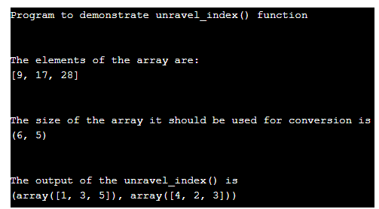

In the above program, we can see have first imported NumPy module to use the unravel_index() function. Then we are declaring few items of the array which is stored in the variable “a” to get their coordinates of rows and columns together in the form of a tuple and then we are declaring the size of the array stored in the variable “b” to be converted from flattened array. In the above program we then call the function and pass these both variables “a = [9, 17, 28]” and “b = (6,5)” to get the output as shown in the above program. We get the coordinates of element “9” as (1,4), for element “17” as (3,2), and element “28” as (5,3). So the output would result in the combination of these coordinates with rows and columns such as the tuple = (array ([1, 3, 5]), array ([4, 2, 3])). In this program we are specifying the order so by default it will take “C” style, therefore the elements here are placed row-wise when we see an array in (6,5) size. So to specify the order in the “F” style parameter the above program needs to be modified when we are calling the function such as

**res = ed.unravel_index(a, b, order = 'F')  
print(res)**

So the above line of the above code needs to be modified in the above program and the output will be as shown in the below screenshot.

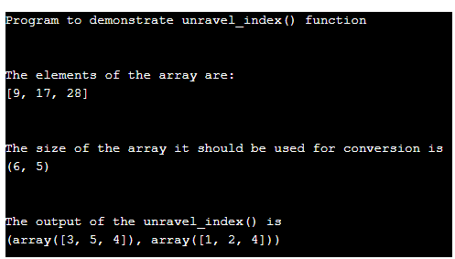

In the above output, we can we get an output as a tuple of arrays such as (array([3, 5, 4]), array([1, 2, 4])) where the output is different from the above because here we have changed the order as “F”. Therefore in this it will arrange the elements of an array in (6, 5) column-wise.

Now we will see below the exact working of how the unravel_ index() arranges the indices of the given array.

#### Example #2

The elements of the array are [9, 17, 28] and the size of the array to be converted is (6, 5) which specifies the dimension of the target array from which we need to fetch the indices.

So if the array is flattened which means if no dimension is mentioned then it would like below:

[ 0, 1, 2, 3, 4, 5, 6, 7, 8, **9,** 10, 11, 12, 13, 14, 15, 16,

**17**, 18, 19, 20, 21, 22, 23, 24, 25, 26, 27, **28**, 29]

And now we want to convert this above flatten array to (6, 5) dimensional array so this will look like below:

[[ 0, 1, 2, 3, 4],

[5, 6, 7, 8, **9** ] ,

[10, 11, 12, 13, 14],

[15, 16, **17**, 18, 19],

[20, 21, 22, 23, 24],

[25, 26, 27, **28**, 29]]

So the bold numbers are the indices of the array to unflattened the above-flattened array. So in the above array indices of the array are placed row-wise when “C” style having 6 rows starting from (0, 1, 2, 3, 4, 5) rows and 5 columns as (0, 1, 2, 3, 4). So the coordinates of the given indices elements of the above (6, 5) dimensional array are (1,4) for 9, (3, 2) for 17, (5,3) for 28 and therefore the output array of tuple would be (array ([1, 3, 5]), array ([4, 2, 3])).

Suppose the order is “F” then the above (6, 5) array would be arranged in column-wise as shown below:

[[0, 6, 12, 18, 24] [1, 7, 13, 19, 25] [2, 8, 14, 20, 26] [3, **9**, 15, 21, 27] [4, 10, 16, 22, **28**] [5, 11, **17**, 23, 29]]

So the above array is in Order “F” style so the bold numbers are the indices elements of the array and the coordinates are (3,1) for 9, (5,2) for 17 and (4,4) for 28 and output results as (array([3, 5, 4]), array([1, 2, 4])).

### Conclusion

In this article, we conclude that the NumPy module of Python provides a function for converting the flattened array of indices as elements to the tuple of arrays contains the coordinates of these indices placed in the given dimensions of the array. In this article, we saw how to use the unravel_index() function to unflatten the flattened array of indices with an example for both order “C” row-wise and “F” column-wise with program and demonstration.

<https://www.educba.com/numpy-eye/>

## Introduction to Numpy.eye()

The Numpy.eye() function is typically used in the Python coding language. With the help of the function the system is enabled to return the output array that all the values contained within the array are equal to zero with the exception of the kth diagonal, the value of which is equal to 1. the user has ability while using this function, to choose the diagonal which will be allocated the value of 1.

**Syntax:**

Following is the syntax which used to utilize the numpy.eye() while writing codes in the Python programming language:

**numpy.eye(* N *, * M * = * None *, * k * = * 0 *, * dtype * = * < * class * ' * float * ' * > *, * order * = * ' * C * ' *) \***

**Parameters for application of NumPy.eye()**

Following is the parameters used for the numpy *.eye() function written in the Python programming language:

|  |  |
| --- | --- |
| **Parameters used in the function** | **Description of the Parameter** |
| **N * int** | The parameter ‘N’, represents the total number of rows that are present in the array. * * * * * * * |
| **M * int, optional** | The parameter ‘N’ represents the total number of columns that are present in the array. The default value for the function is where the total number of columns and the total number of rows are equal. It is an optional parameter. * * * * * * * * * * * * * * * * * * * * * * |
| **k * int, optional** | This parameter is enabled to represents the main diagonal. The default value of k is 0. If the value is positive (i.e., k>0), it represents that it is an upper diagonal; whereas when the value of k is negative, it represents a lower diagonal. The default value for the parameter is assumed to be zero. It is an optional parameter. * * * * * * * * * * * * * * * |
| **d * typedata-type, optional** | It is an optional parameter. The data type of the returned array is represented by the parameter. The default value of the parameter is float datatype. |
| **order{‘C’,** * **‘F’}, optional** | It is an optional parameter. This can be assigned either of the two values C_ contiguous or F_ contiguous. This parameter suggests the user the option of the orientation of the output. Whether it should be stored in the C-style (i.e., row-major style) or Fortran-style (i.e., column-major style) for the order of the data to placed in the memory of the system. |
| **Indarray of shape (N,M)** | The output array after the function numpy.eye() is applied on the input array.  The output array has all the elements represented as zero with the exception of the k-th element representing the value of the diagonal. The values of the diagonal will be equal to one. |

### How does the Numpy.eye function?

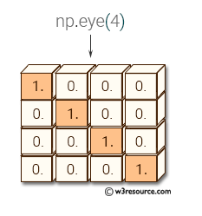

The diagonal is calculated by the system, identifying the position of the elements on the main matrix and then the function proceeds to replace the value except for the diagonal values by 0’s. The value of 1’s is replaced in all the elements spread across at the indices at the diagonal. The figure represents how the diagonal is replaced by 1st and the remaining elements in the matrix are replaced by the value zero.

### Examples

Lets us discuss Examples to implement eye function in NumPy.

#### Example #1 – Python Programming used to illustrate the use of the NumPy.eye() function

**Code:**

**# importing the numpy class as np1  
import numpy as np1  
# declaration of a 2x2 matrix with 1 on its main diagonal  
o1 = np1.eye(2, dtype = float)  
print("The array which has been entered by the system : \n", o1)  
# declaration of the array using the matrix with Row set at a value of 2 and Colum set at the value of 3 and the diagonal is equal to 1  
o2 = np1.eye(2, 3, k = 1)  
print("The array which has been entered by the system : \n", o2)**

**Output:**

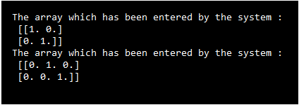Example #2 – Python Programming used to illustrate the use of the NumPy.eye() function

**Code:**

**# importing the numpy class as np1  
import numpy as np1  
# declaration of a 2x2 matrix with 1 on its main diagonal  
b1 = np1.eye(2, dtype = float)  
print("The Matrix B which has been entered by the system : \n :", b1)  
# declaration of the array using the matrix with Row set at a value of 4 and Colum set at the value of 5 and the diagonal is equal to 1  
a1 = np1.eye(4, 5, k = -1)  
print("\n The Matrix A which has been entered by the system :\n", a1)**

**Output:**

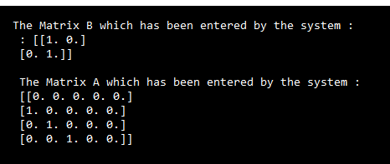

### Conclusion

The eye function provides for a pre-developed functionality which is quintessential and very handy acting as a preparatory step. Python’s function NumPy eye() is one of the in-built functions which is used in order to return a resultant matrix i.e., a two-dimensional array having the value of 1 in the diagonal section in the matrix and 0 placed at values in all other elements in the matrix (elsewhere with respect to the specific position on the kth value). This function helps in creating multiple multidimensional arrays and in turn, derives other mathematical and statistics related functions to be performed on the array which helps in resolving the complete value to the function.